AzURE MACHINE LEARNING WORKSHOP

MAY 2020

**AGENDA**

**Introduction to Azure Machine Learning**

1. **Create your Machine Learning Workspace**
2. **Create Compute**
3. **Create Dataset**
4. **Automatic Machine Learning**
5. **Azure Machine Learning Designer**
6. **Notebook VM and Python SDK**
7. **Azure ML R SDK and R studio inteface**
8. **MLOpS**

**Introduction to Azure Machine Learning**

Azure Machine Learning can be used for any kind of machine learning, from classical ml to deep learning, supervised, and unsupervised learning. Whether you prefer to write Python or R code or zero-code/low-code options such as the [designer](https://docs.microsoft.com/en-us/azure/machine-learning/tutorial-designer-automobile-price-train-score), you can build, train, and track highly accurate machine learning and deep-learning models in an Azure Machine Learning Workspace.

Azure Machine Learning provides all the tools developers and data scientists need for their machine learning workflows, including:

* The [Azure Machine Learning](https://docs.microsoft.com/en-us/azure/machine-learning/tutorial-designer-automobile-price-train-score) designer (preview): drag-n-drop modules to build your experiments and then deploy pipelines.
* Jupyter notebooks: use our [example notebooks](https://aka.ms/aml-notebooks)or create your own notebooks to leverage our [SDK for Python](https://docs.microsoft.com/python/api/overview/azure/ml/intro?view=azure-ml-py) samples for your machine learning.
* R scripts or notebooks in which you use the [SDK for R](https://azure.github.io/azureml-sdk-for-r/reference/index.html) to write your own code, or use the R modules in the designer.
* [Visual Studio Code extension](https://docs.microsoft.com/en-us/azure/machine-learning/tutorial-setup-vscode-extension)
* [Machine learning CLI](https://docs.microsoft.com/en-us/azure/machine-learning/reference-azure-machine-learning-cli)
* Open-source frameworks such as PyTorch, TensorFlow, and scikit-learn and many more
* You can even use [MLflow to track metrics and deploy models](https://docs.microsoft.com/en-us/azure/machine-learning/how-to-use-mlflow) or Kubeflow to [build end-to-end workflow pipelines](https://www.kubeflow.org/docs/azure/).

A [taxonomy](https://docs.microsoft.com/en-us/azure/machine-learning/concept-workspace) of the workspace is illustrated in the following diagram:

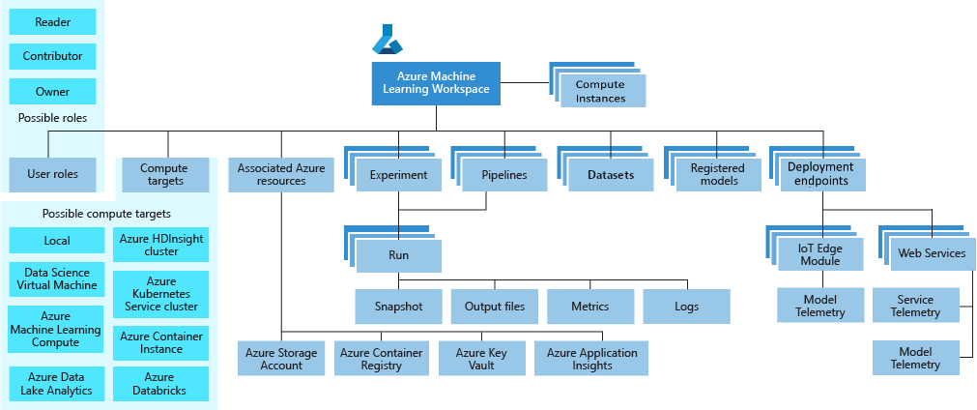

1. **Azure Machine Learning Workspace**

* Sign in to the [Azure portal](https://portal.azure.com/)by using the credentials for your Azure subscription.
* In the upper-left corner of Azure portal, select **+ Create a resource.**
* Use the search bar to find **Machine Learning**
* Select **Machine Learning**

[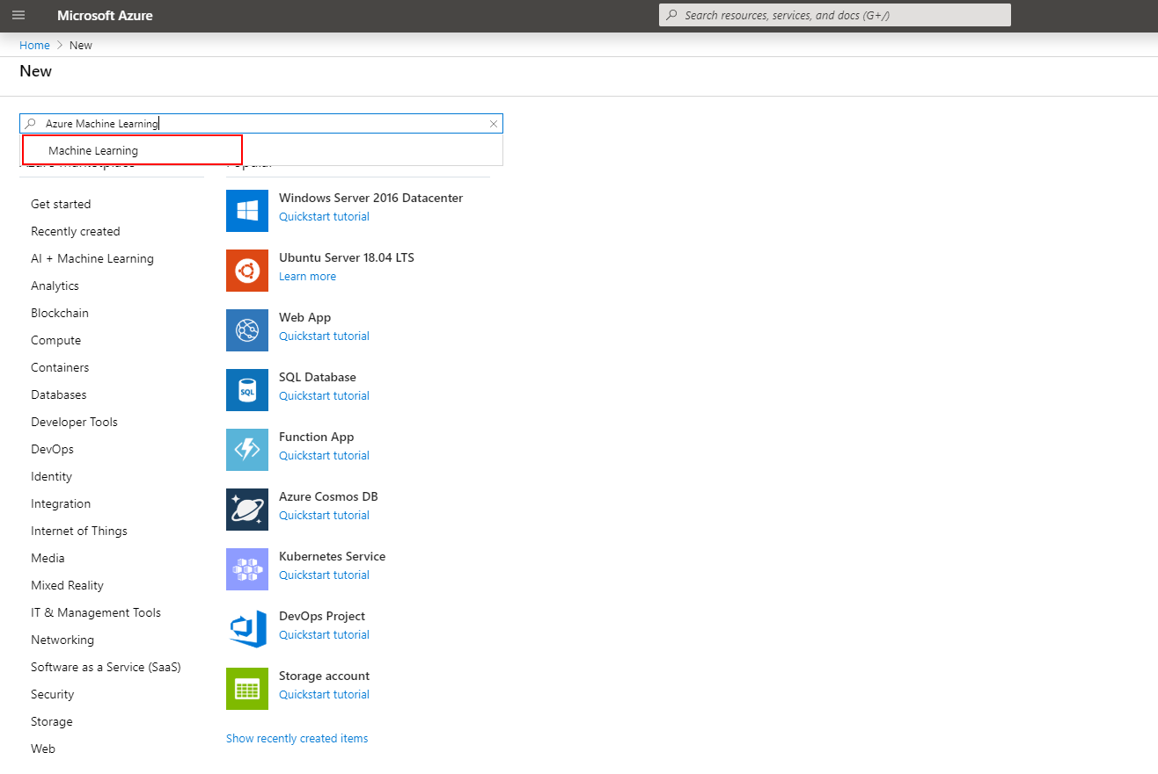](https://github.com/microsoft/MCW-Machine-Learning/blob/master/Hands-on%20lab/images/create-aml-resource-01.png)

* In the **Machine Learning** pane, select **Create** to begin.

[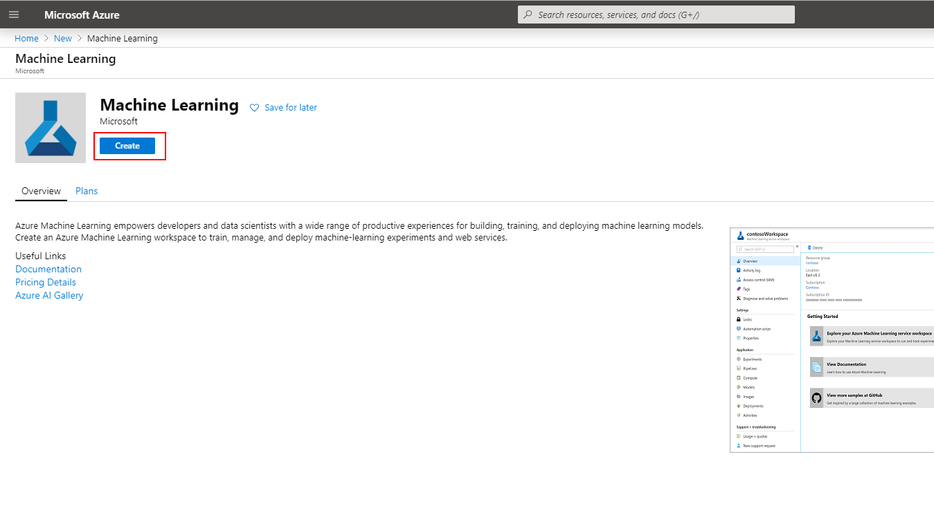](https://github.com/microsoft/MCW-Machine-Learning/blob/master/Hands-on%20lab/images/create-aml-resource-02.png)

* Provide the following information to configure your new workspace.

| **Field** | **Description** |
| --- | --- |
| Workspace name | Enter a unique name that identifies your workspace. Names must be unique across the resource group. Use a name that is easy to recall and to differentiate from workspaces created by others. The workspace name is case-insensitive. |
| Subscription | Select the Azure subscription that you want to use. |
| Resource group | Use an existing resource group in your subscription or enter a name to create a new resource group. A resource group holds related resources for an Azure solution. |
| Location | Select the location closest to your users and the data resources to create your workspace. |
| Workspace edition | Select Enterprise. This workspace edition determines the features to which you'll have access and pricing. Learn more about [Basic and Enterprise edition offerings](https://docs.microsoft.com/en-us/azure/machine-learning/overview-what-is-azure-ml#sku). |

**Keep this information saved for future use.**

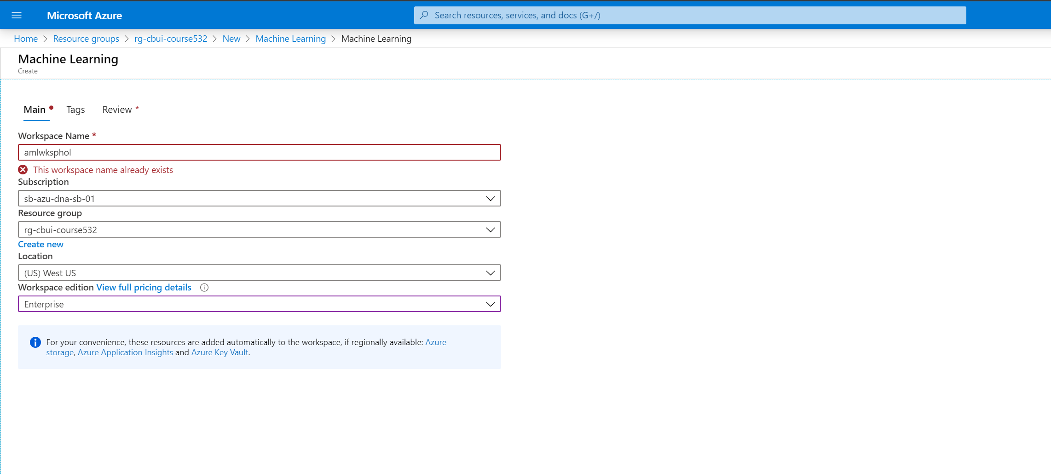

* When you're finished configuring the workspace, select **Review + Create**.
* Review the settings and make any additional changes or corrections. When you're satisfied with the settings, select **Create**.
* To view the new workspace, select **Go to resource**.

1. **Create Compute**

**Create Compute Cluster**

An Azure Machine Learning compute instance (preview) is a fully managed cloud-based workstation for data scientists. Compute instances make it easy to get started with Azure Machine Learning development as well as provide management and enterprise readiness capabilities for IT administrators. Use a compute instance as your fully configured and managed development environment in the cloud. Compute instances are typically used as development environments. They can also be used as a compute target for training and inferencing for development and testing. For large tasks, an [Azure Machine Learning compute cluster](https://docs.microsoft.com/en-us/azure/machine-learning/how-to-set-up-training-targets#amlcompute) with multi-node scaling capabilities is a better compute target choice.

We will do several actions that require a compute target to be executed on. We will start by creating a cluster of CPUs VMs.

* Sign in at [https://ml.azure.com](https://ml.azure.com/).
* Select Compute in the Assets section of the left pane.

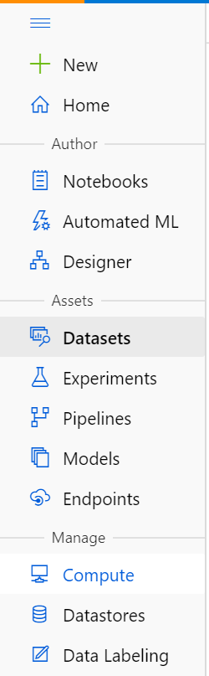

* Navigate to Compute > Compute Clusters in the Manage section and click New.

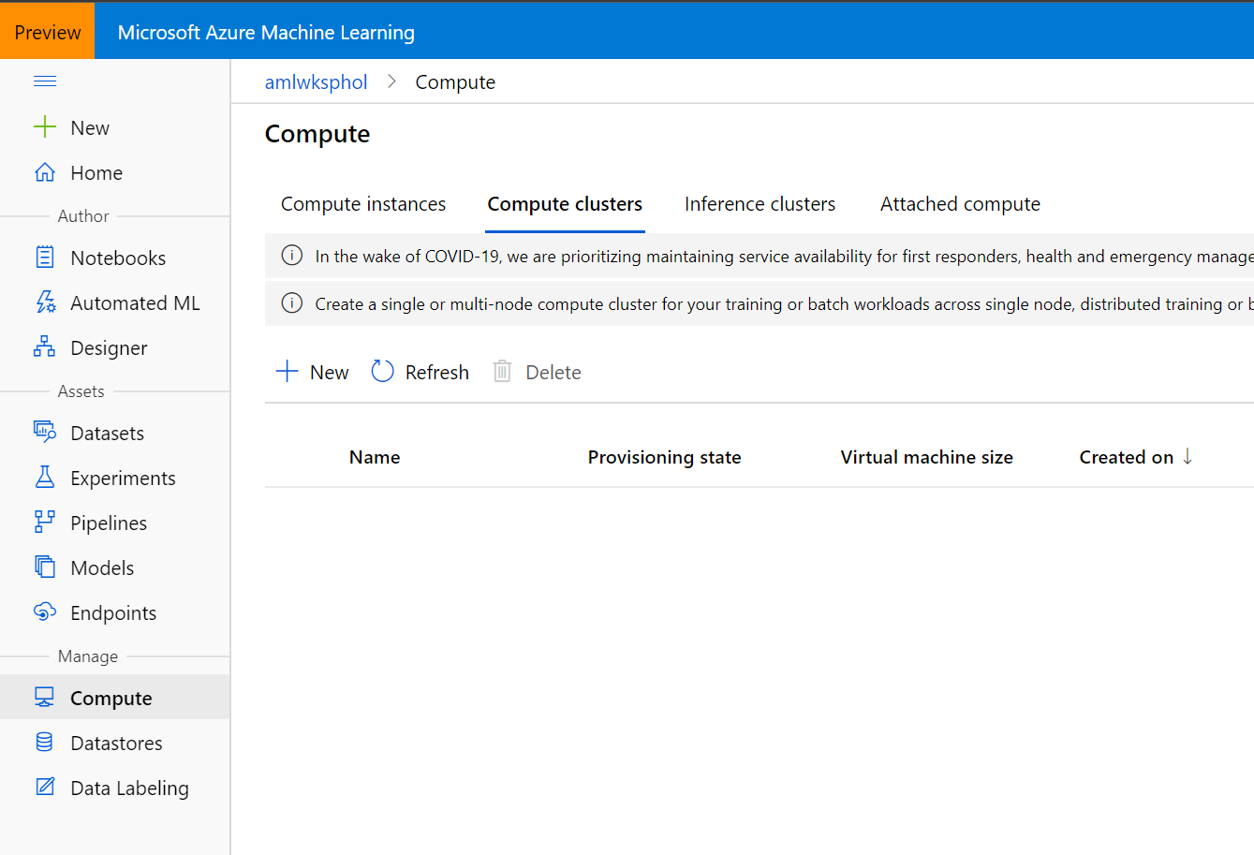

* **Name** the cluster cpucluster.
* **Virtual machine type**  CPU
* For **machine size** choose Standard_DS2_v2.
* Set the **Minimum number of nodes** to 0 and the **Maximum number of nodes** to 4. That way the cluster will scale automatically to up to 4 nodes as jobs require them.
* Set the **Idle seconds before scaling down** to 600. That means that nodes will be kept around for 10 minutes before they are spun down. That way, during our workshop, jobs will not have to wait for spin-up. Make sure that number is lower if you are using a more expensive VM size.

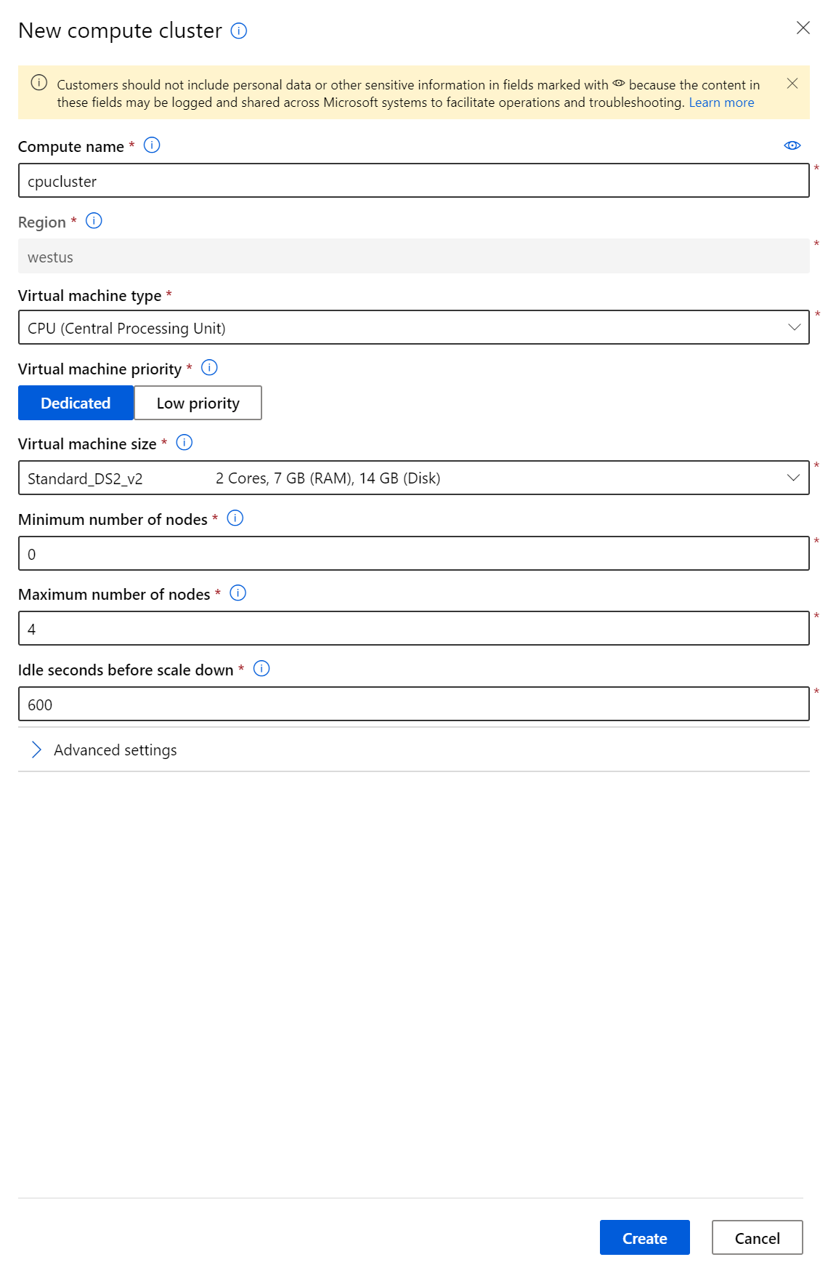

* Click Create.
* Wait for the provisioning state to be “Succeeded”

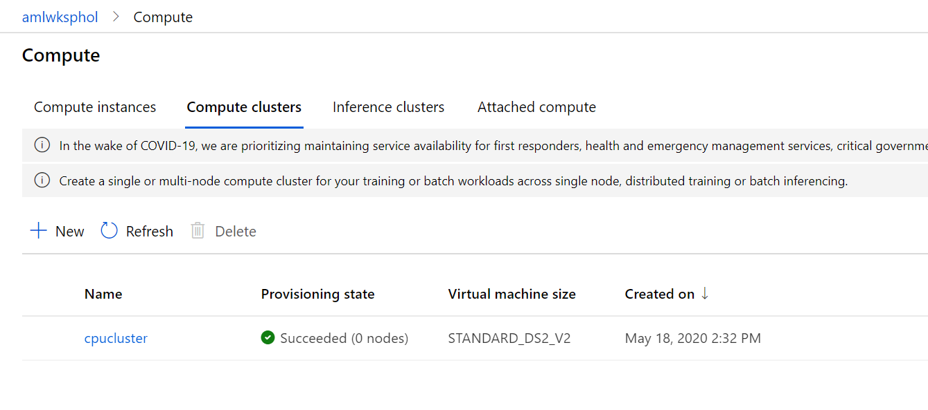

**Create Compute Instance**

Next, we will create a Compute Instance. The Compute Instance will serve as an interactive workstation in the cloud that serves as a Jupyter server, but also hosts and instance of RStudio server and can run TensorBoard, Bokeh, Shiny or other apps used during the development work of a Data Scientist.

* Navigate to Compute Instances tab in the Compute section and click on New.

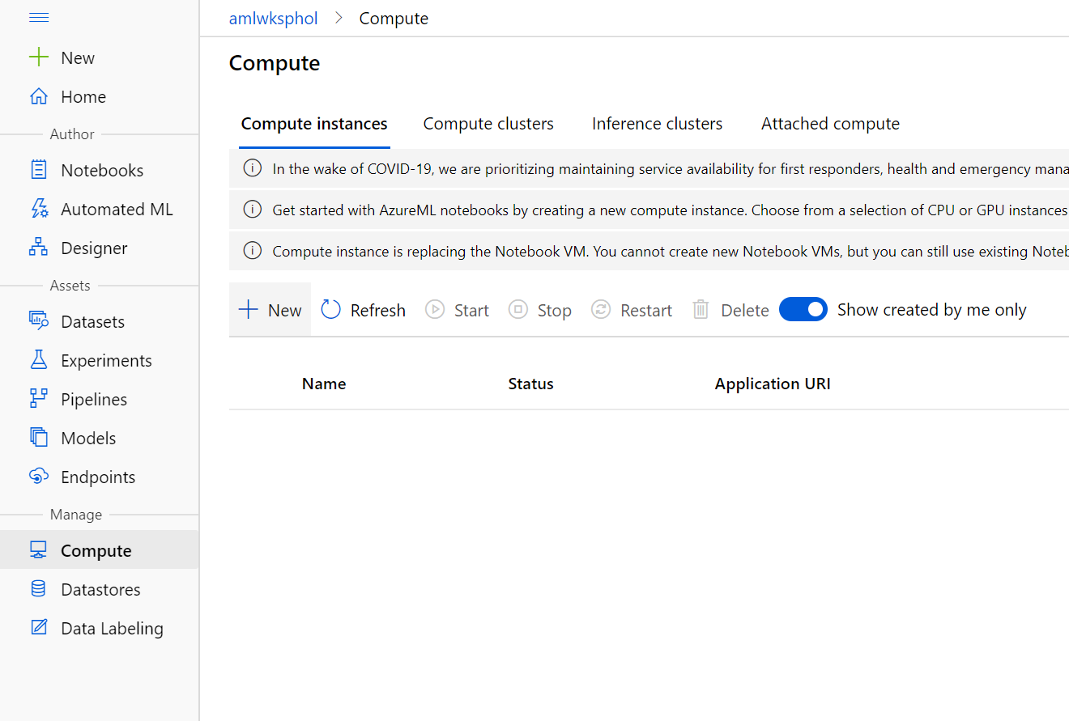

* Choose some sufficiently unique name, keep the default VM type (STANDARD_DS3_V2 - a fairly inexpensive machine type costing).

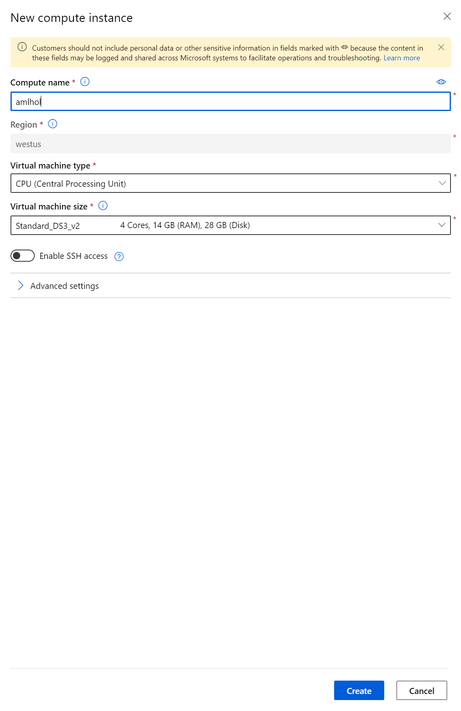

* Click Create.
* Wait for it to change the status to “Running”.

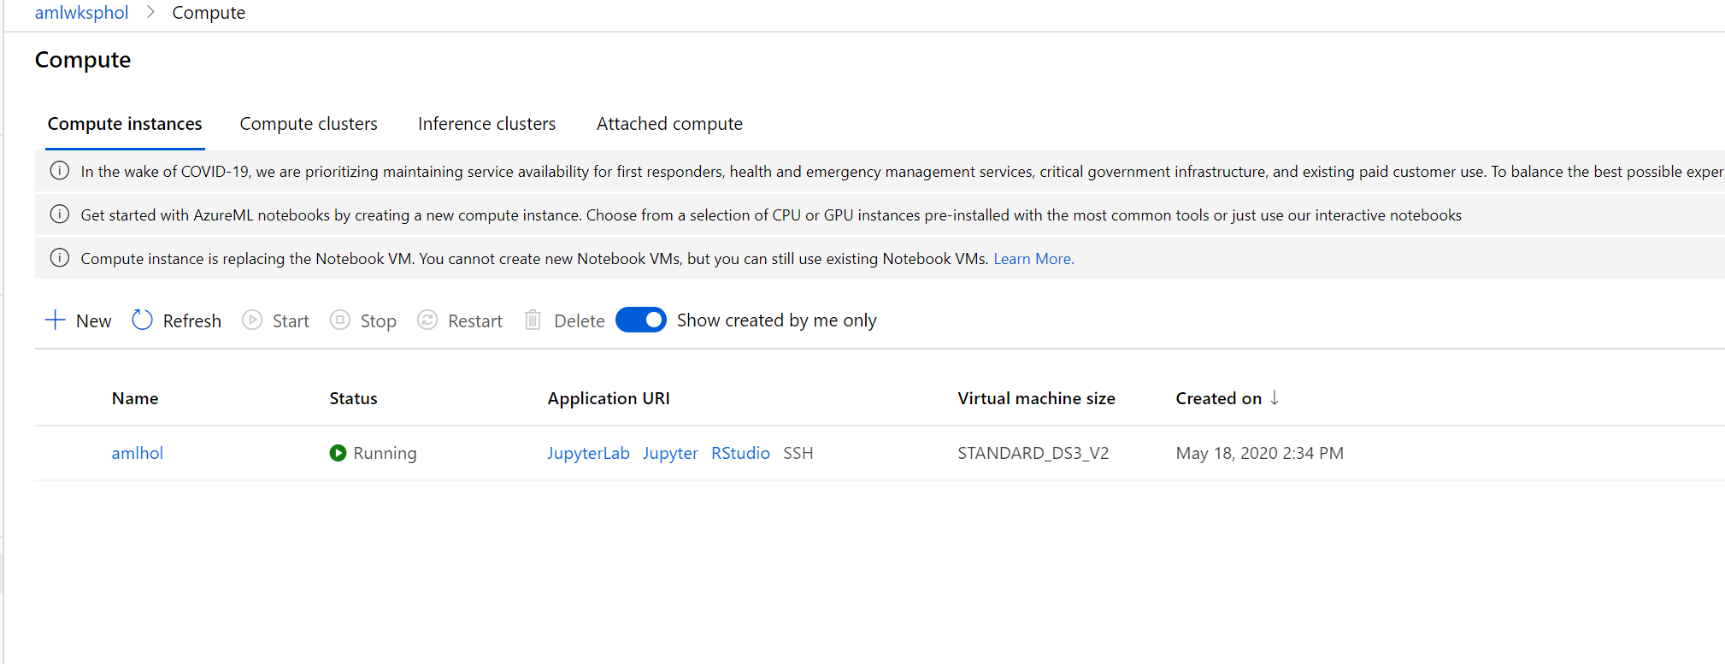

* **Note that this machine will keep running until you stop it!**

**3. Create Dataset**

With Azure Machine Learning datasets, you can:

* Keep a single copy of data in your storage, referenced by datasets.
* Seamlessly access data during model training without worrying about connection strings or data paths.
* Share data and collaborate with other users.

There are two dataset types, based on how users consume them in training:

* [TabularDataset](https://docs.microsoft.com/python/api/azureml-core/azureml.data.tabulardataset?view=azure-ml-py)represents data in a tabular format by parsing the provided file or list of files. This provides you with the ability to materialize the data into a Pandas or Spark DataFrame. You can create a TabularDataset object from .csv, .tsv, .parquet, .jsonl files, and from SQL query results. For a complete list, see [TabularDatasetFactory class](https://aka.ms/tabulardataset-api-reference).
* The [FileDataset](https://docs.microsoft.com/python/api/azureml-core/azureml.data.file_dataset.filedataset?view=azure-ml-py)class references single or multiple files in your datastores or public URLs. By this method, you can download or mount the files to your compute as a FileDataset object. The files can be in any format, which enables a wider range of machine learning scenarios, including deep learning.

Once you have created an instance of Azure Machine Learning, select 'Launch Azure Machine Learning studio' (or browse to <https://ml.azure.com/>)

By creating a dataset, you create a reference to the data source location, along with a copy of its metadata. To create a dataset in the studio:

* Sign in at [https://ml.azure.com](https://ml.azure.com/).
* Select Datasets in the Assets section of the left pane.

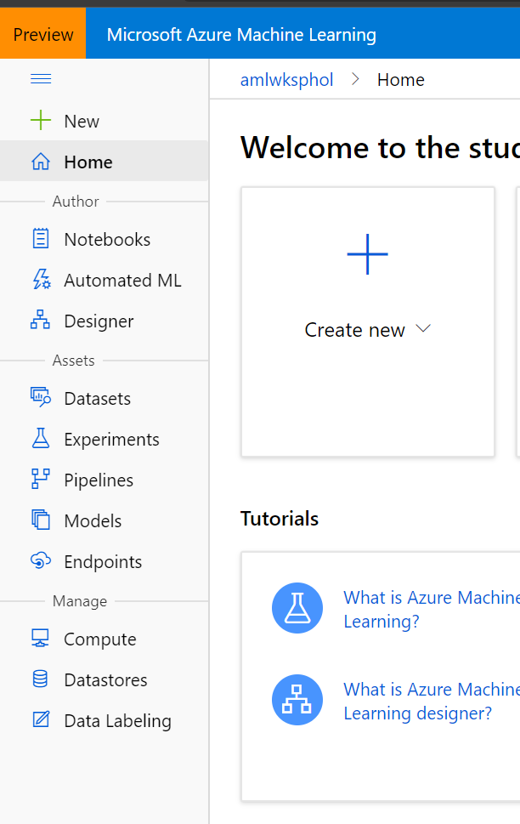

* Select Create Dataset to choose the source of your dataset. This source can be local files, a datastore, or public URLs. For our workshop we will upload the data from local files. You can download the dataset from [here](https://github.com/shkumar64/AzureMachineLearningWorkshop/blob/master/dataset/HR-Employee-Attrition.csv).

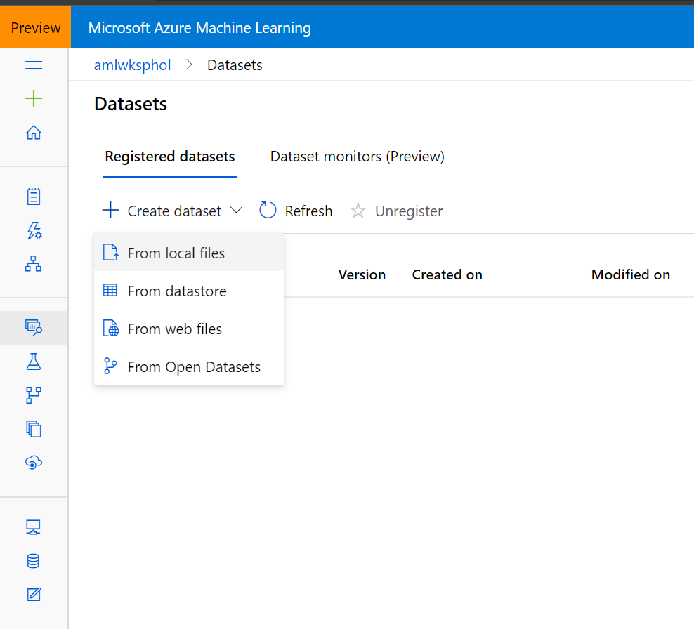

* Select Tabular for Dataset type and give your dataset a name.

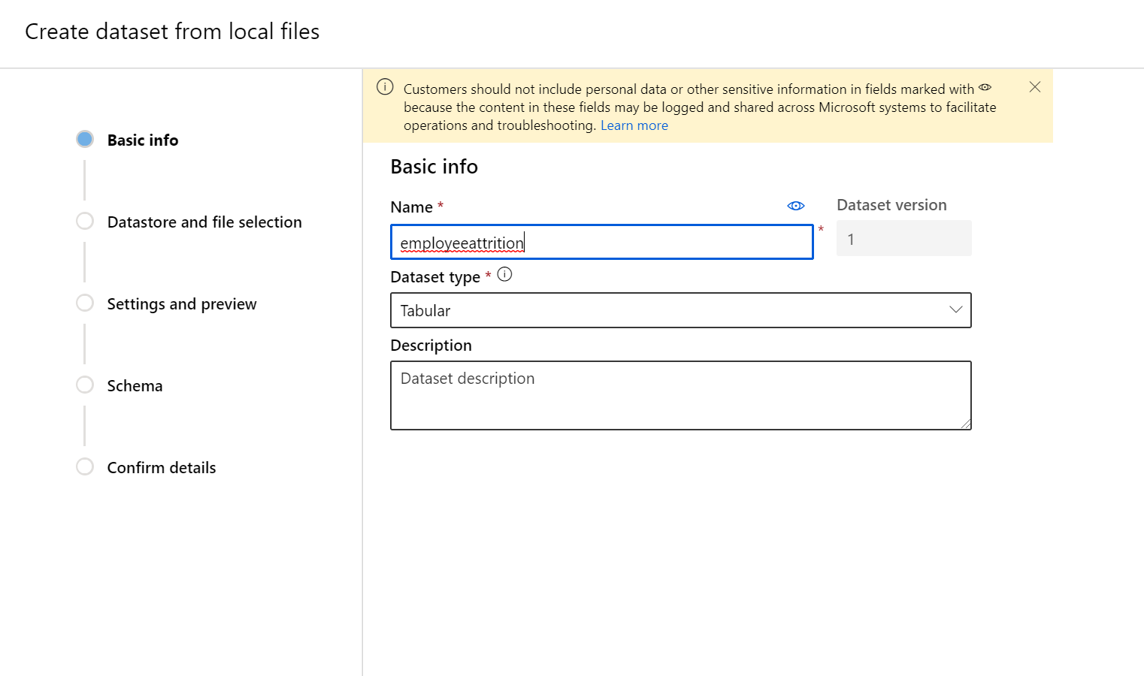

* Select Next to open the Datastore and file selection form. On this form you select where to keep your dataset after creation, as well as select what data files to use for your dataset. Select Browse and upload the file from your local desktop. Keep rest of the default values.

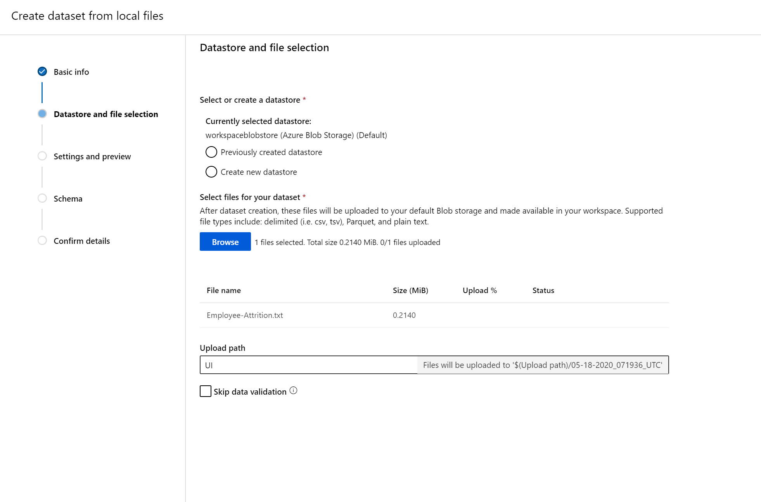

* Select Next to populate the Settings and preview and Schema forms; they are intelligently populated based on file type and you can further configure your dataset prior to creation on these forms. Change the Column header to “All files have same header”. Ensure the rest of the setting and preview of the data.

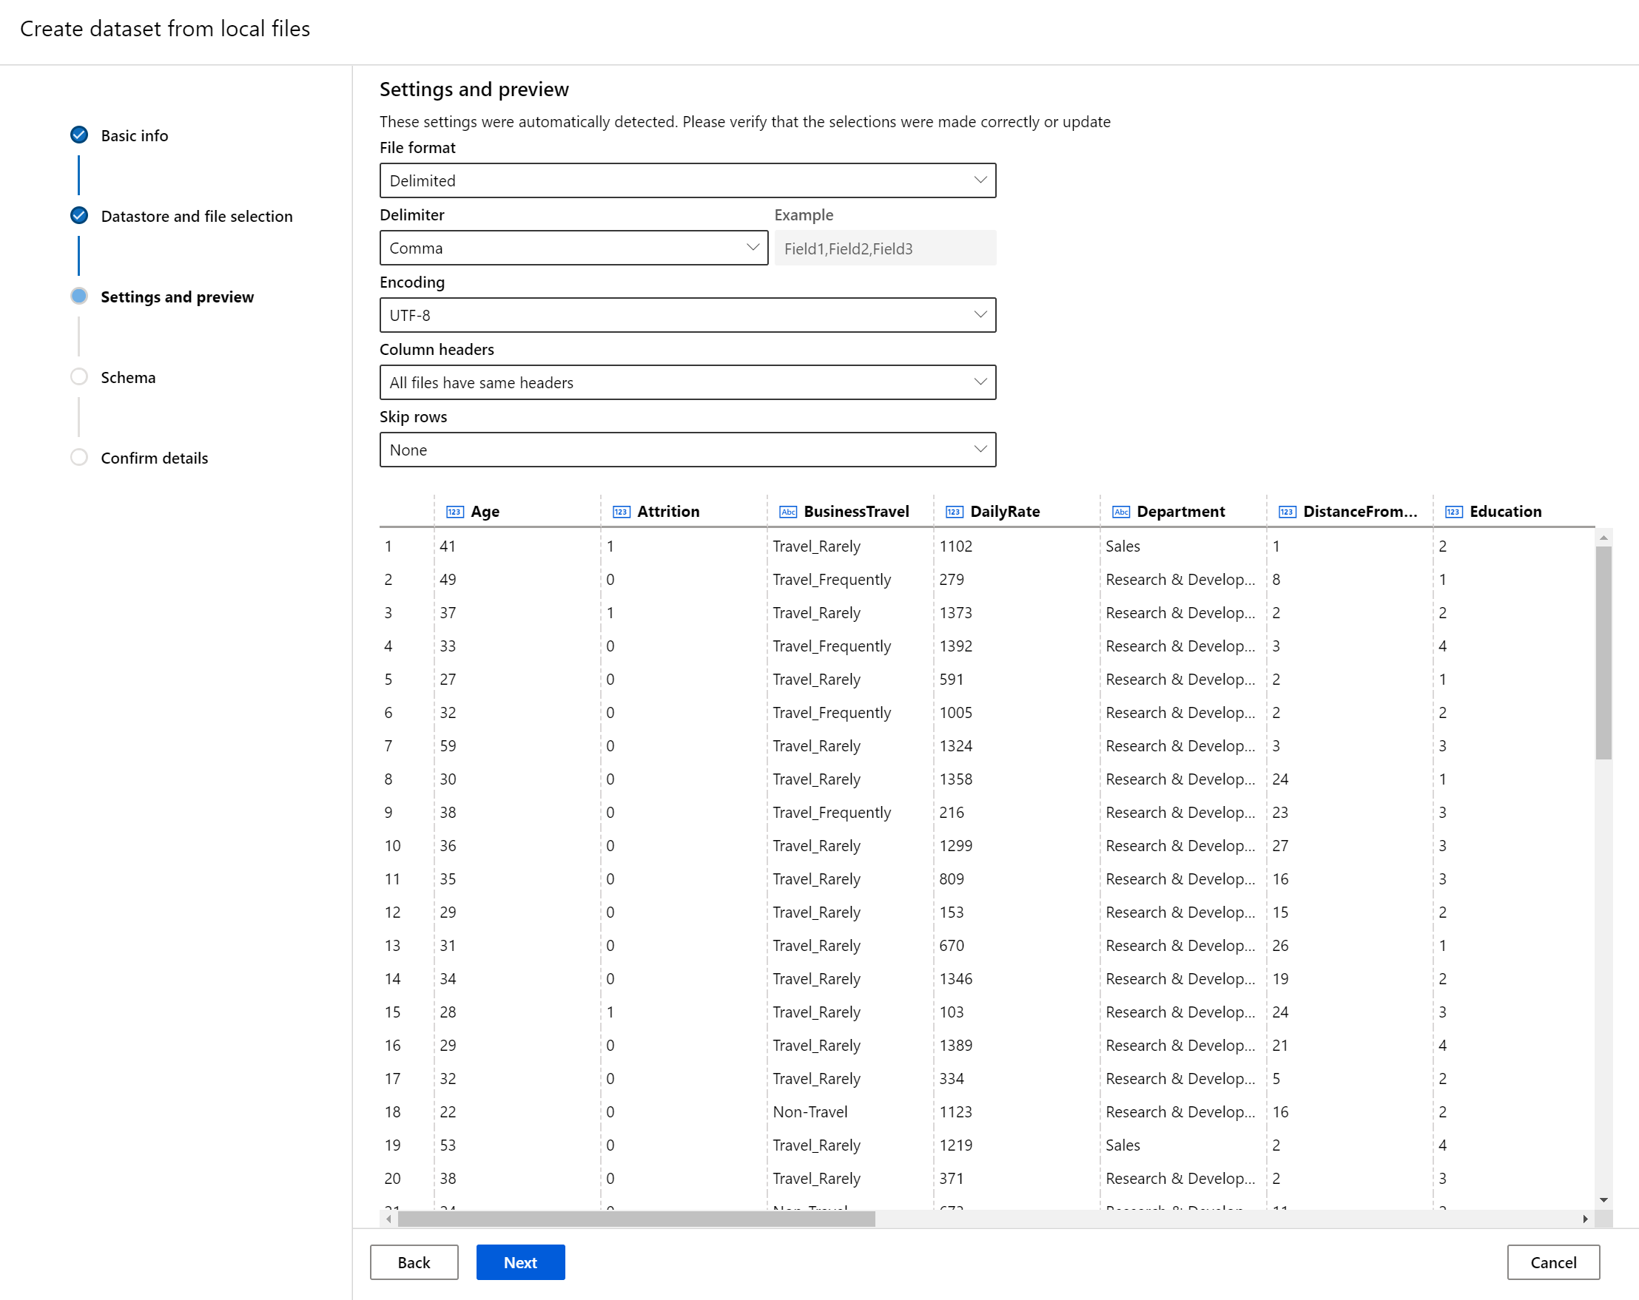

* Select Next to review the Schema and Data type.

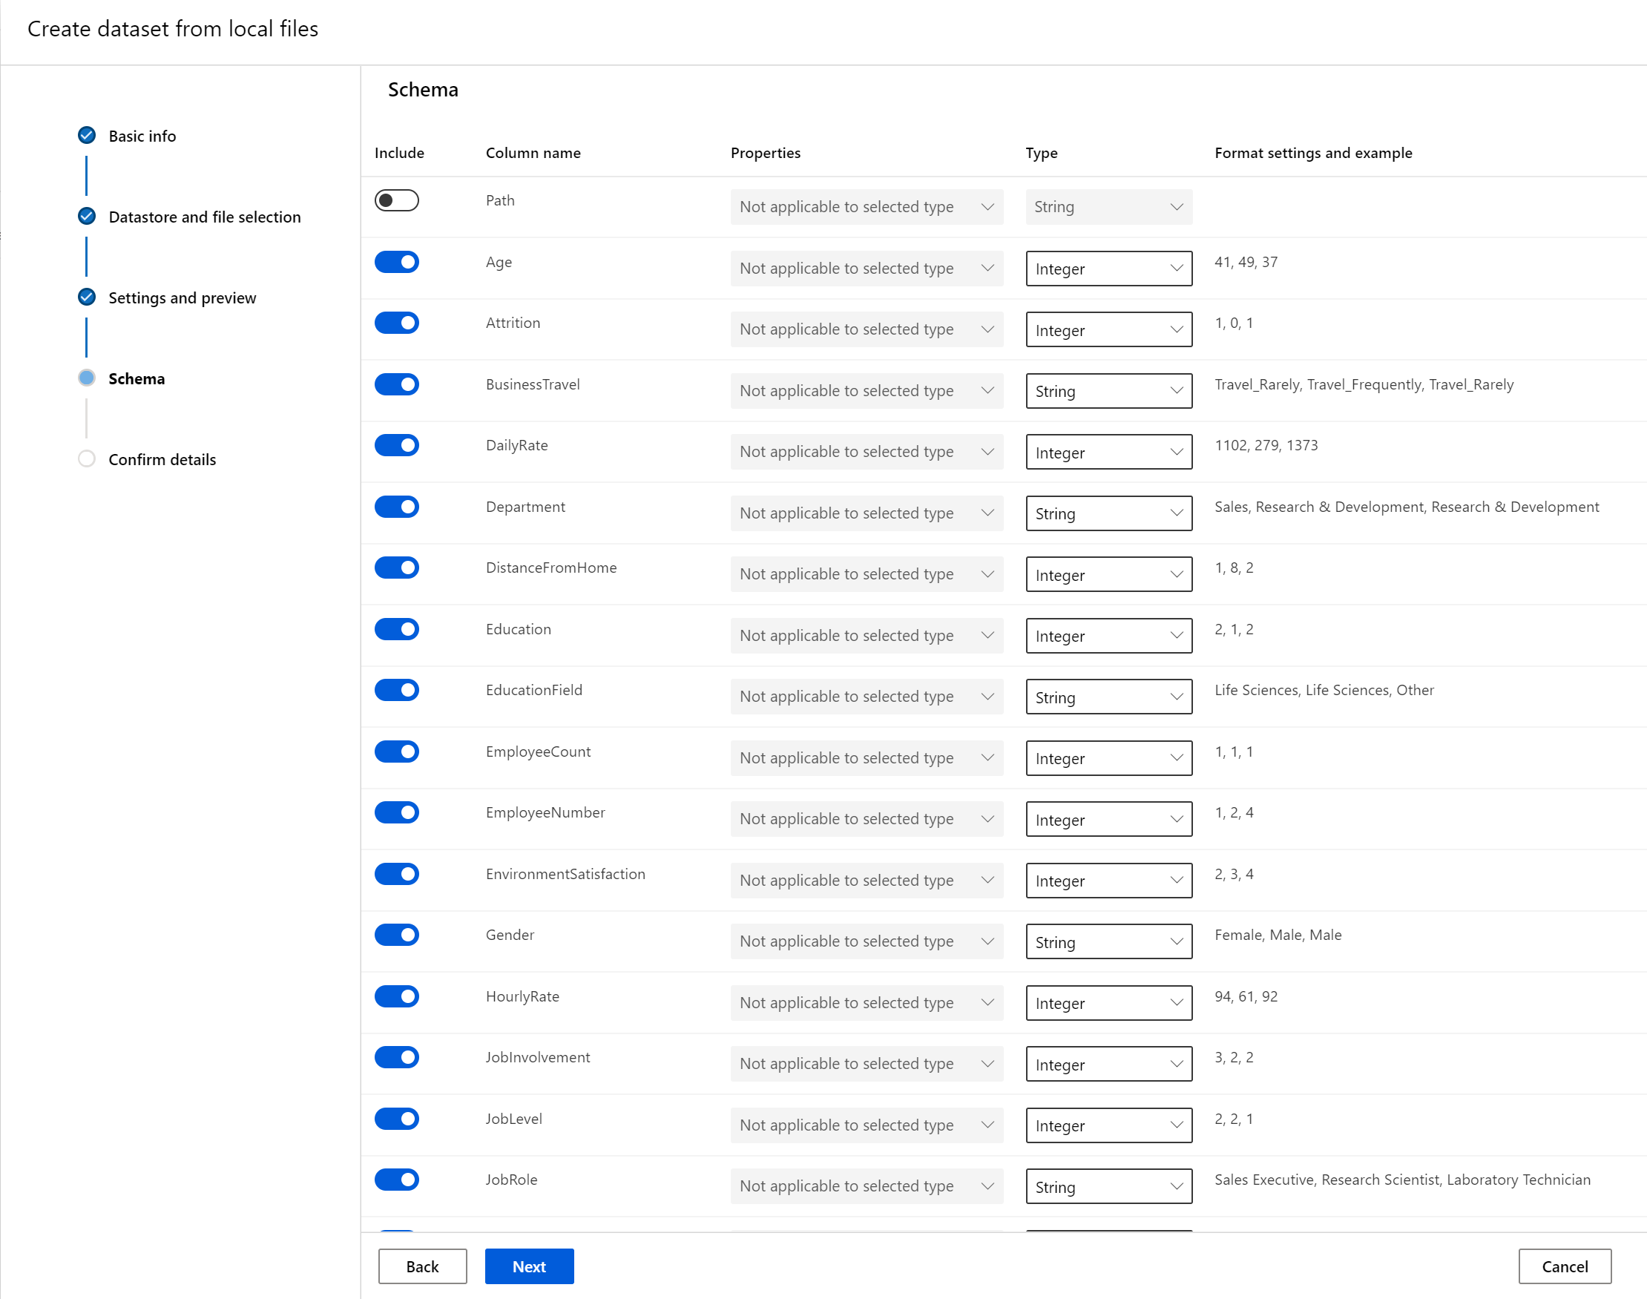

* Select Next to review the Confirm details form. Check your selections and create an data profile for your dataset. Learn more about [data profiling](https://docs.microsoft.com/en-us/azure/machine-learning/how-to-use-automated-ml-for-ml-models#profile).

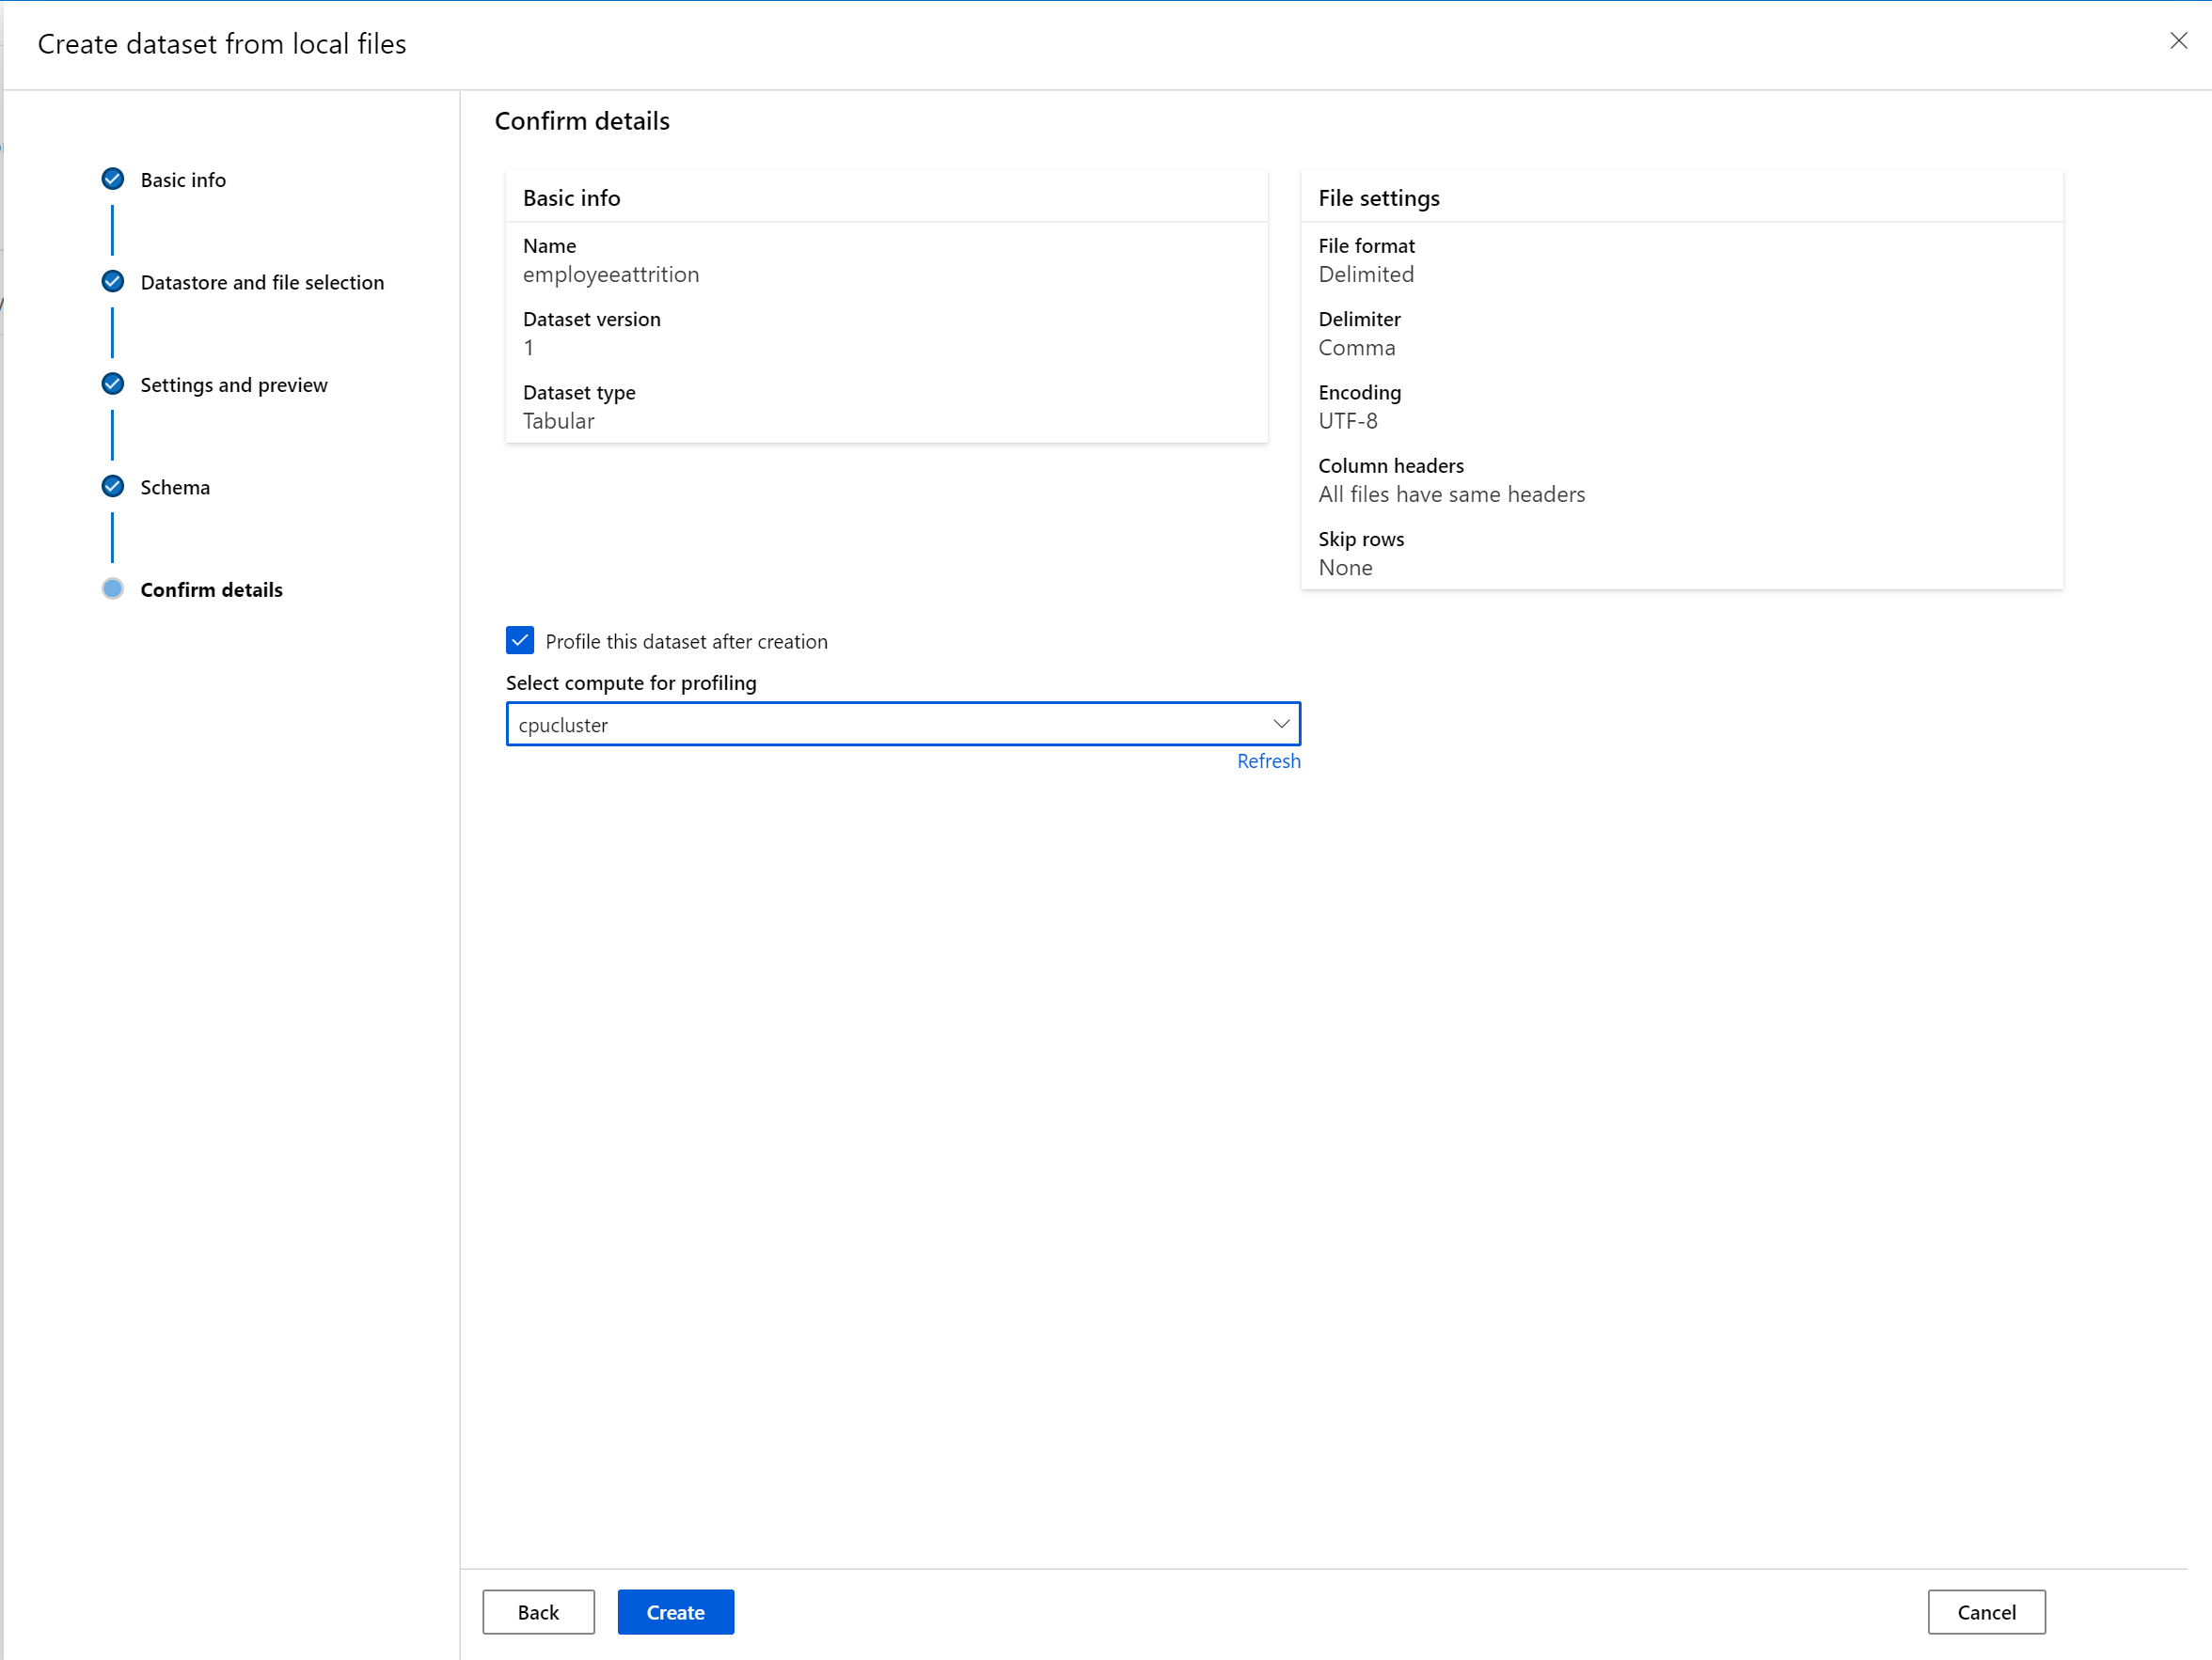

* Select Create to complete your dataset creation.
* Dataset should be registered and available for use.

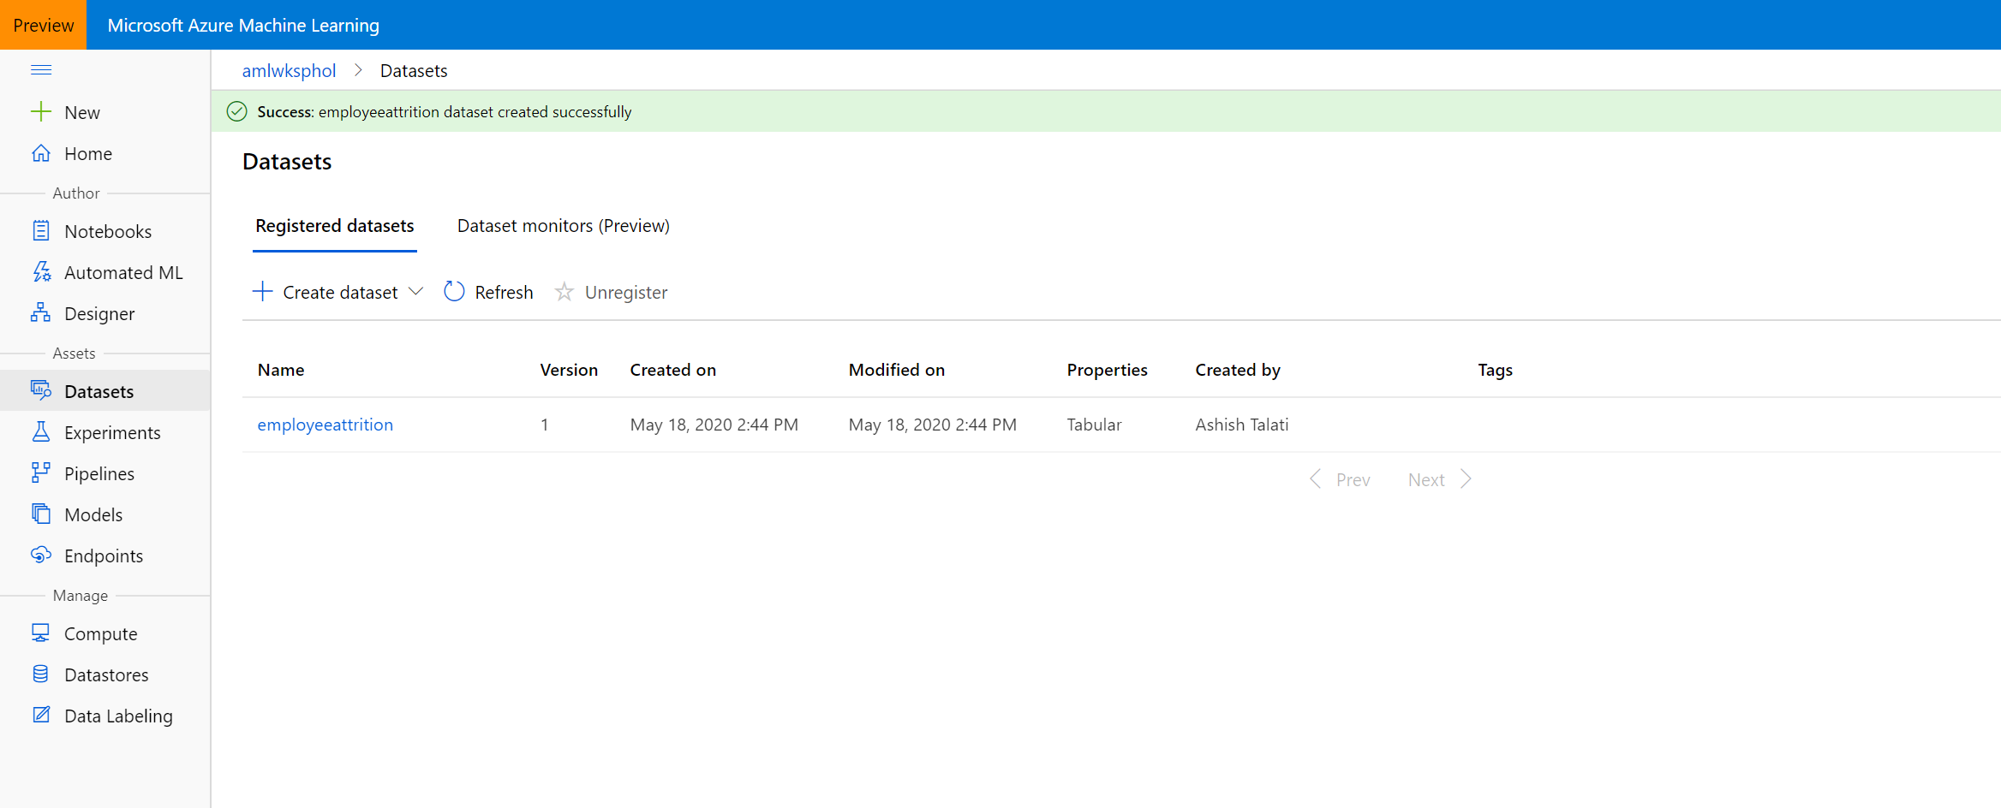

* You can register a new dataset under the same name by creating a new version. A dataset version is a way to bookmark the state of your data so that you can apply a specific version of the dataset for experimentation or future reproduction. Learn more about [dataset versions](https://docs.microsoft.com/en-us/azure/machine-learning/how-to-version-track-datasets).
* Once the data profile is completed (profile generation), you can get a vast variety of summary statistics across your data set to verify whether your data set is ML-ready. For non-numeric columns, they include only basic statistics like min, max, and error count. For numeric columns, you can also review their statistical moments and estimated quantiles.

| **Statistic** | **Description** |
| --- | --- |
| Feature | Name of the column that is being summarized. |
| Profile | In-line visualization based on the type inferred. For example, strings, booleans, and dates will have value counts, while decimals (numerics) have approximated histograms. This allows you to gain a quick understanding of the distribution of the data. |
| Type distribution | In-line value count of types within a column. Nulls are their own type, so this visualization is useful for detecting odd or missing values. |
| Type | Inferred type of the column. Possible values include: strings, booleans, dates, and decimals. |
| Min | Minimum value of the column. Blank entries appear for features whose type does not have an inherent ordering (e.g. booleans). |
| Max | Maximum value of the column. |
| Count | Total number of missing and non-missing entries in the column. |
| Not missing count | Number of entries in the column that are not missing. Empty strings and errors are treated as values, so they will not contribute to the "not missing count." |
| Quantiles | Approximated values at each quantile to provide a sense of the distribution of the data. |
| Mean | Arithmetic mean or average of the column. |
| Standard deviation | Measure of the amount of dispersion or variation of this column's data. |
| Variance | Measure of how far spread out this column's data is from its average value. |
| Skewness | Measure of how different this column's data is from a normal distribution. |
| Kurtosis | Measure of how heavily tailed this column's data is compared to a normal distribution. |

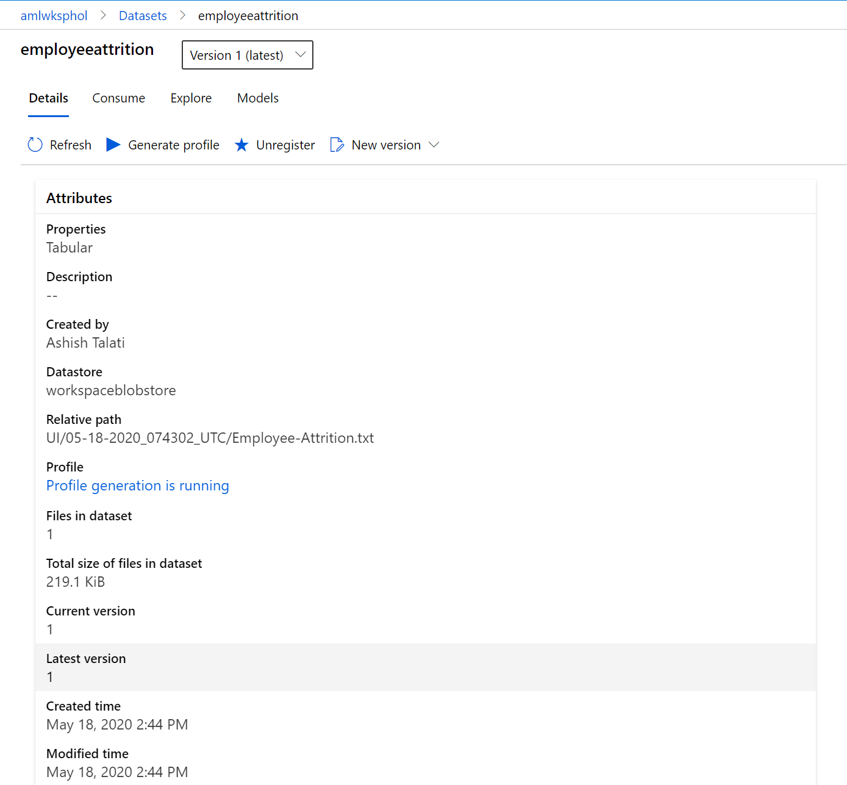

* Now, click on the newly created dataset and click Explore. Here you can see the fields of the Tabular dataset.

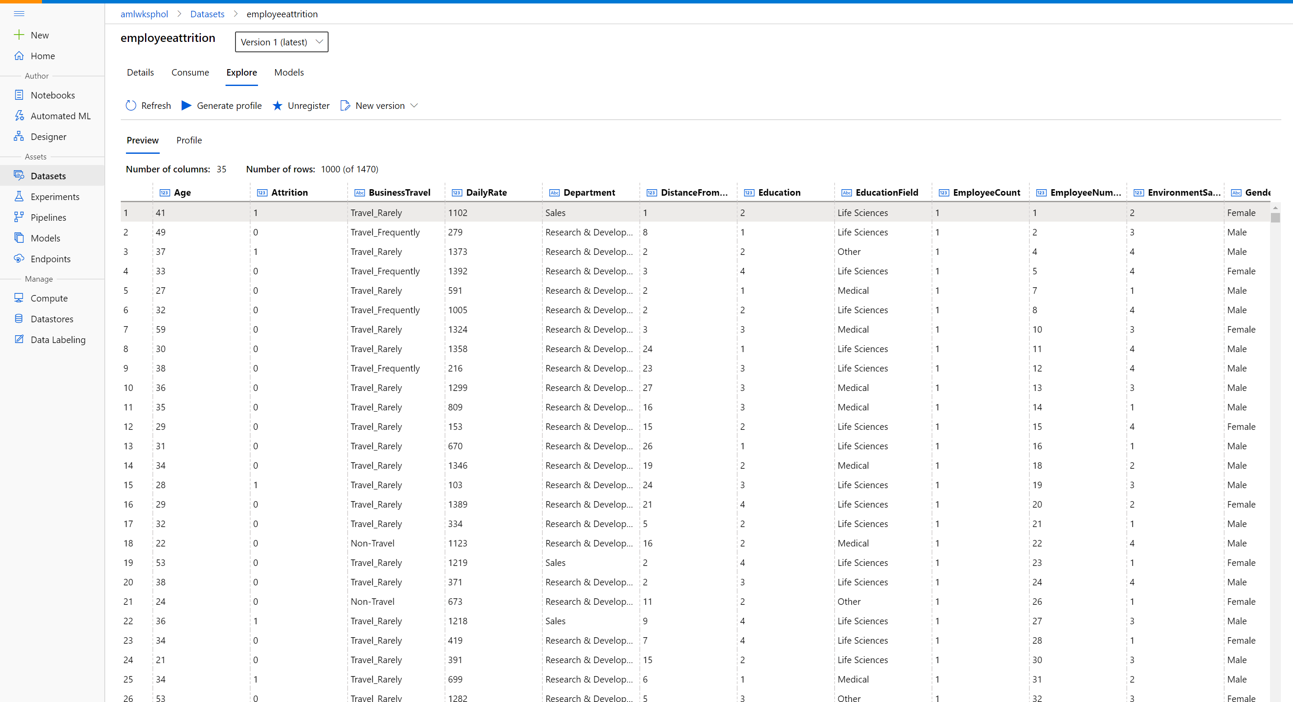

To view the profile of the dataset we generated in the previous step, click the Profile tab. If you want to

regenerate a profile (or you created the dataset without selecting the profile option), you can click Generate profile and select a cluster to generate profile information for the dataset.

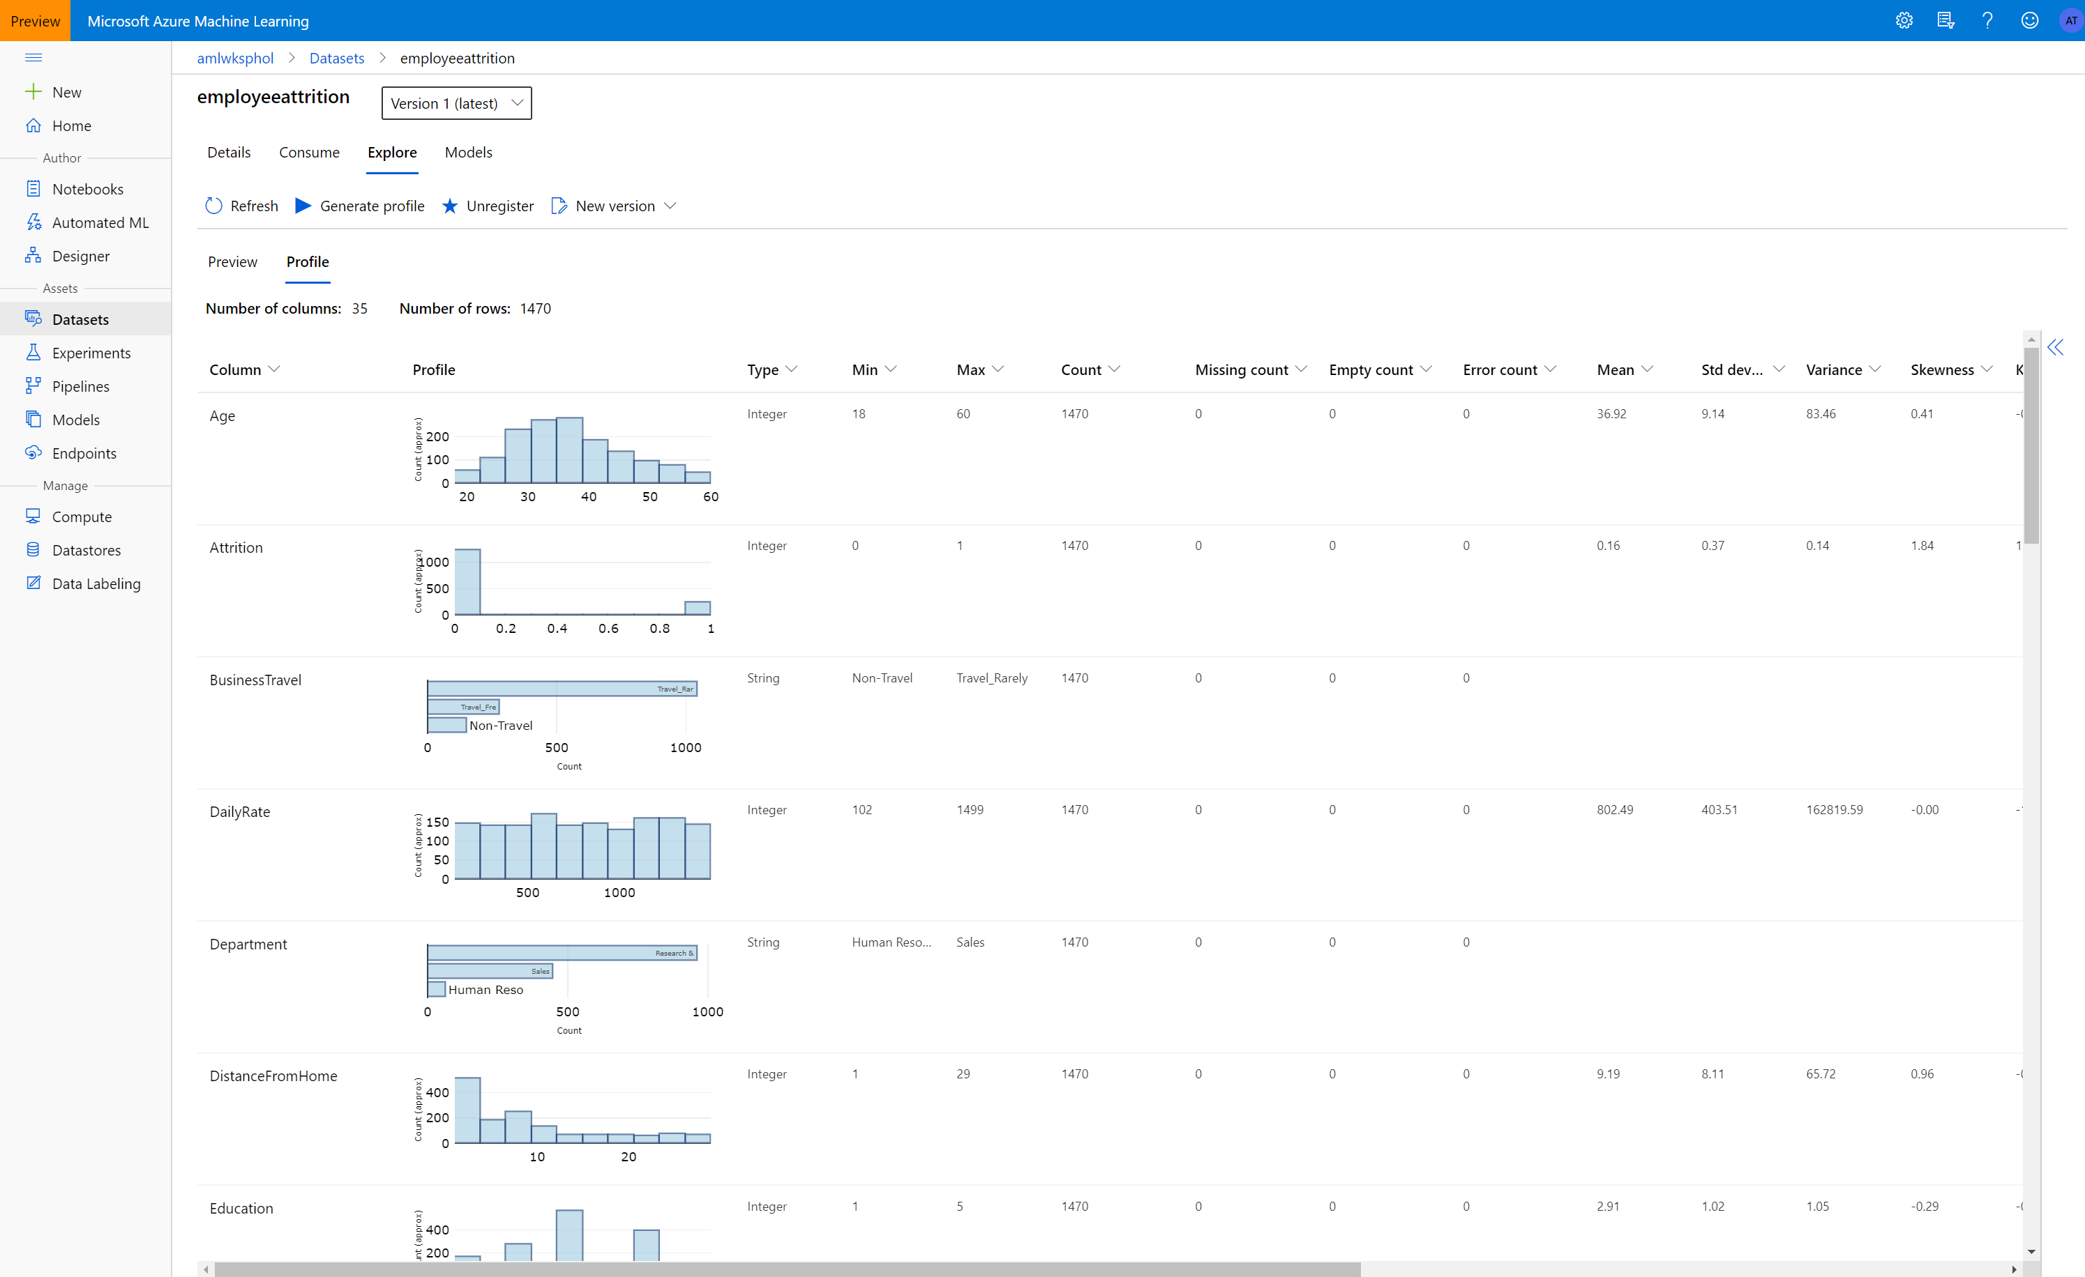

* In the Consume tab we can find a short code snippet for consuming the dataset from Notebooks.

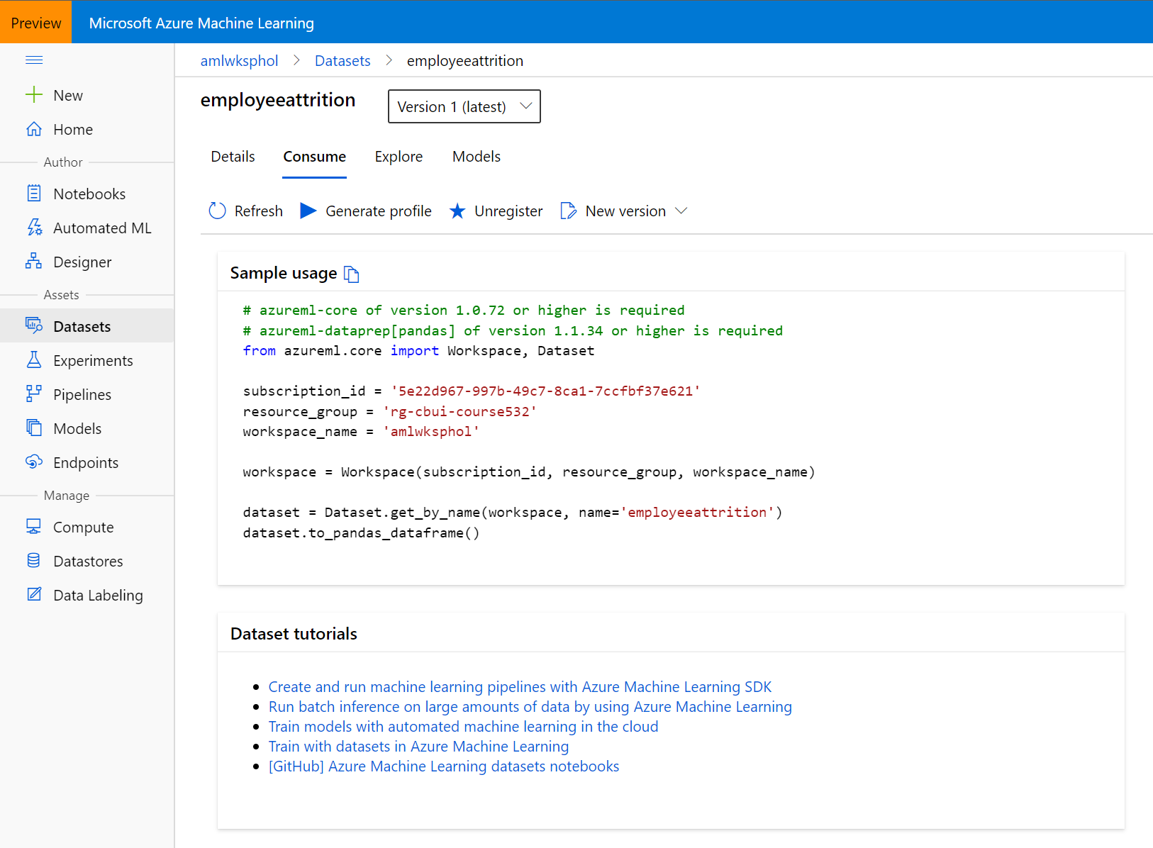

* For more information on datasets, see the [how-to for more information on creating and using Datasets](https://docs.microsoft.com/en-us/azure/machine-learning/service/how-to-create-register-datasets).

**2. Automated Machine Learning**

Automated machine learning (automated ML) builds high quality machine learning models for you by automating model and hyperparameter selection. Bring a labelled dataset that you want to build a model for, and automated ML will give you a high quality machine learning model that you can use for predictions.

If you are new to Data Science, automated ML will help you get jumpstarted by simplifying machine learning model building. It abstracts you from needing to perform model selection, hyperparameter selection and in one step creates a high-quality trained model for you to use.

If you are an experienced data scientist, automated ML will help increase your productivity by intelligently performing the model and hyperparameter selection for your training and generates high quality models much quicker than manually specifying several combinations of the parameters and running training jobs. Automated ML provides visibility and access to all the training jobs and the performance characteristics of the models to help you further tune the pipeline if you desire.

Follow the instructions in the [documentation](https://docs.microsoft.com/en-us/azure/machine-learning/how-to-use-automated-ml-for-ml-models) for a full overview of the user interface.

* Navigate to the left pane of your workspace. Select Automated ML under the Author section.

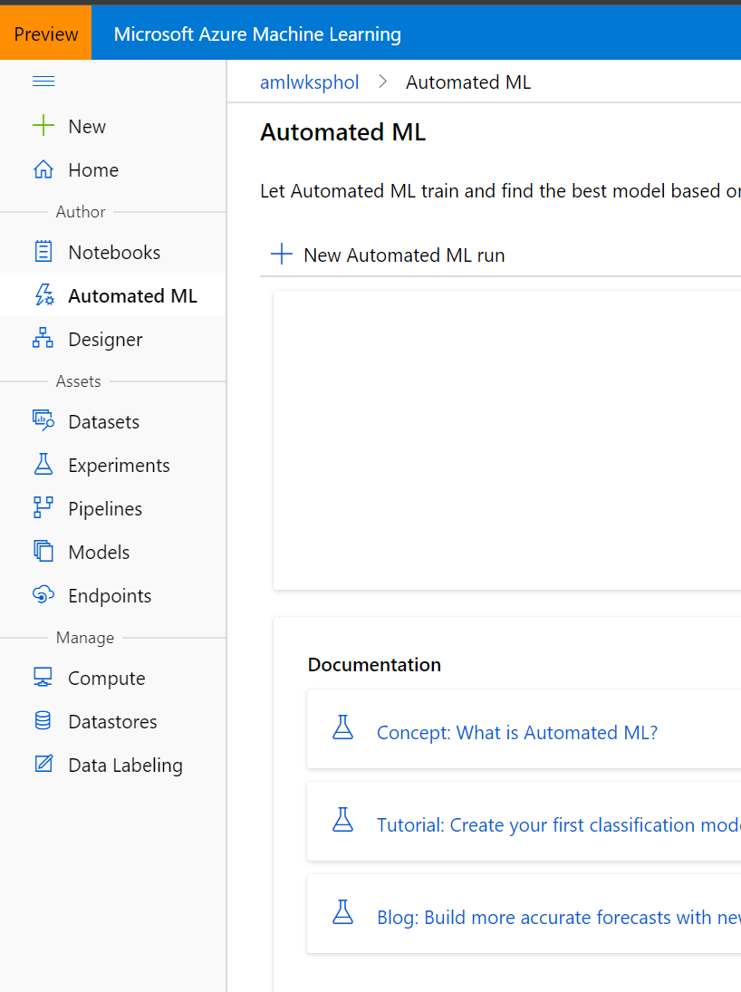

* Select New Automated ML run and select the employeeattrition dataset that you had created earlier.

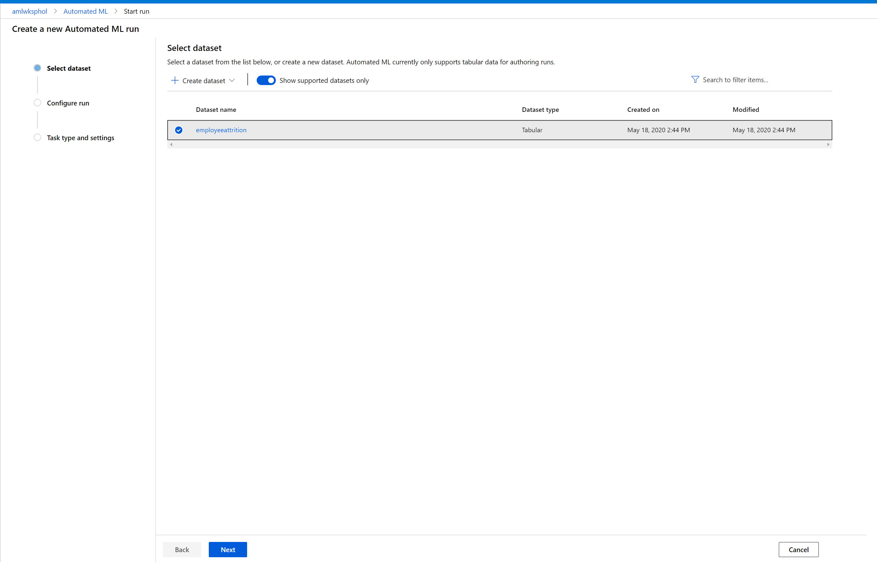

* Select Next
* Enter the Experiment name, select the target column Attrition (this is what we want to predict), and select the cluster cpucluster which you've created earlier.

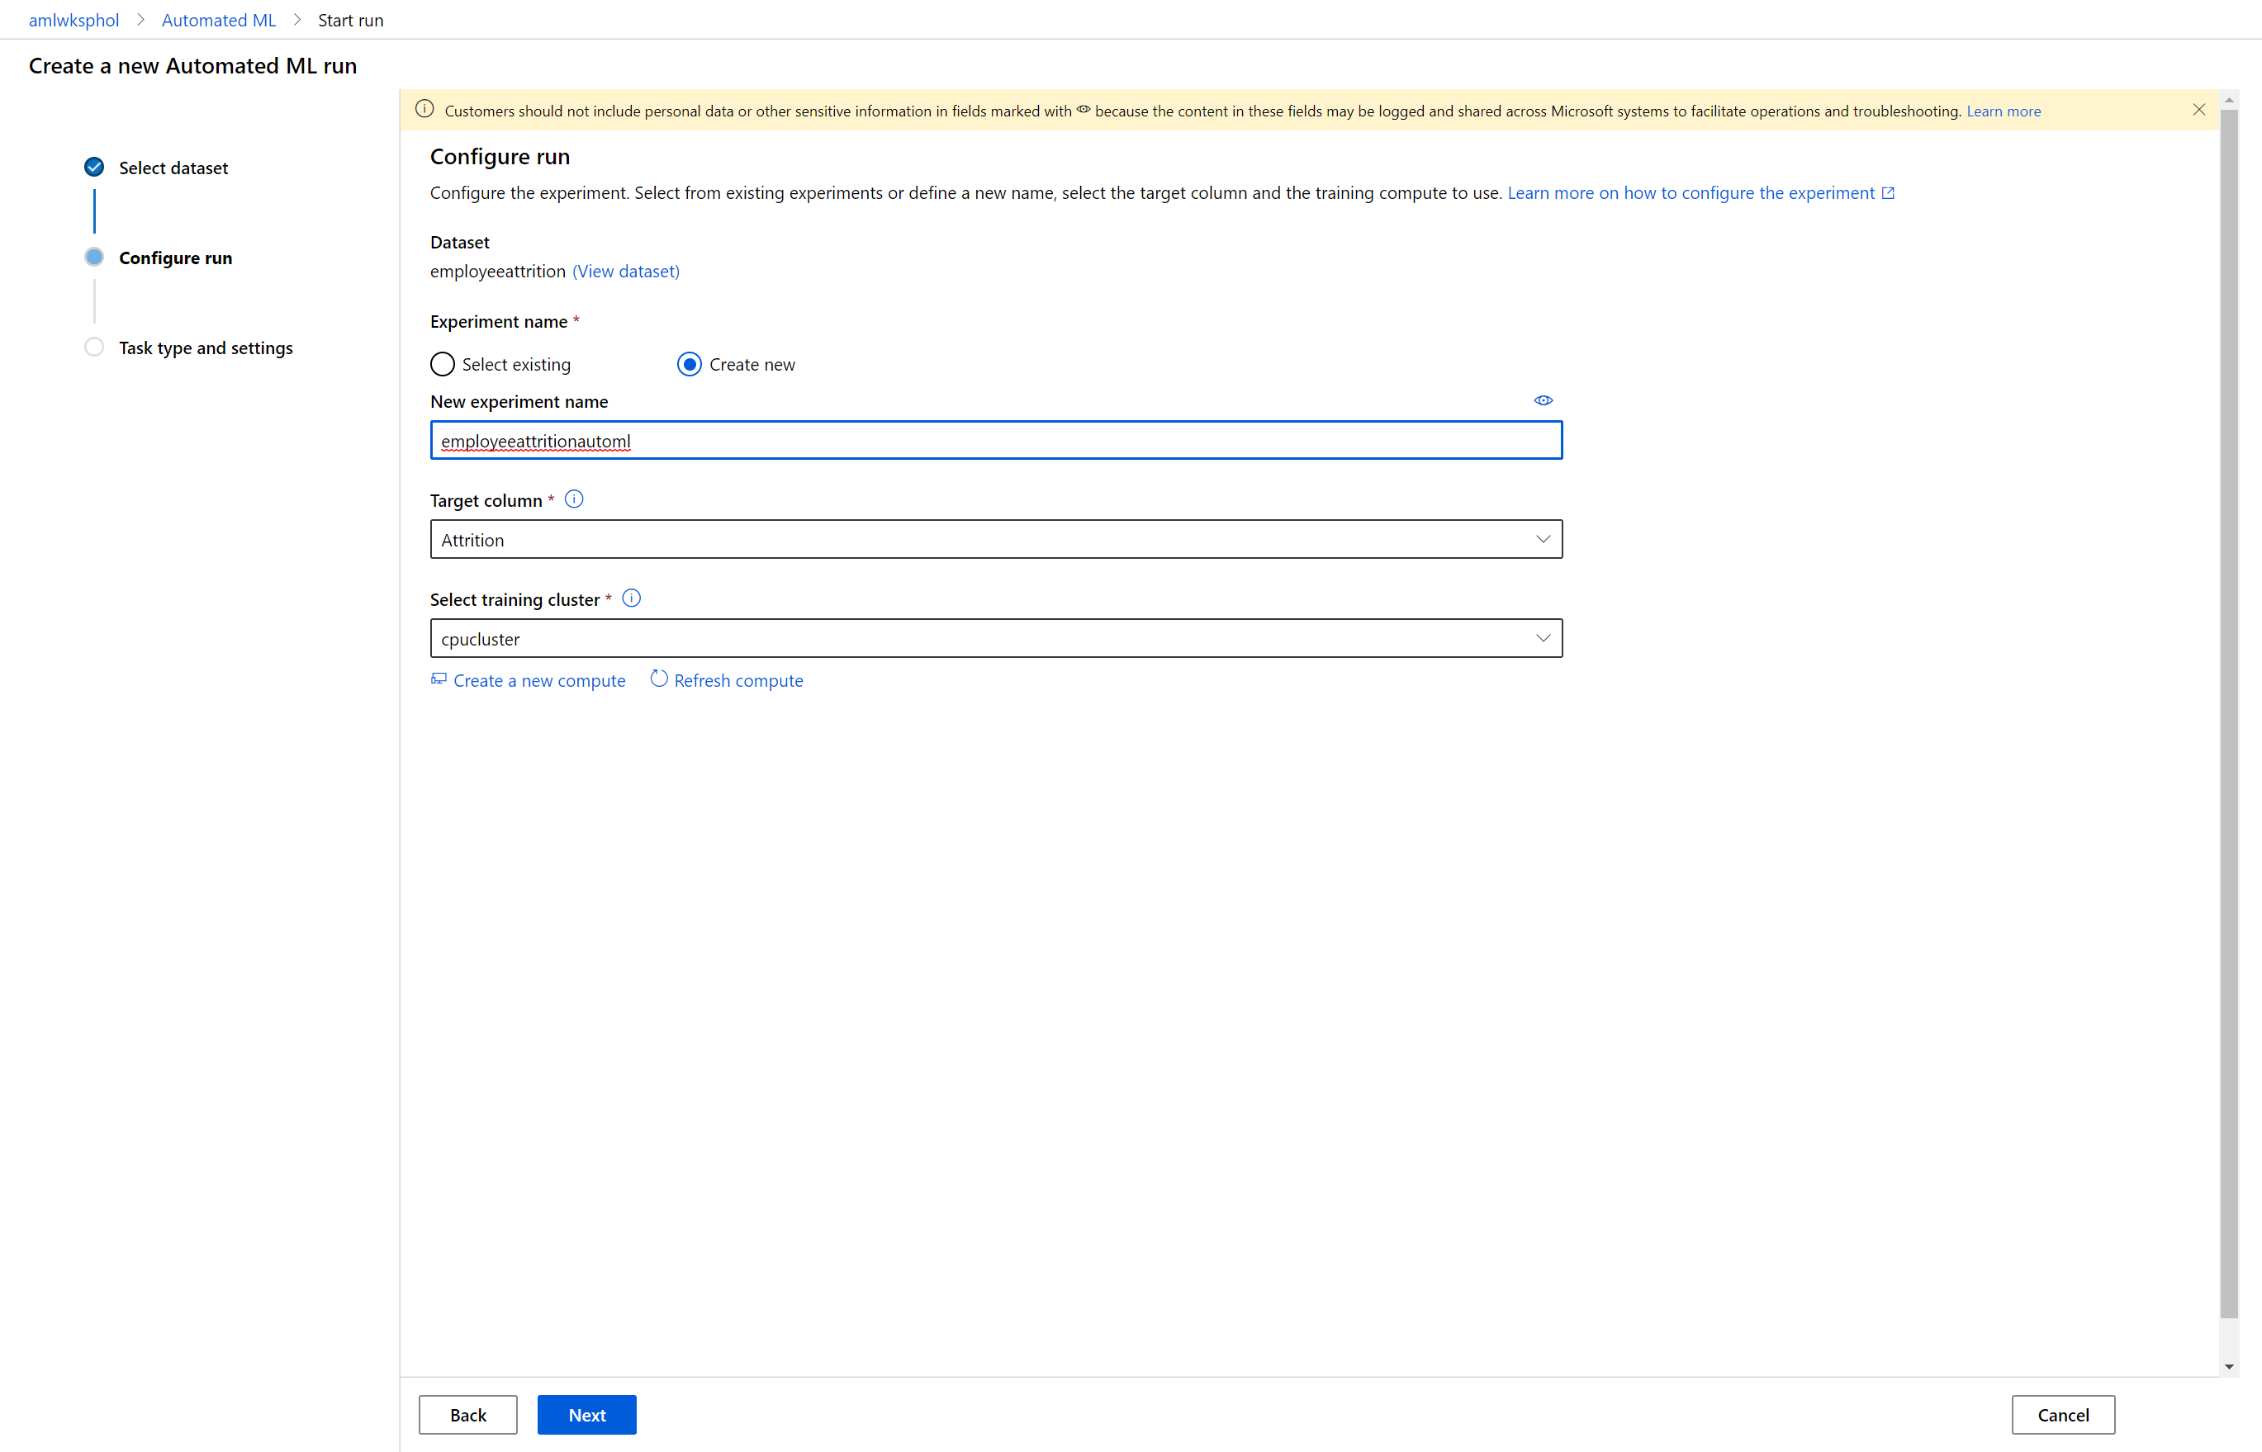

* Select Next
* Keep the task type as “classification”
* Select view additional configuration.

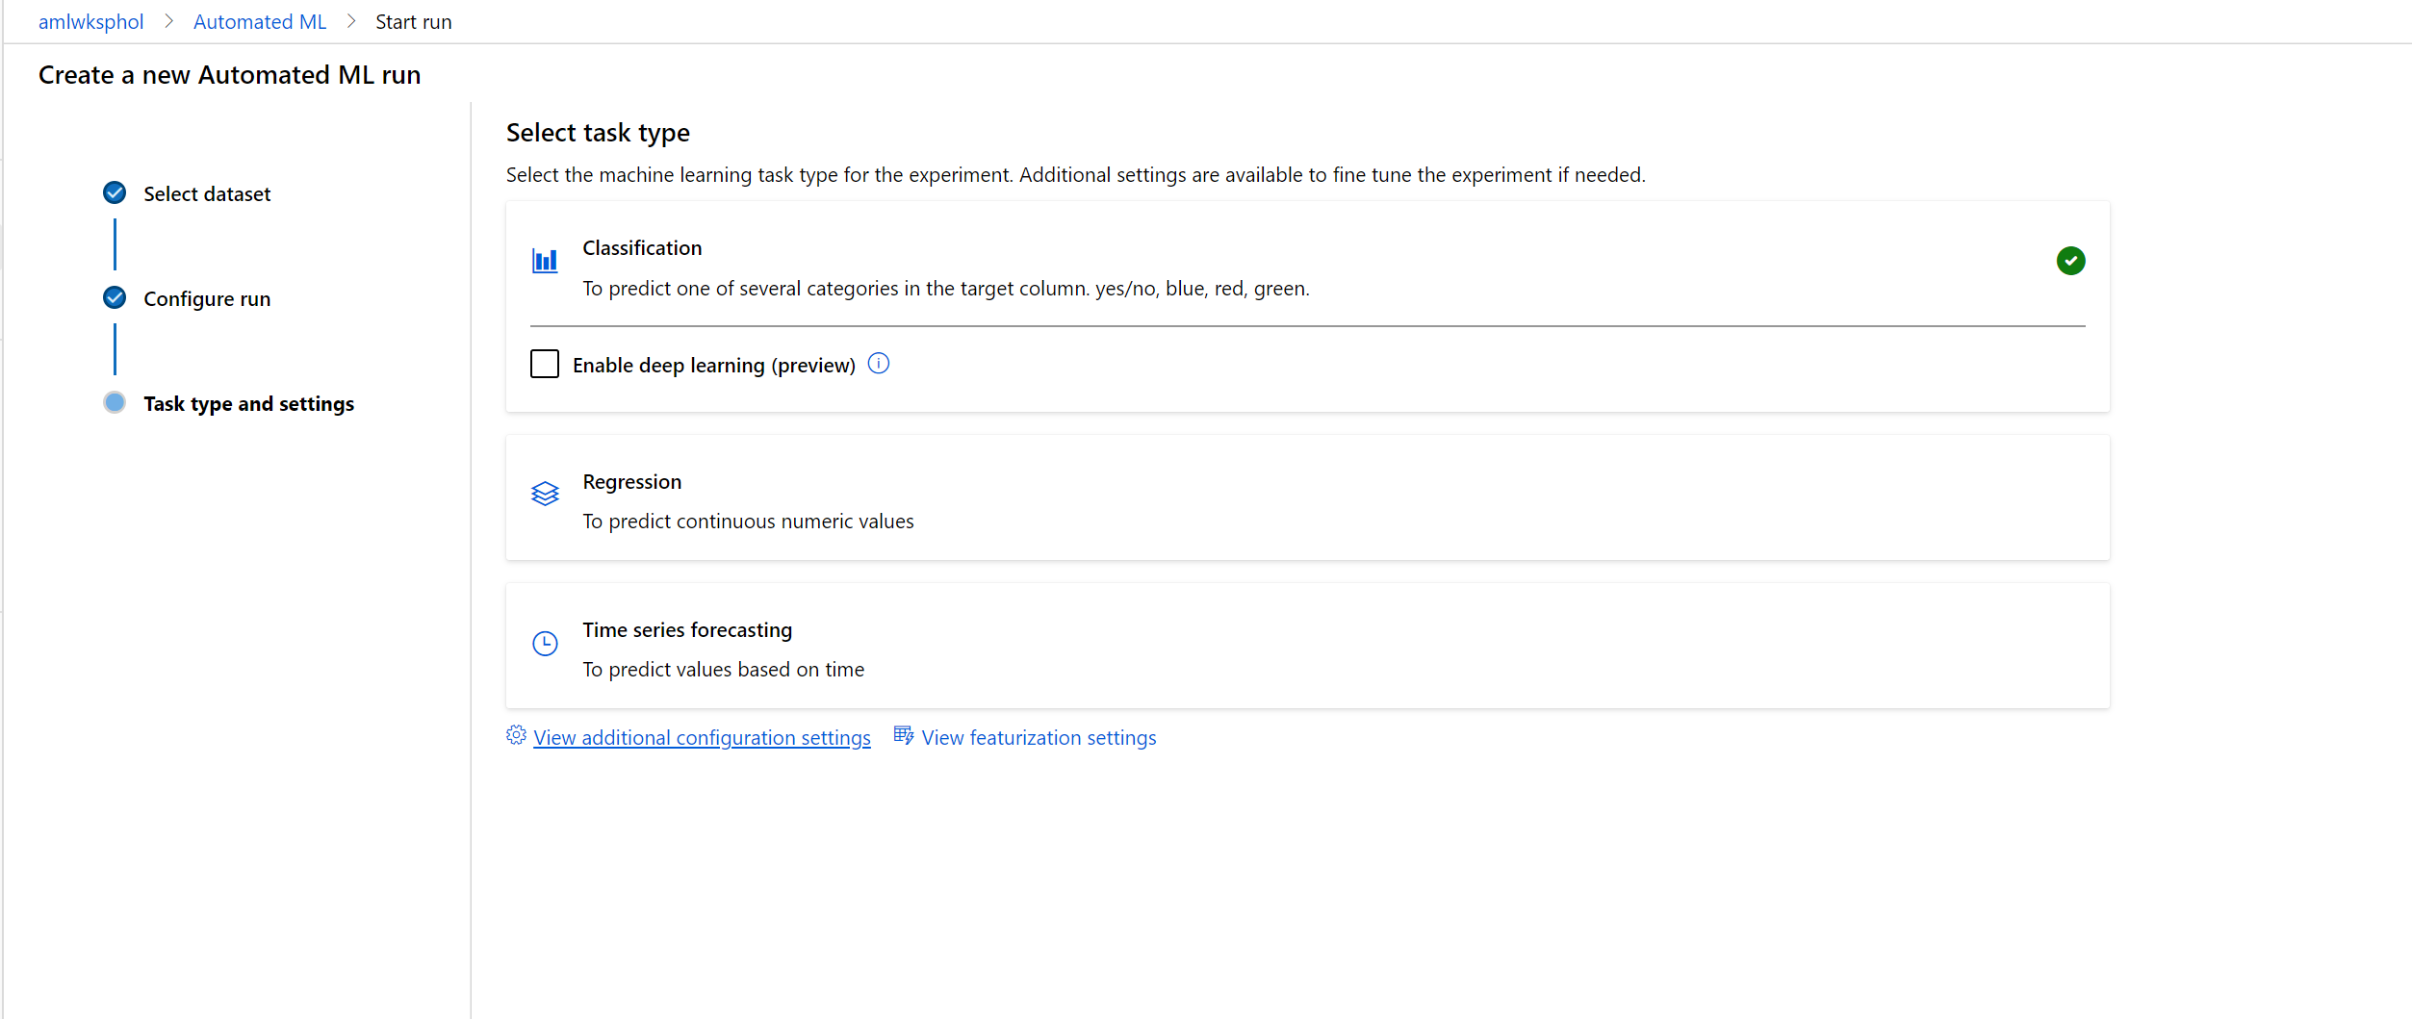

* Set the Primary [metric](https://docs.microsoft.com/en-us/azure/machine-learning/how-to-configure-auto-train#primary-metric)to AUC_weighted, the training job time to 0.25 and Max concurrent iterations to 4 (sufficient for the workshop). The concurrency parameter defines how many nodes of your cluster will be used for training.

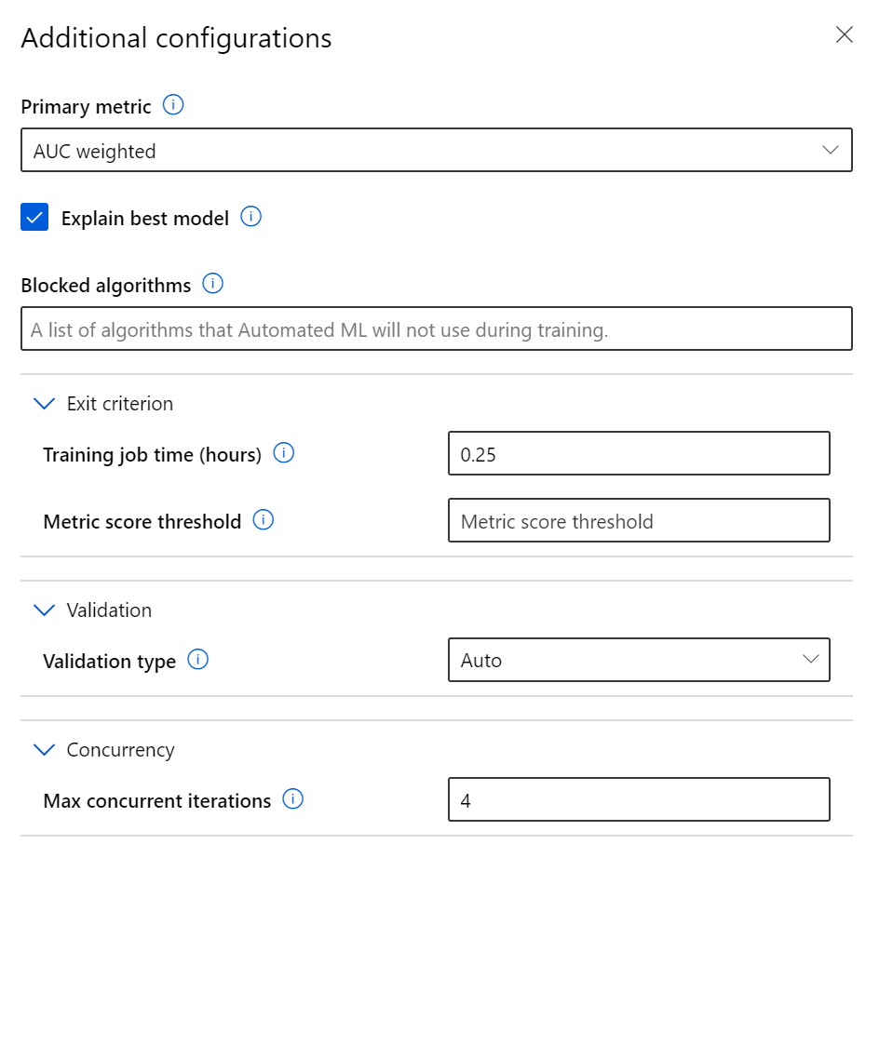

* Click Save
* Hit Finish and wait for the training job to start. You'll be able to see the models which are created during the run, click on any of the models to open the detailed view of that model, where you can analyze the [graphs and metrics](https://docs.microsoft.com/en-us/azure/machine-learning/service/how-to-understand-automated-ml).
* Once the run is completed( Should take about 17 minutes) , click Deploy best model to create a deployed endpoint from the model.
* 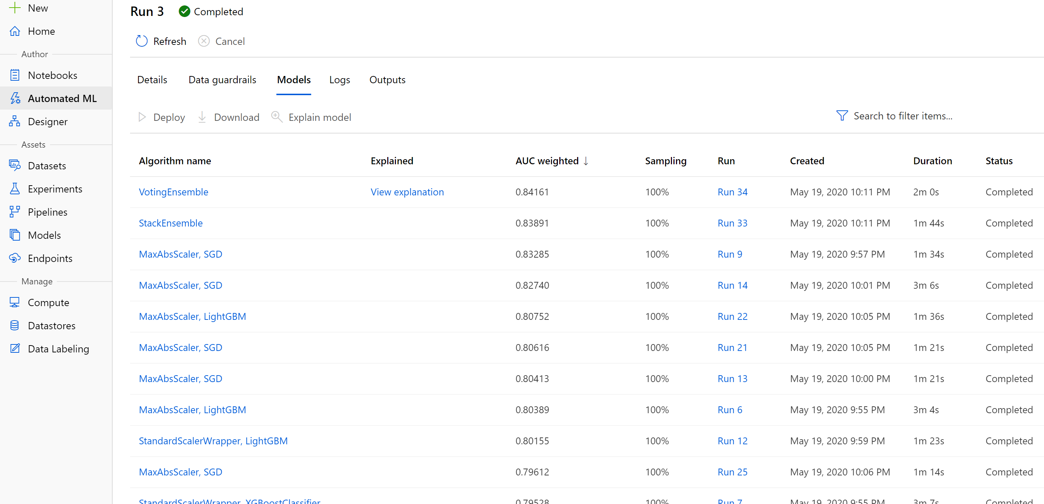
* Once the model is deployed, you can consume that API in any client. For instance, you can call the API from Postman. Go to EndPoints in AML assets
* 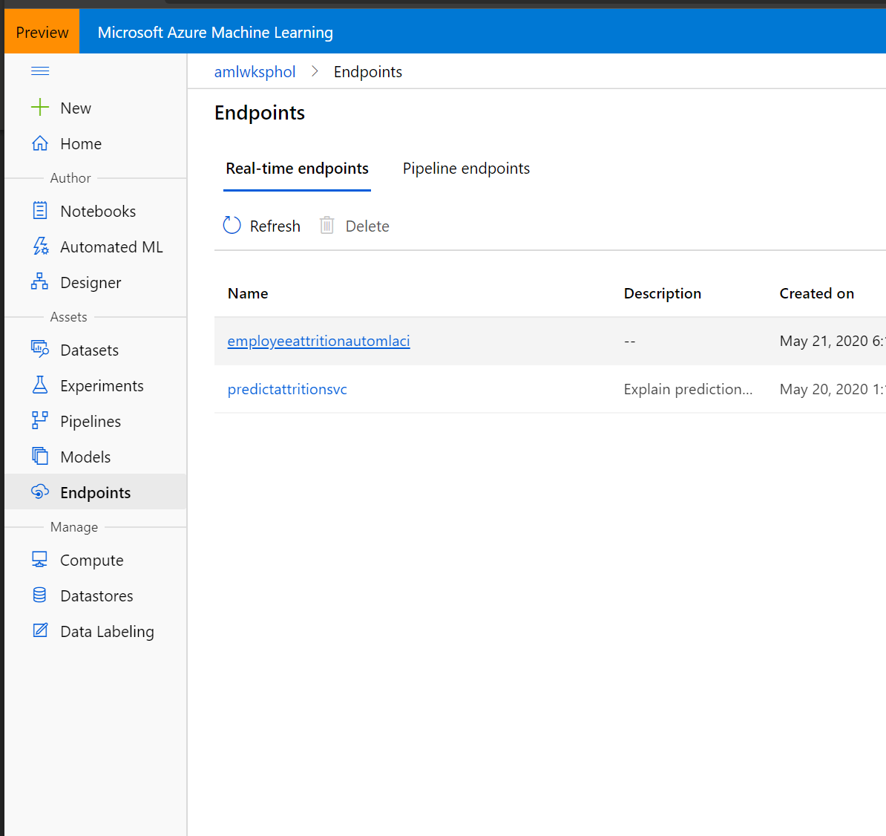
* Go to consume tab and find the URL Endpoint and key(if authentication was enabled)
* 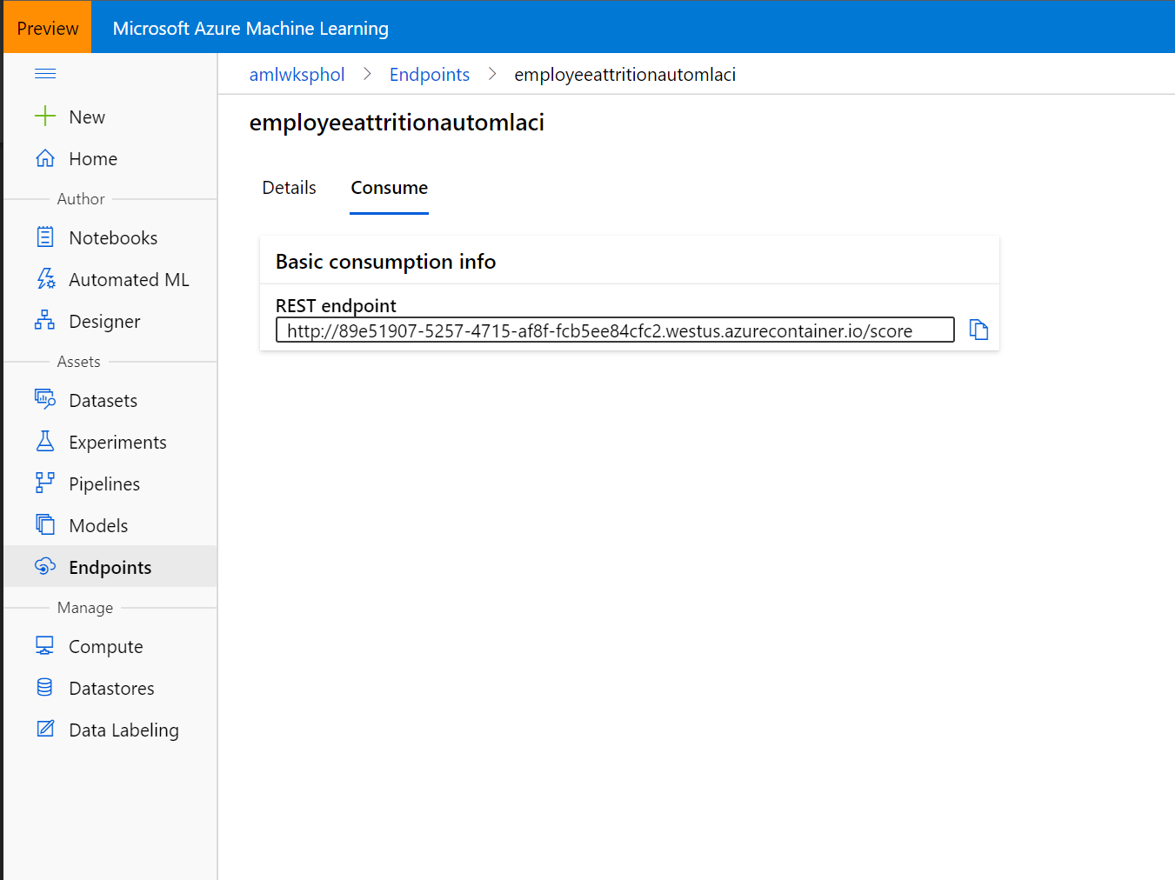
* Open Postman and create a new HTTP Post for that Rest Endpoint and send following HTTP Body

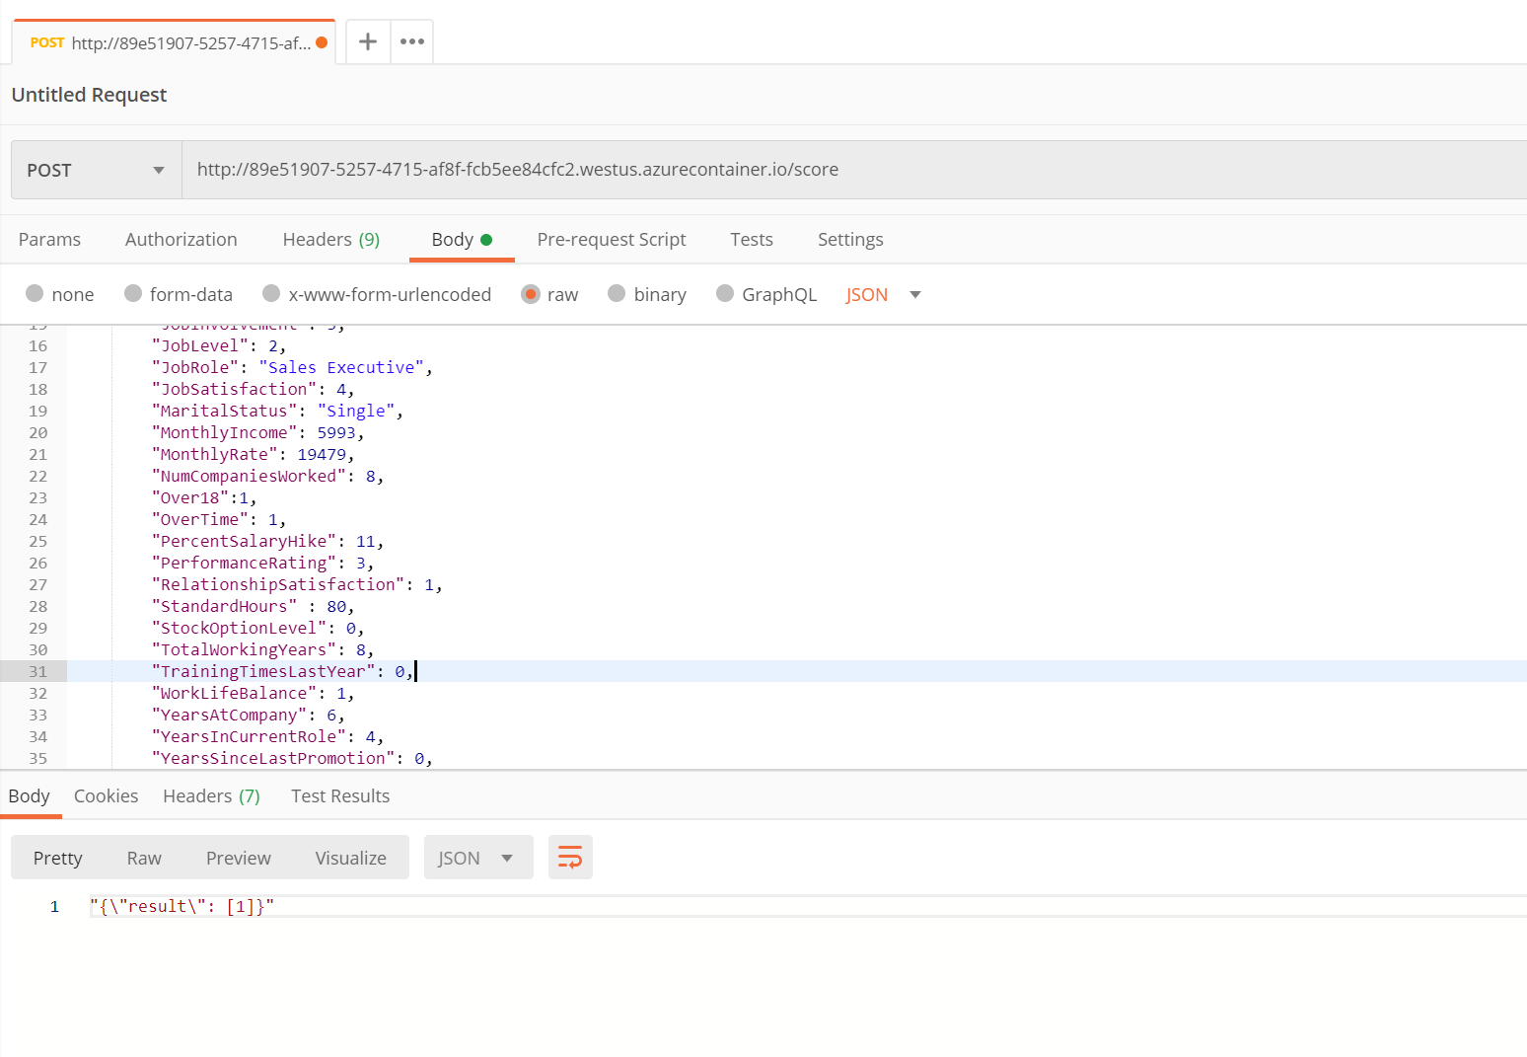

{

"data": [{

"Age": 41,

"BusinessTravel": "Travel_Rarely",

"DailyRate": 1102,

"Department": "Sales",

"DistanceFromHome": 1,

"Education": 2,

"EducationField": "Life Sciences",

"EmployeeCount" : 1,

"EmployeeNumber" : 1,

"EnvironmentSatisfaction": 2,

"Gender": "Female",

"HourlyRate": 94,

"JobInvolvement": 3,

"JobLevel": 2,

"JobRole": "Sales Executive",

"JobSatisfaction": 4,

"MaritalStatus": "Single",

"MonthlyIncome": 5993,

"MonthlyRate": 19479,

"NumCompaniesWorked": 8,

"Over18":1,

"OverTime": 1,

"PercentSalaryHike": 11,

"PerformanceRating": 3,

"RelationshipSatisfaction": 1,

"StandardHours" : 80,

"StockOptionLevel": 0,

"TotalWorkingYears": 8,

"TrainingTimesLastYear": 0,

"WorkLifeBalance": 1,

"YearsAtCompany": 6,

"YearsInCurrentRole": 4,

"YearsSinceLastPromotion": 0,

"YearsWithCurrManager": 5

}]

}

To learn more about automated ML, see documentation [here](https://docs.microsoft.com/en-us/azure/machine-learning/service/concept-automated-ml).

**Optional Tasks:**

* Once your model has been deployed, follow these [instructions](https://docs.microsoft.com/en-us/power-bi/service-machine-learning-integration) to consume the model from Power BI.
* Feature engineering: Auto ML also allows you to do feature engineering before starting the run. You can checkout this Featurization option on the start run page.

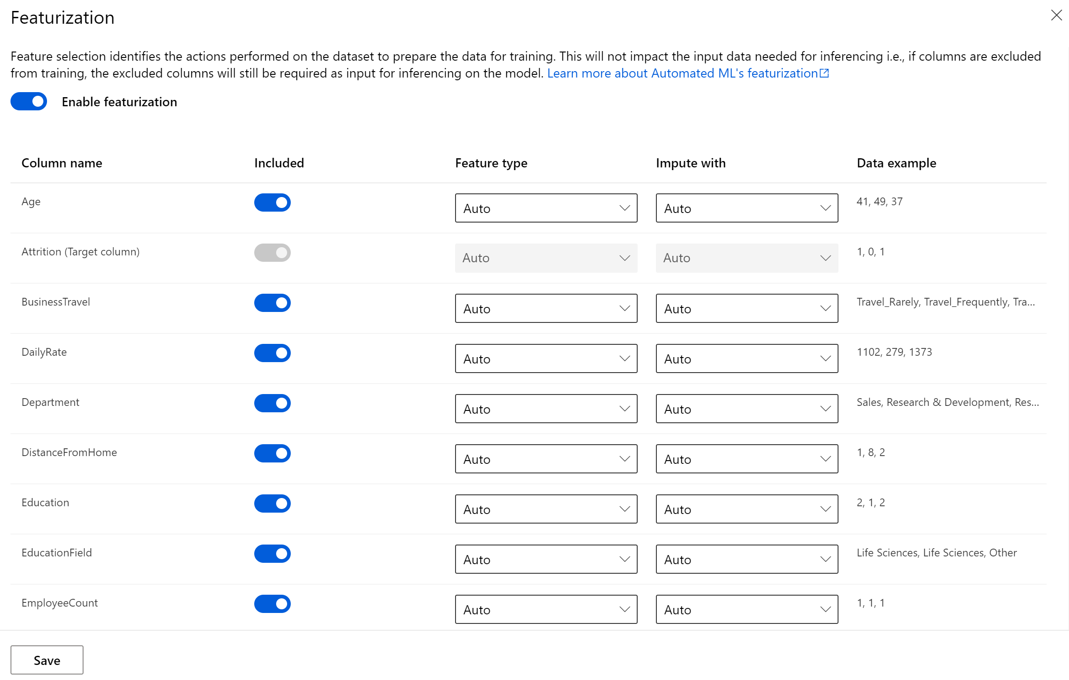

Try the [sample notebooks](https://github.com/Azure/MachineLearningNotebooks/tree/master/how-to-use-azureml/automated-machine-learning).

**3. Azure Machine Learning Designer**

Azure Machine Learning designer lets you visually connect [datasets](https://docs.microsoft.com/en-us/azure/machine-learning/concept-designer#datasets)and [modules](https://docs.microsoft.com/en-us/azure/machine-learning/concept-designer#module)on an interactive canvas to create machine learning models.

The designer uses your Azure Machine Learning [workspace](https://docs.microsoft.com/en-us/azure/machine-learning/concept-workspace) to organize shared resources such as:

* [Pipelines](https://docs.microsoft.com/en-us/azure/machine-learning/concept-designer#pipeline)
* [Datasets](https://docs.microsoft.com/en-us/azure/machine-learning/concept-designer#datasets)
* [Compute resources](https://docs.microsoft.com/en-us/azure/machine-learning/concept-designer#compute)
* [Registered models](https://docs.microsoft.com/en-us/azure/machine-learning/concept-azure-machine-learning-architecture#models)
* [Published pipelines](https://docs.microsoft.com/en-us/azure/machine-learning/concept-designer#publish)
* [Real-time endpoints](https://docs.microsoft.com/en-us/azure/machine-learning/concept-designer#deploy)

The designer gives you a visual canvas to build, test, and deploy machine learning models. With the designer you can:

Drag-and-drop [datasets](https://docs.microsoft.com/en-us/azure/machine-learning/concept-designer#datasets) and [modules](https://docs.microsoft.com/en-us/azure/machine-learning/concept-designer#module) onto the canvas.

* Connect the modules together to create a [pipeline draft](https://docs.microsoft.com/en-us/azure/machine-learning/concept-designer#pipeline-draft).
* Submit a [pipeline run](https://docs.microsoft.com/en-us/azure/machine-learning/concept-designer#pipeline-run) using the compute resources in your Azure Machine Learning workspace.
* Convert your training pipelines to inference pipelines.
* [Publish](https://docs.microsoft.com/en-us/azure/machine-learning/concept-designer#publish) your pipelines to a REST pipeline endpoint to submit new pipeline runs with different parameters and datasets.
* Publish a training pipeline to reuse a single pipeline to train multiple models while changing parameters and datasets.
* Publish a batch inference pipeline to make predictions on new data by using a previously trained model.
* [Deploy](https://docs.microsoft.com/en-us/azure/machine-learning/concept-designer#deploy) a real-time inference pipeline to a real-time endpoint to make predictions on new data in real time.

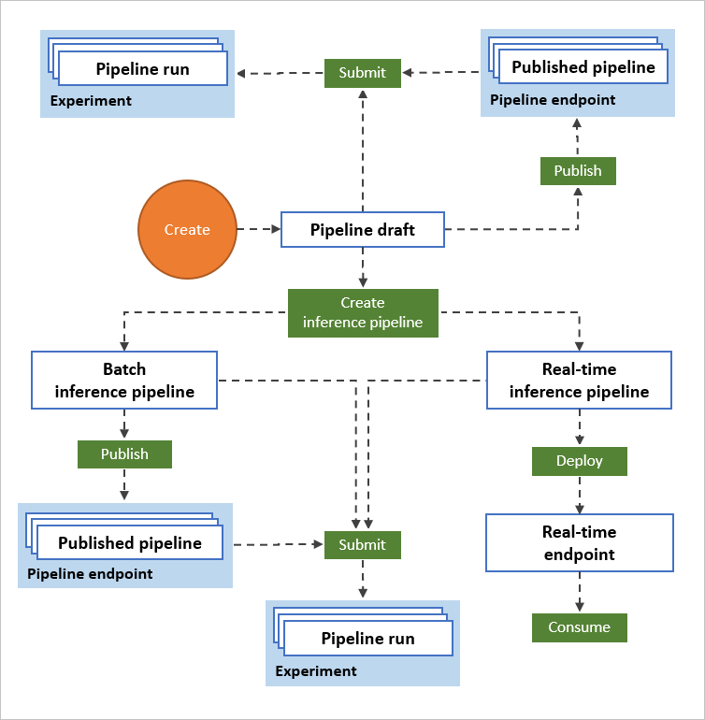

* In the AML, navigate to the Designer tab under the Author section and launch it.
* Create a new experiment by click +

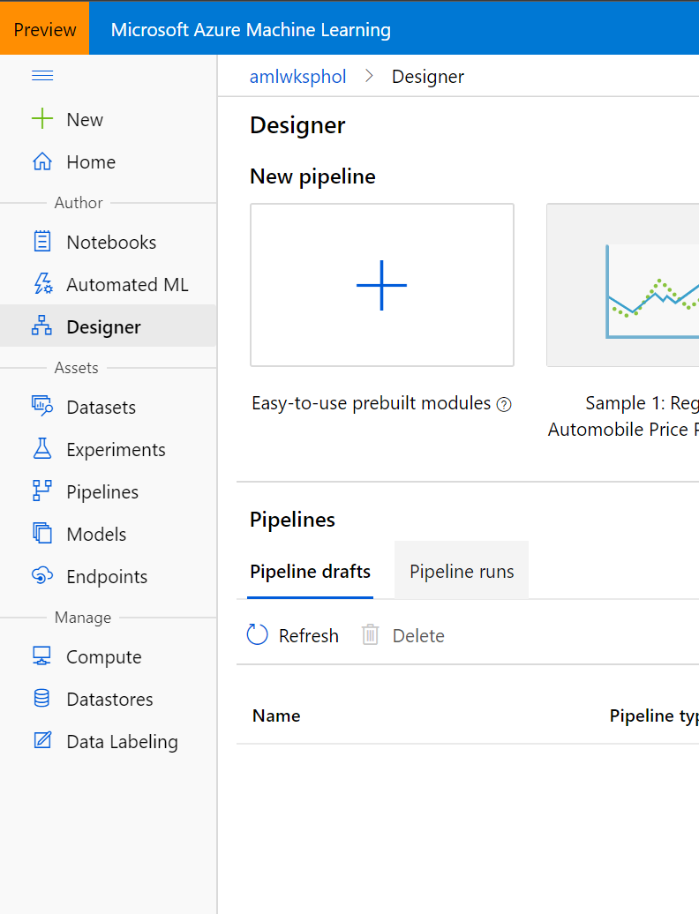

* Rename the pipeline to Employee Attrition

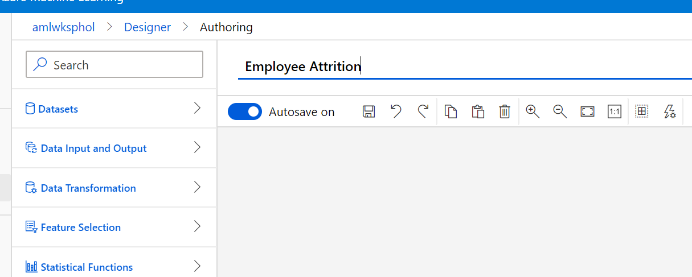

* Select the compute target to the one that you created earlier. Click Save.

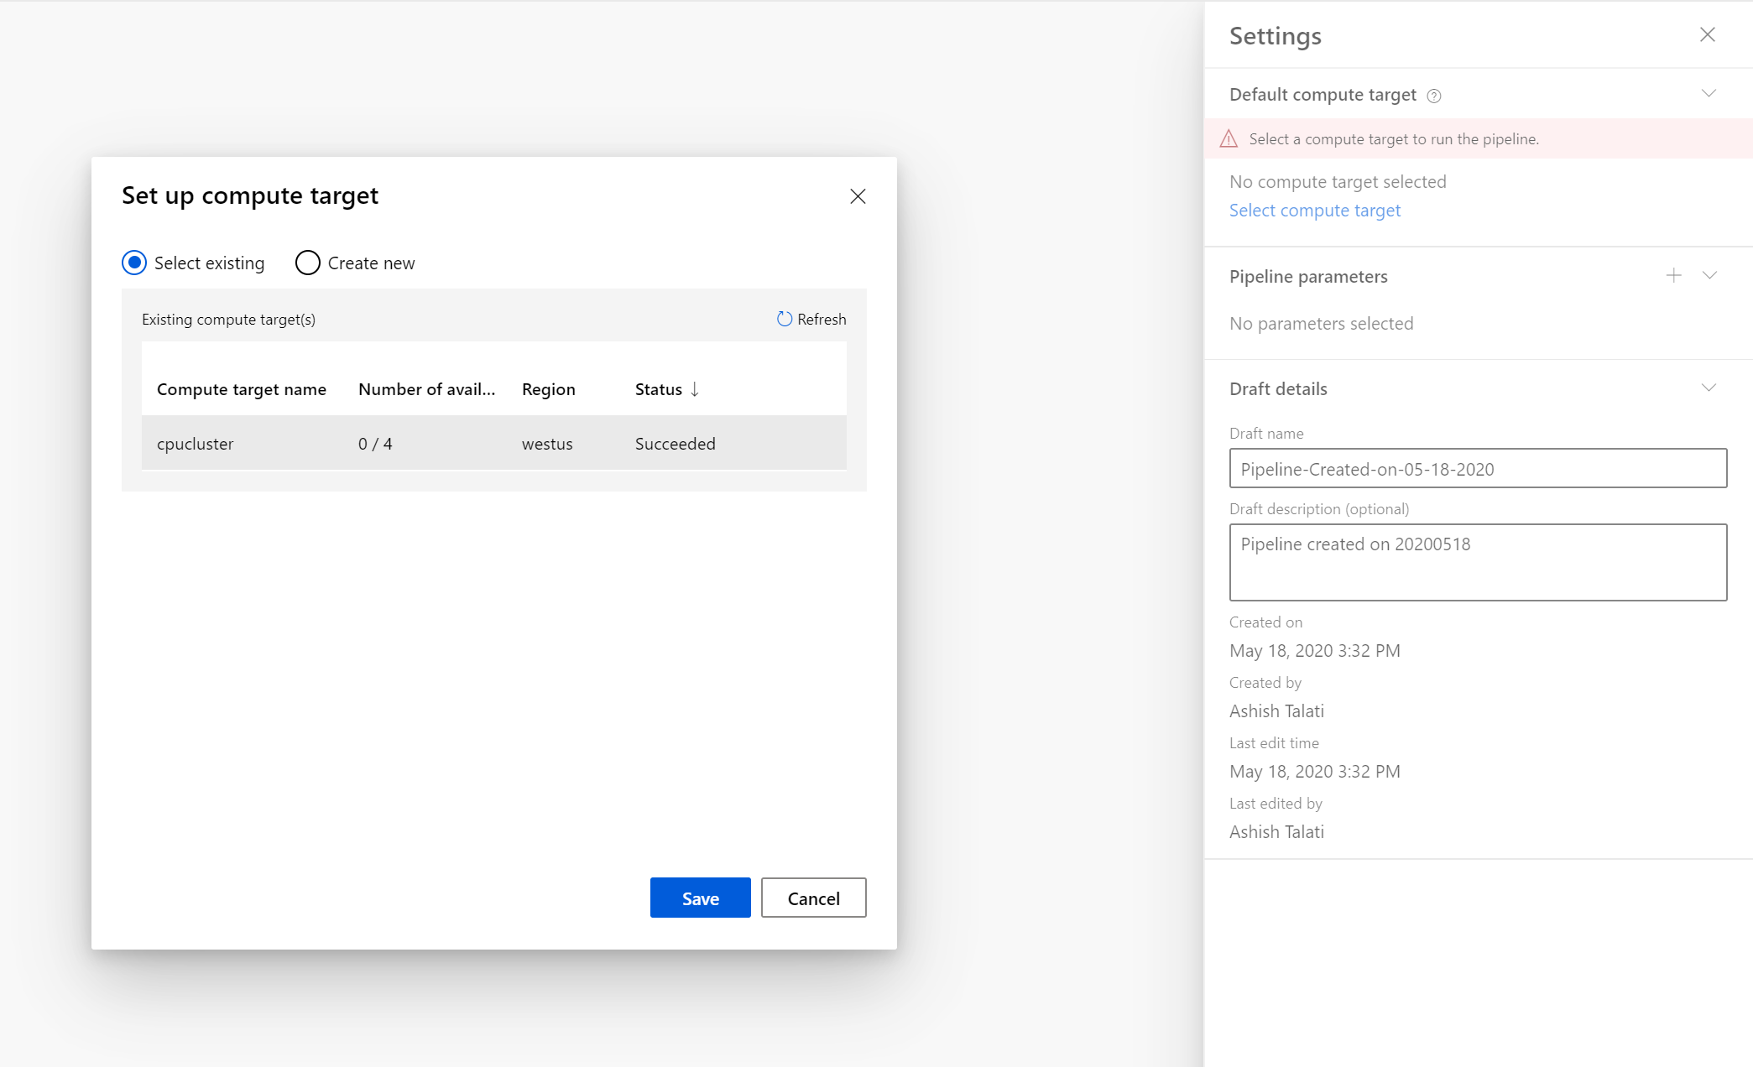

* Click “X” to close the property window
* Expand Datasets -> My DataSets and select employeeattrition dataset that was created earlier.
* Drag the employeeatrition dataset module into the pipeline canvas.

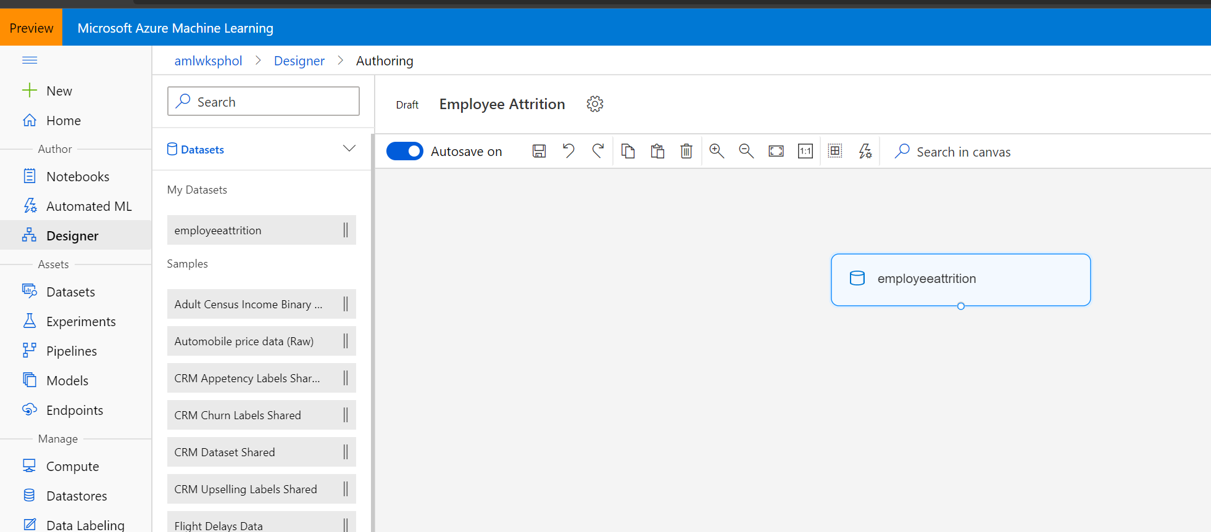

* Add “Select Columns in Dataset” module to remove “EmployeeCount, EmployeeNumber, Over18 and StandardHours” columns.
* 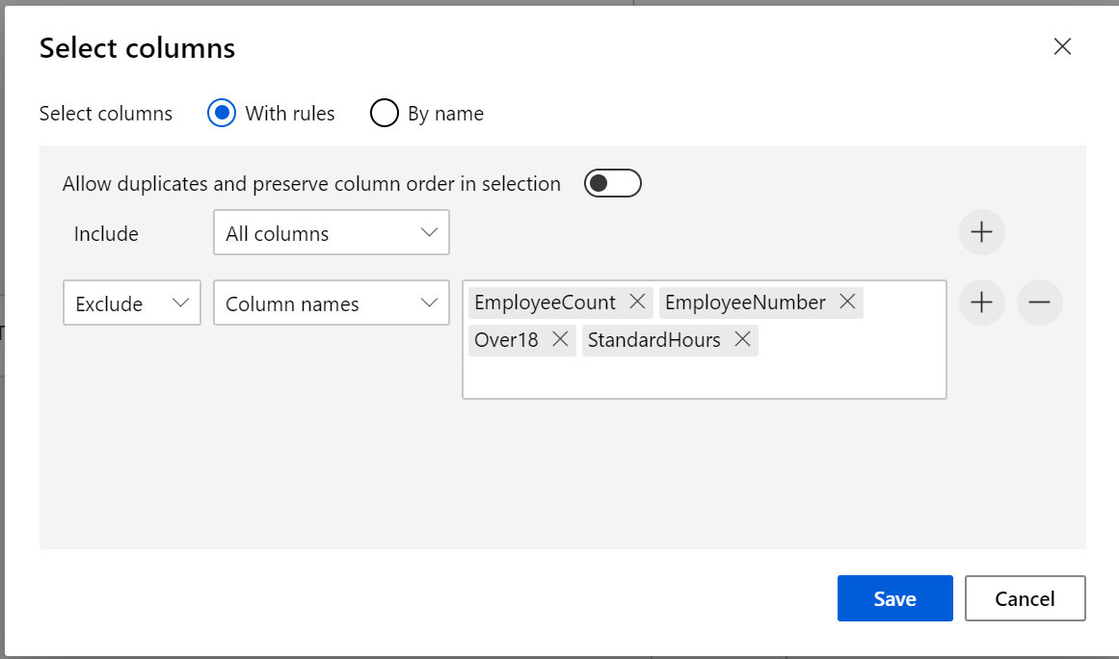
* Add a Split Data module to create the training and test sets. Set the fraction of rows in the first output dataset to 0.7. This setting specifies that 70% of the data will be output to the left port of the module and the rest to the right port. We use the left dataset for training and the right one for testing.

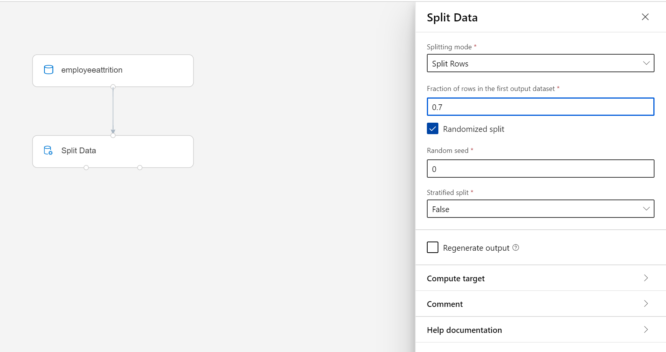

* Add a Two-Class Logistics Regression module to initialize a boosted decision tree classifier.
* Add a Train Model module. Connect the classifier from the previous step to the left input port of the Train Model. Connect the filtered dataset from Filter Based Feature Selection module as training dataset. Add the target column as Attrition in the label Column option. (**Column names: Attrition**) The Train Model will train the classifier.

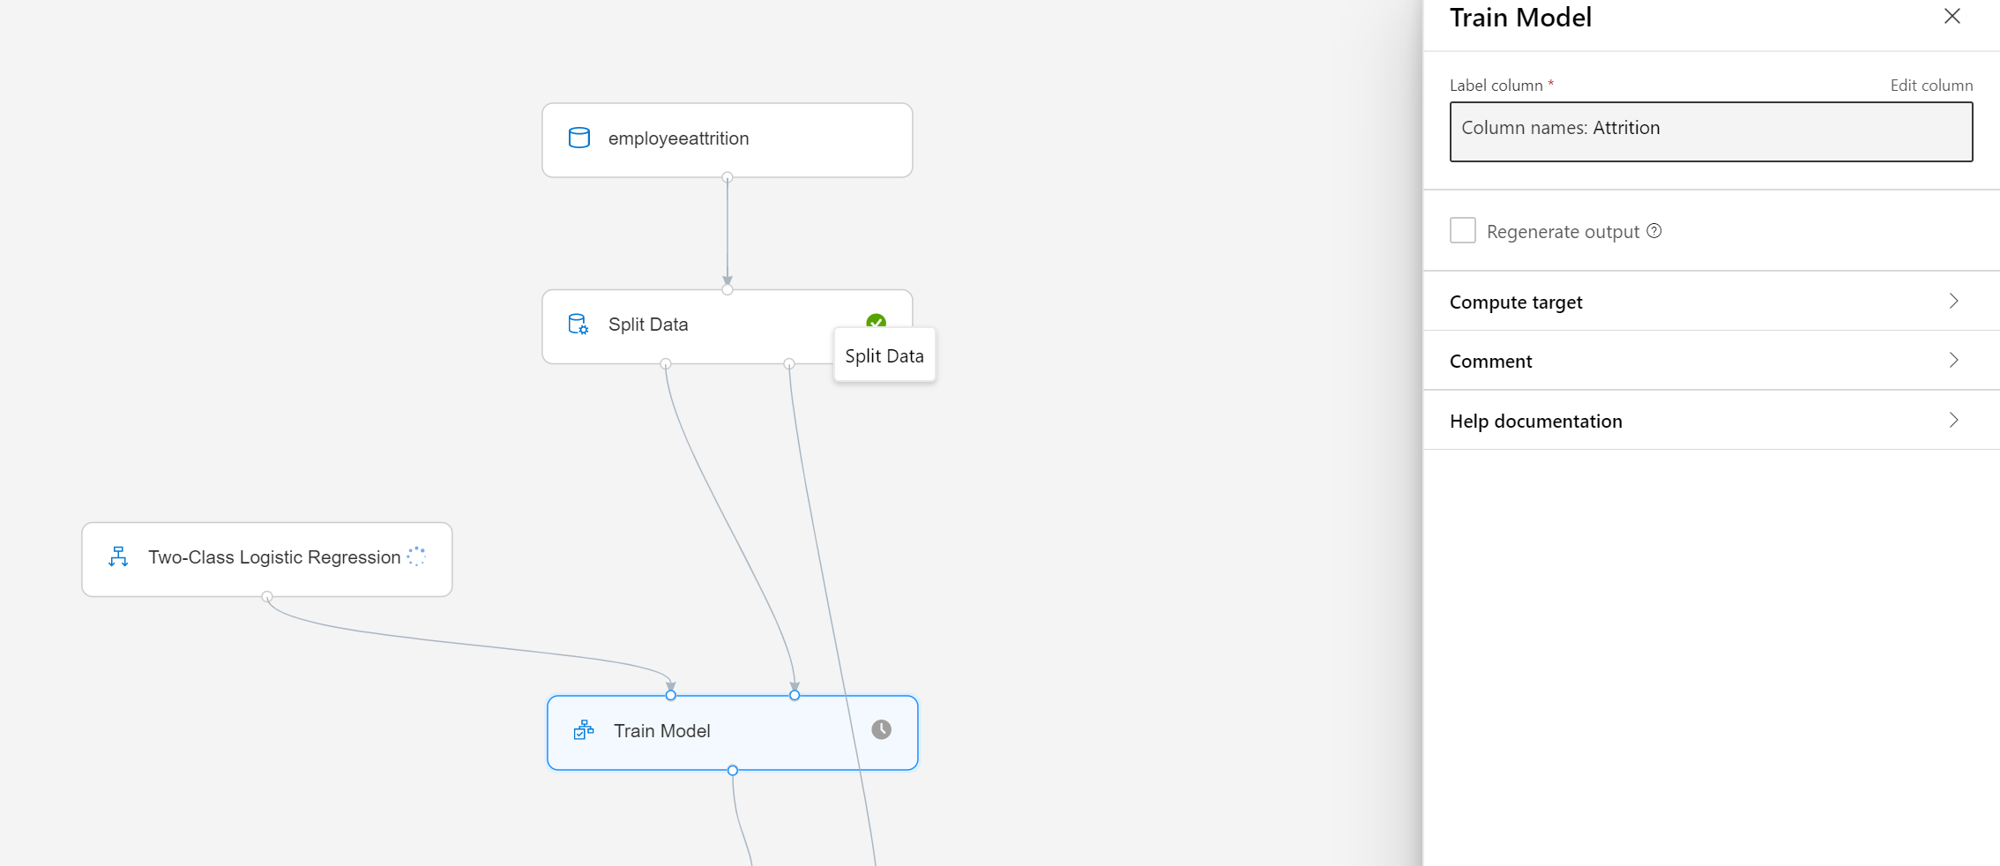

* Add **Score Model** module and connect the **Train Model** module to it. Then add the test set (the output of Filter Based Feature Selection module which apply feature selection to test set too) to the **Score Model**. The **Score Model** will make the predictions. You can select its output port to see the predictions and the positive class probabilities.
* Add an Evaluate Model module and connect the scored dataset to its left input port. To see the evaluation results, select the output port of the Evaluate Model module and select Visualize.

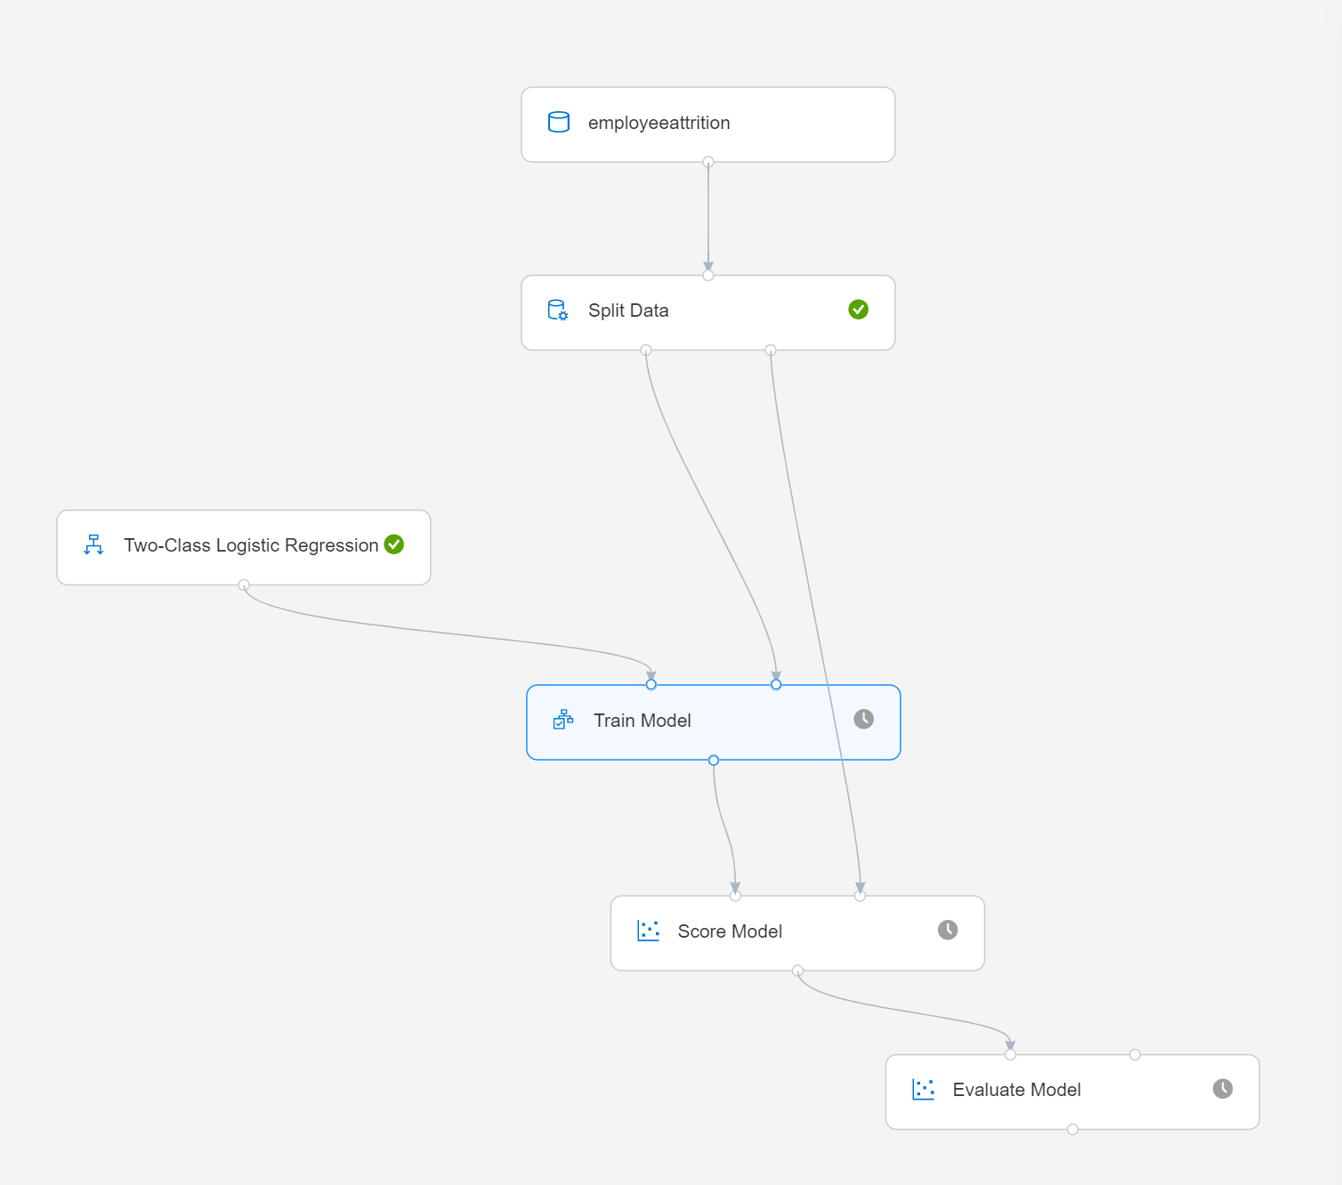

* Click Submit at the top and give your experiment a name.

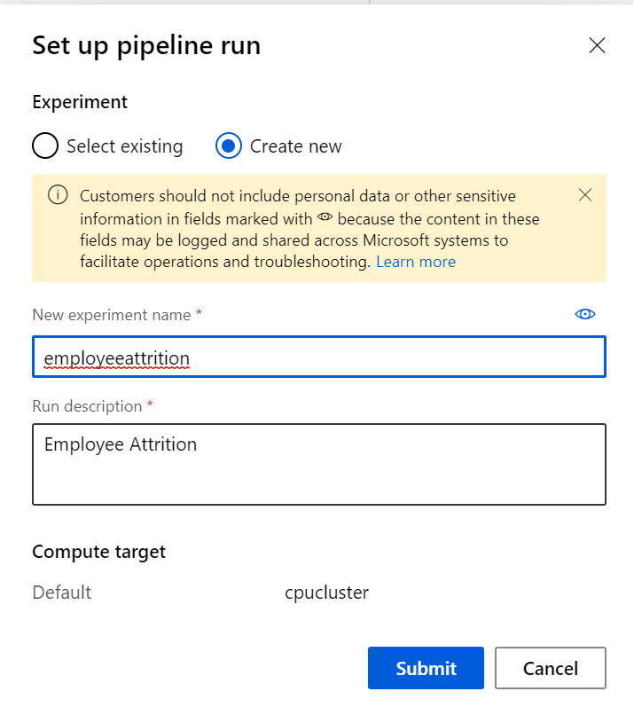

* Once you ran the experiment, you can inspect the outputs of the individual steps - check out the output of the different steps, the last one by right-clicking it and selecting Visualize Scored dataset.

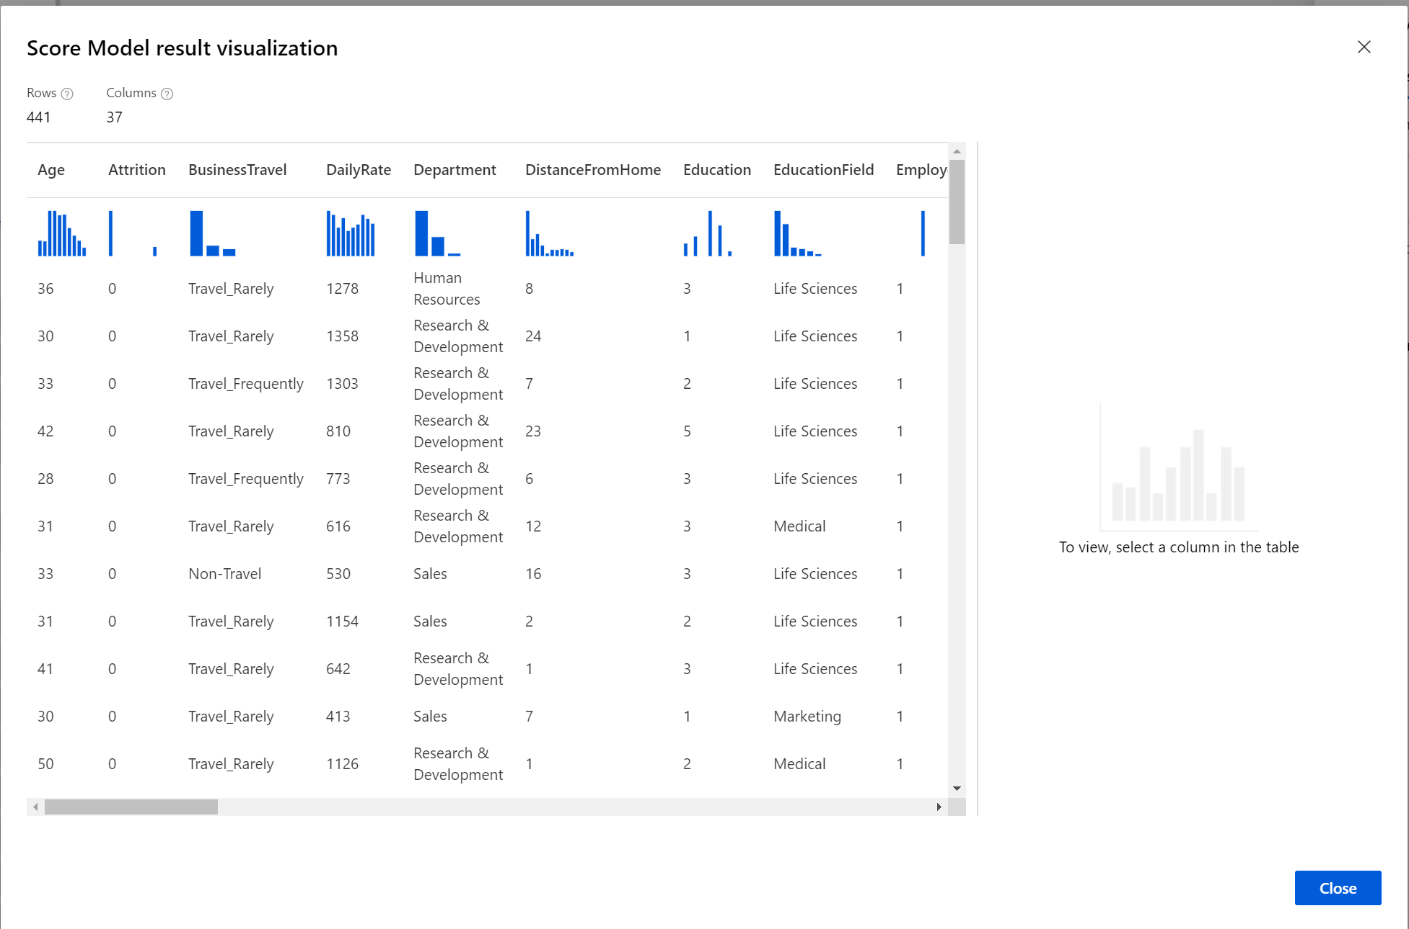

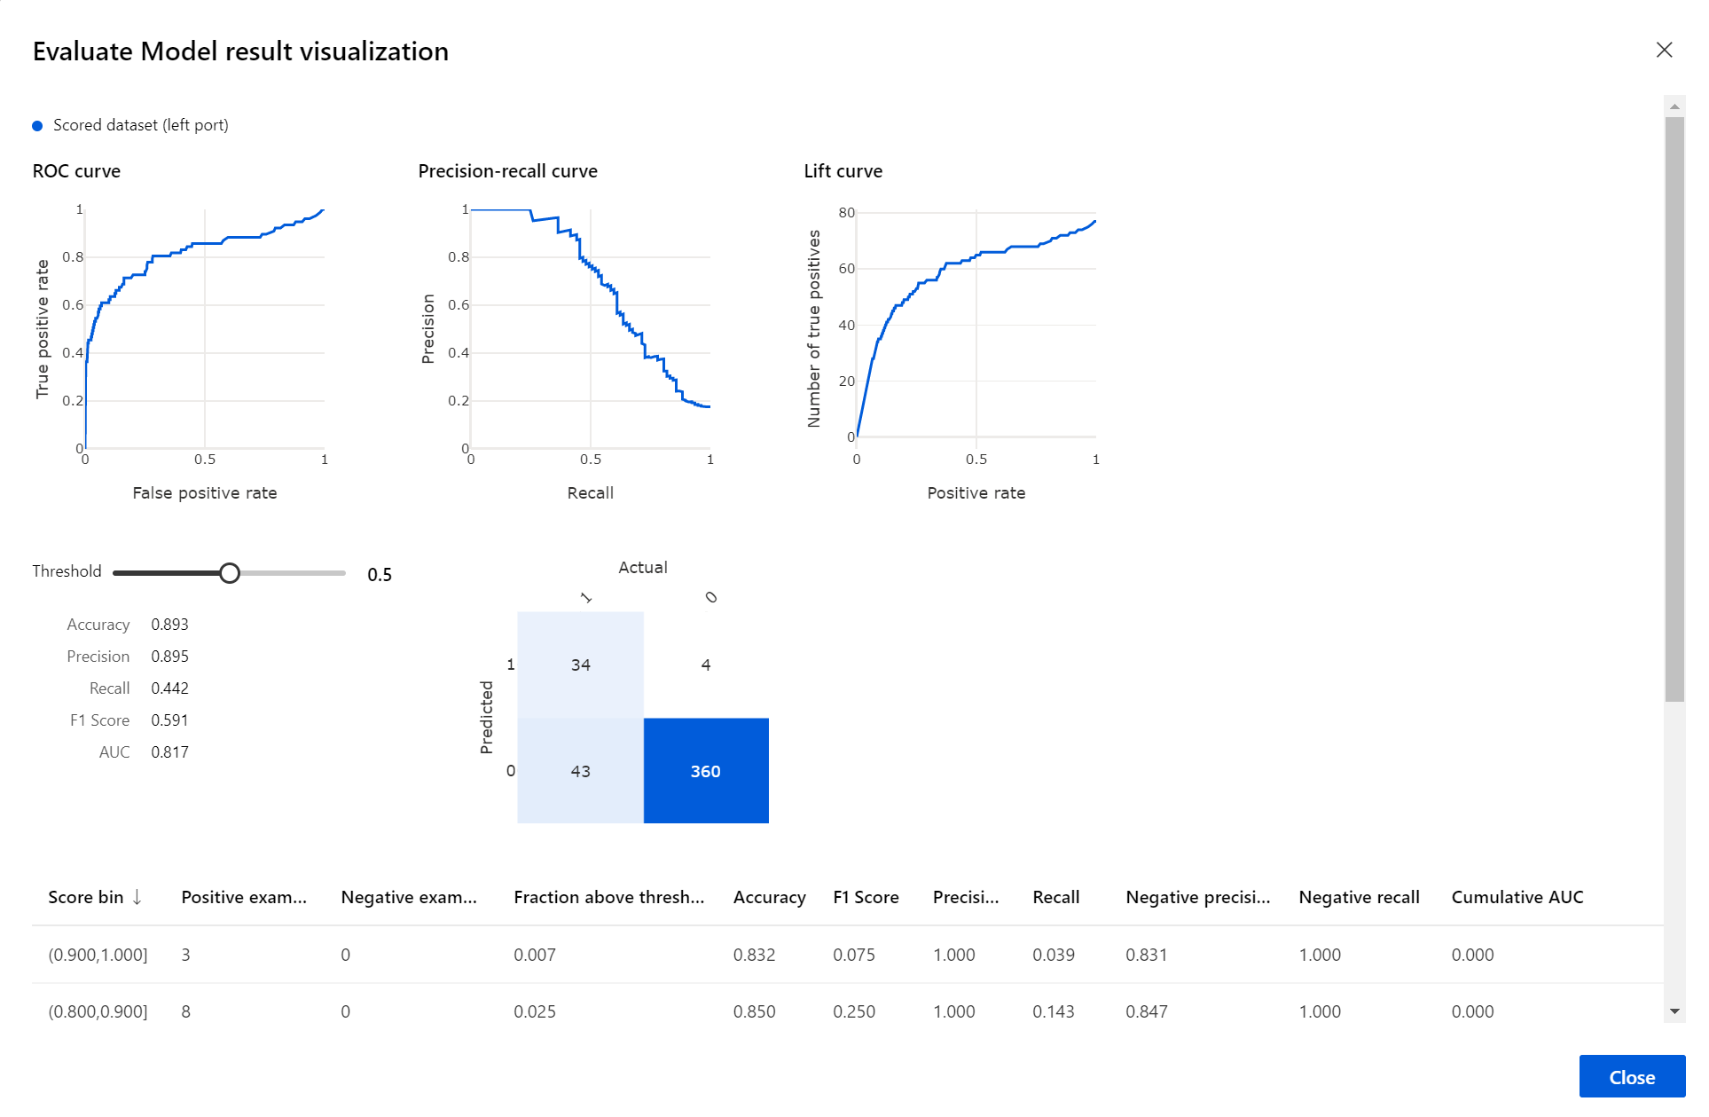

**6. Notebook VM & Python SDK**

The Azure ML Notebook VM is a cloud-based workstation created specifically for data scientists. Notebook VM based authoring is directly integrated into Azure Machine Learning service, providing a code-first experience for Python developers to conveniently build and deploy models in the workspace. Developers and data scientists can perform every operation supported by the [Azure Machine Learning Python SDK](https://docs.microsoft.com/python/api/overview/azure/ml/intro?view=azure-ml-py) using a familiar Jupyter notebook in a secure, enterprise-ready environment. Notebook VM is secure and easy-to-use, preconfigured for machine learning, and fully customizable.

Key features Azure Machine Learning service Notebook VMs are:

* **Secure** – provides AAD login integrated with the AML Workspace, provides access to files stored in the workspace, implicitly configured for the workspace.
* **Preconfigured** – with Jupyter, JupyterLab, up-to-date AML Python Environment, GPU drivers, Tensorflow, Pytorch, Scikit learn, etc. (uses DSVM under the hood)
* **Simple to set up** – created with a few clicks in the AML workspace portal, managed from within the AML workspace portal.
* **Customizable**– use CPU or GPU machine types, install your own tools (or drivers), ssh to the machine, changes persist across restarts.

The Notebook VM creation experience has been streamlined, as it takes just two parameters

– a VM name and a VM type.

Once the Notebook VM is created it provides access to Jupyter, JupyterLab and R Studio – popular notebook environments for data science.

The access to the notebooks is secured out-of-the-box with HTTPS and Azure Active Directory, which makes it possible for IT pros to enforce a single sign-on environment with strong security features like Multi-Factor Authentication, ensuring a secure environment in compliance with organizational policies.

Notebook VM has the most up-to-date, compatible packages preconfigured and ready to use. This way, data scientists can use any of the latest frameworks on Notebook VM without versioning issues and with access to all the latest functionality of Azure Machine Learning service. Inside of the VM, along with Jupyter and JupyterLab, data scientists will find a fully prepared environment for machine learning.

Notebook VM  comes equipped with preconfigured GPU drivers and a selection of ML and Deep Learning Frameworks. Notebook VM is also integrated with its parent, [Azure Machine Learning workspace](https://docs.microsoft.com/en-us/azure/machine-learning/studio/create-workspace). The notebooks that data scientists run on the VM have access to the data stores and compute resources of the workspace. The notebooks themselves are stored in a Blob Storage account of the workspace. This makes it easy to share notebooks between VMs, as well as keeps them safely preserved when the VM is deleted.

**Clone Git Repo**

For the following parts of the workshop, you are going to work on the Compute Instance you provisioned earlier. For that, you will need to clone this git repository onto the workspace.

* Click on Compute -> Compute instance
* To get started, first navigate to the JupyterLab instance running on the Notebook VM by clicking on the JupyterLab link shown below

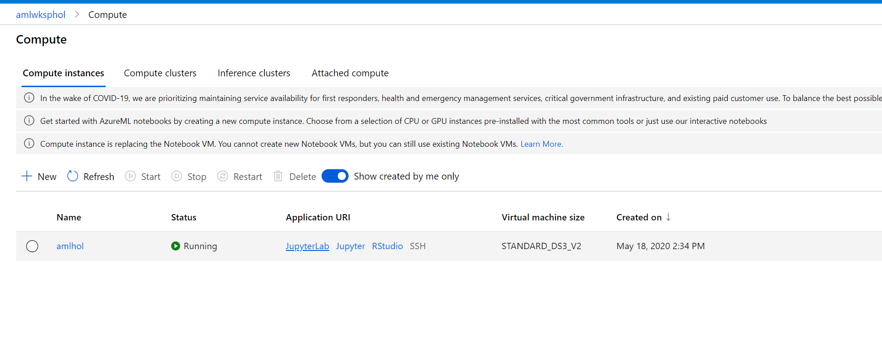

* After going through authentication, you will see the JupyterLab frontend. As you authenticate, make sure to use the same user to log in as was used to create the Compute Instance, or else your access will be denied. Next open an Terminal (either by File -> New -> Terminal, or by just clicking on Terminal in the Launcher Window).

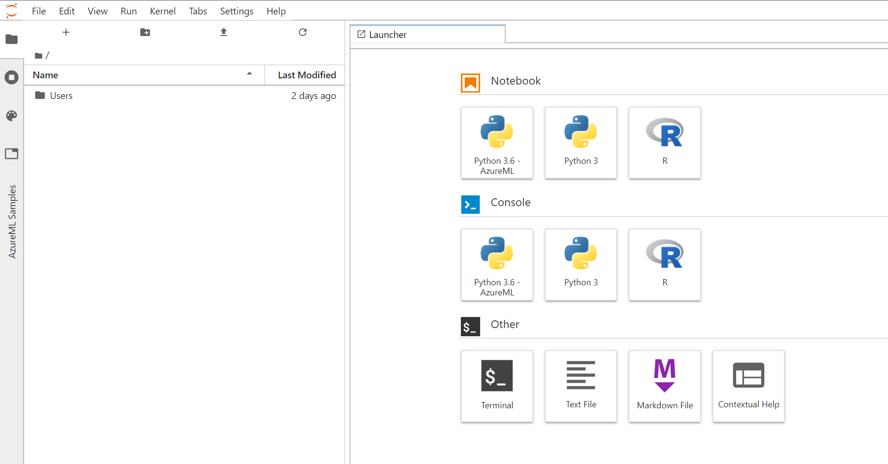

* In the terminal window clone Navigate to your directory (Users/X.X/ ) and then clone this repository by typing:

git clone https://github.com/shkumar64/AzureMachineLearningWorkshop.git

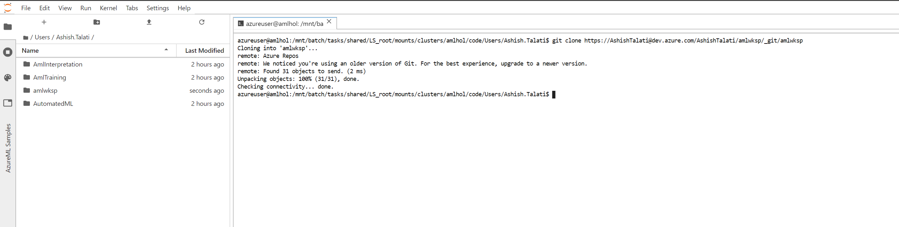

* Go back to Azure ML homepage and click on Notebooks. You should see amlwksp directory created with additional subdirectory in there with the Azure ML notebooks

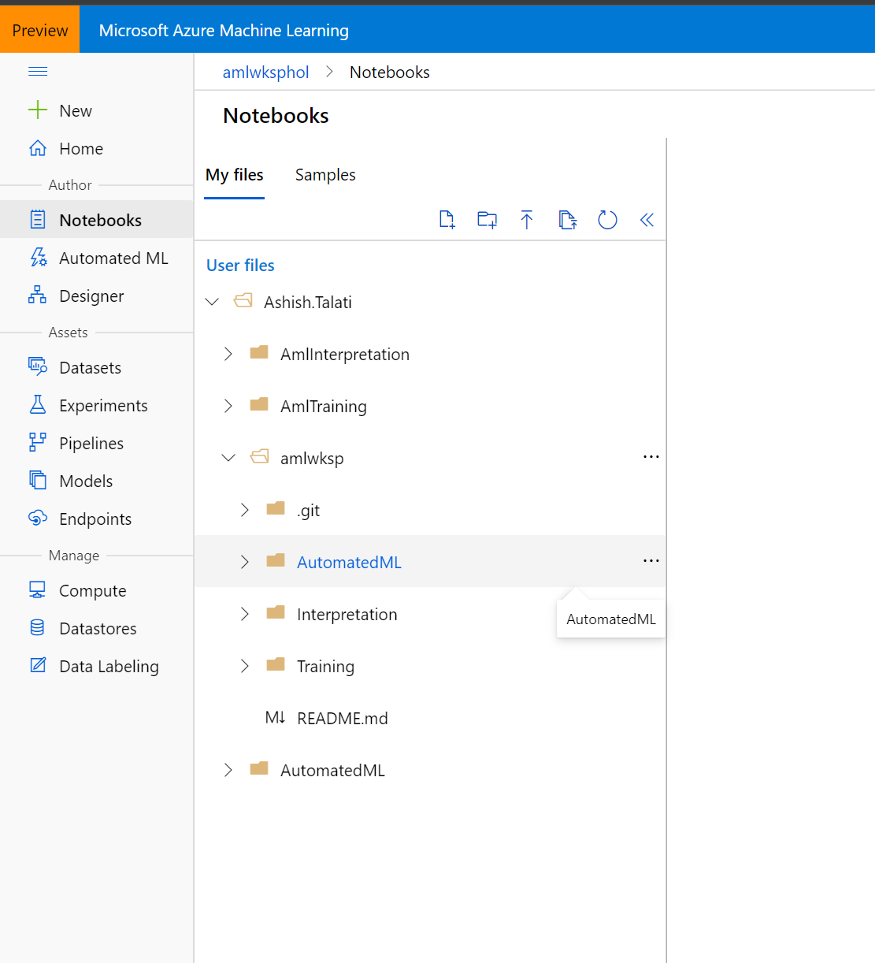

**Following are the notebook that you can execute using SDK and research further:**

Change following notebooks with details from section 1

amlwksp/AutomatedML/binayclassification-employee-attrition-autoaml-local-compute.ipynb

amlwksp/Deployment/deploy-attrition-model.ipynb

amlwksp/Interpretation/2-explain-model-on-amlcompute.ipynb

amlwksp/Training/binayclassification-employee-attrition-notebook.ipynb

Look for the cell with following details

from azureml.core import Workspace, Dataset

from azureml.core.authentication import InteractiveLoginAuthentication

interactive_auth = InteractiveLoginAuthentication(tenant_id="your tenant id")

# Get Workspace defined in by default config.json file

# ws = Workspace.from_config()

ws = Workspace(subscription_id="your subscription id",

               resource_group="your resource group",

               workspace_name="your workspace name",

               auth=interactive_auth)

Training

* binayclassification-employee-attrition-notebook.ipynb => Notebook for plain scikit-learn model training in AML Local compute (AML VM)

Automated ML (Additional information on Automated ML - <https://docs.microsoft.com/en-us/azure/machine-learning/concept-automated-ml>)

* binayclassification-employee-attrition-autoaml-local-compute.ipynb => Notebook for AutoML on local compute

Interpretation (More information on interpretability at <https://docs.microsoft.com/en-us/azure/machine-learning/how-to-machine-learning-interpretability>)

* 1-simple-feature-transformations-explain-local.ipynb => Feature transformation and Local Explanation.
* 2-explain-model-on-amlcompute.ipynb => Explain model on AML Compute

**7. Azure ML R SDK and R Studio Interface**

Azure Machine Learning supports R. You can bring in your existing R codes in to Azure Machine Learning and run it in the same experiment with provided learners and publish this as web service via Azure Machine Learning.Azure ML workspace integrates with R studio which allows seamless access to a R based notebook environment.

* To access the R Studio navigate to the compute instance created in the previous steps and click on R studio.

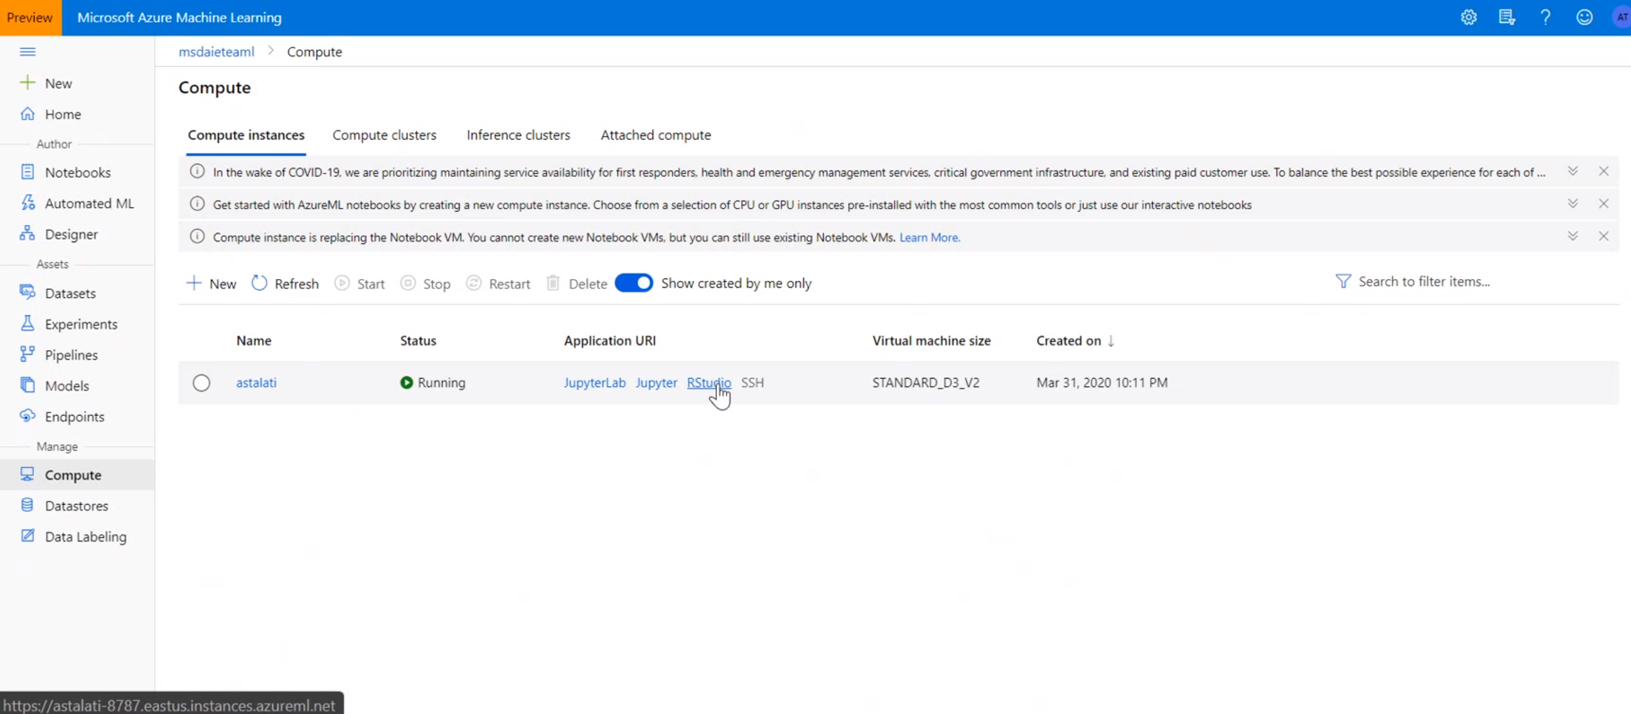

* The R studio interface will start in the separate window. The bottom right pane is the directory browser. Navigate to Users🡪”username”-> “amlworkspace”. You should be able to see the directory that we cloned in the last exercise

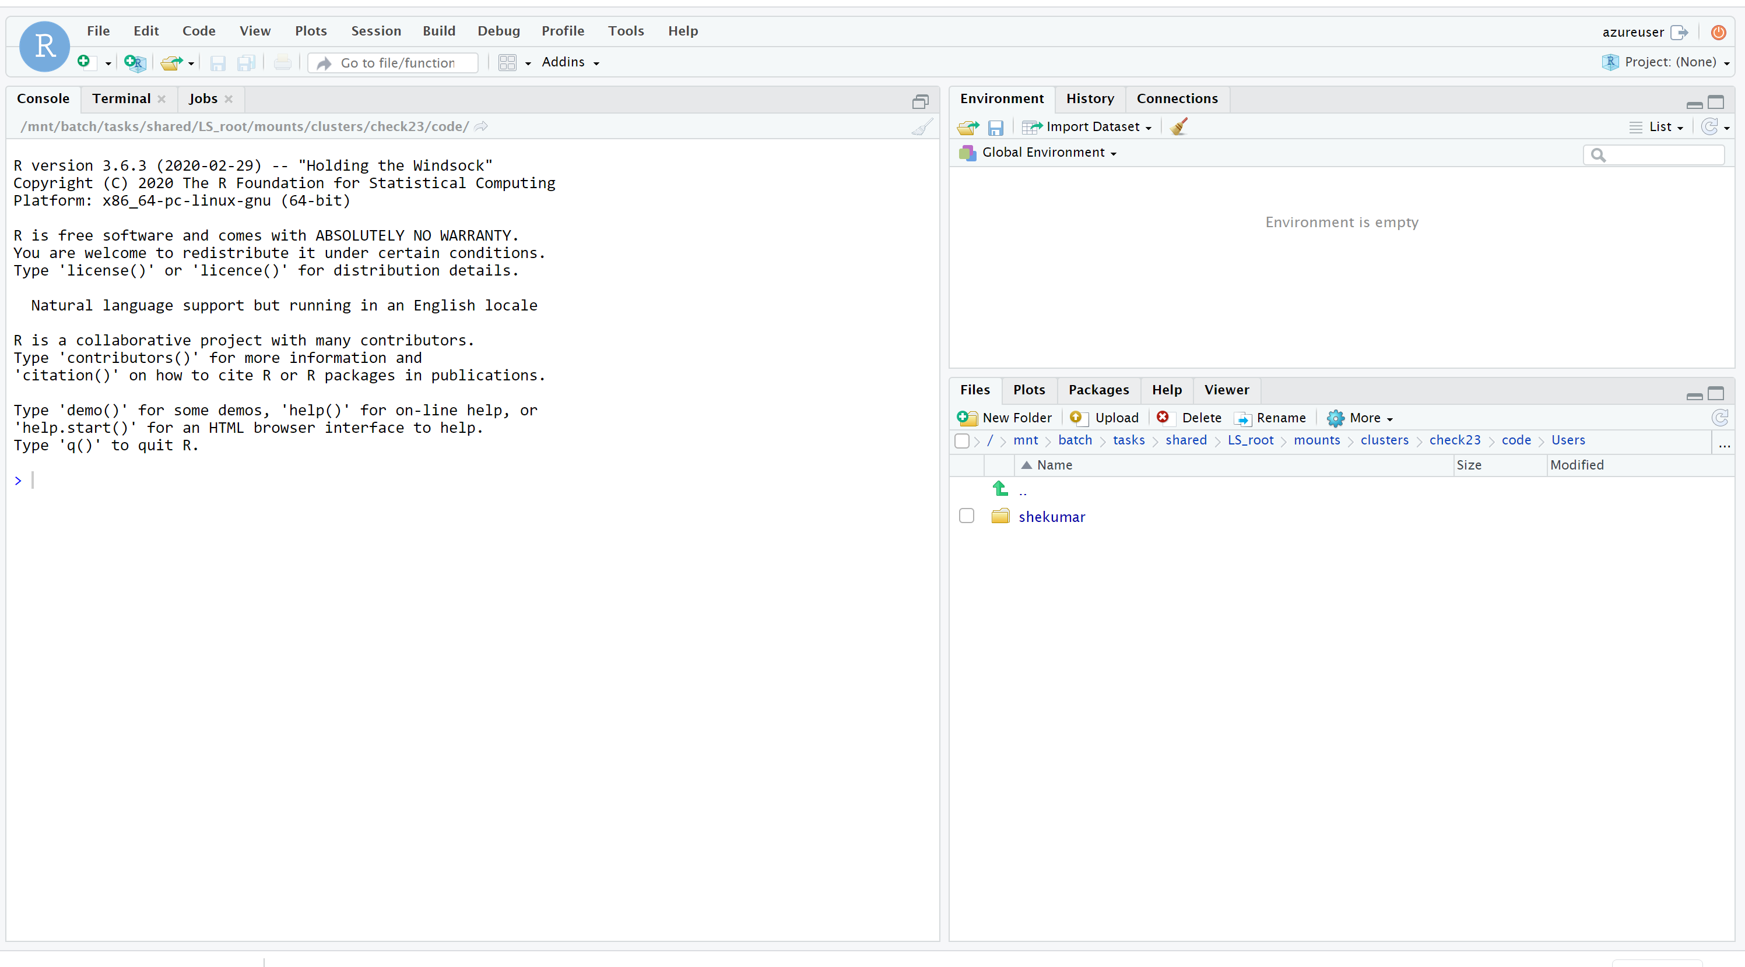

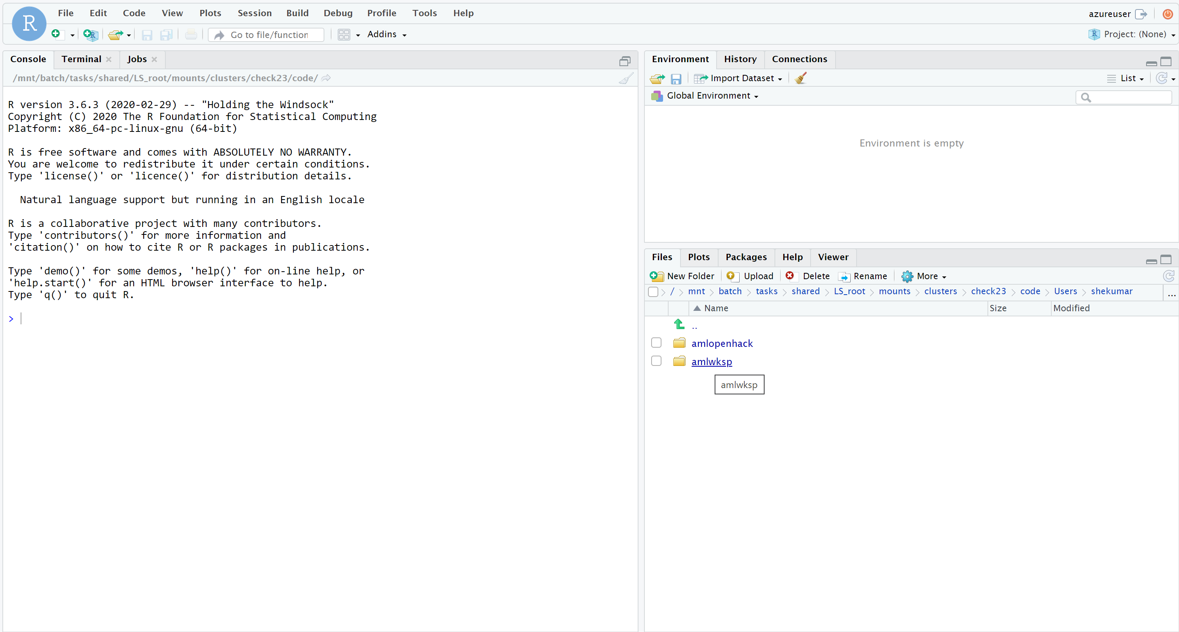

* Open the folder named “R”. This contains R notebooks that we would use through this exercise.
* Use the “More” menu and select the current directory as working directory as in the screenshot below.

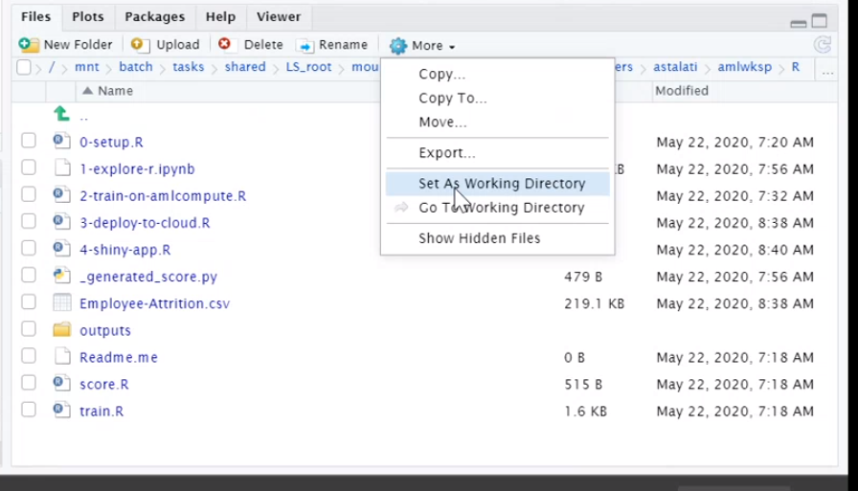

* Click on 0-setup.R file to open it in the file pane. You can start executing it one by one or all together by selecting all lines in the notebook before starting the run. This notebook would install all the dependencies needed to run model training and scoring.

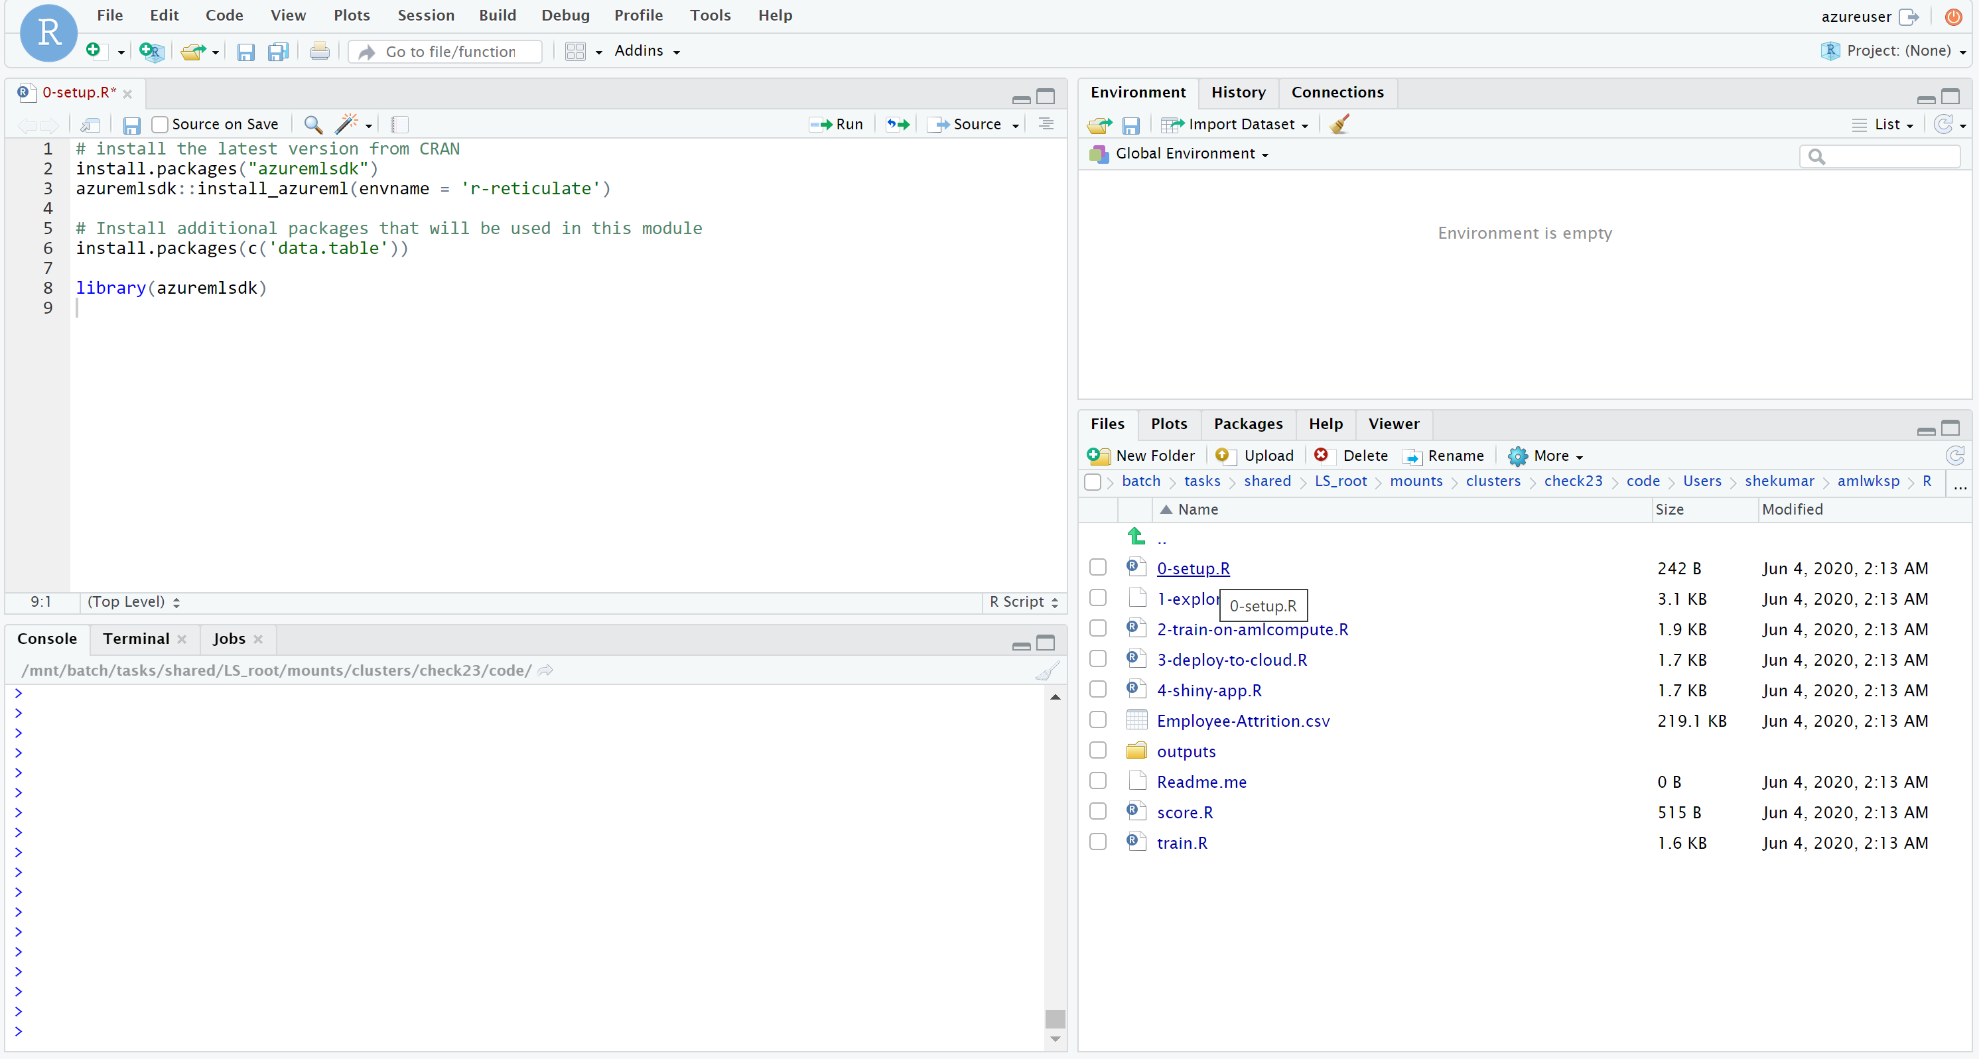

* After the setup is done. Open 2-train-onamlcompute.R This notebook executes the same logic as python notebook from the last exercise. Run commands one by one .
* Make sure you replace the name of the dataset in line 41 with the output of line 39 *print(attrition)*

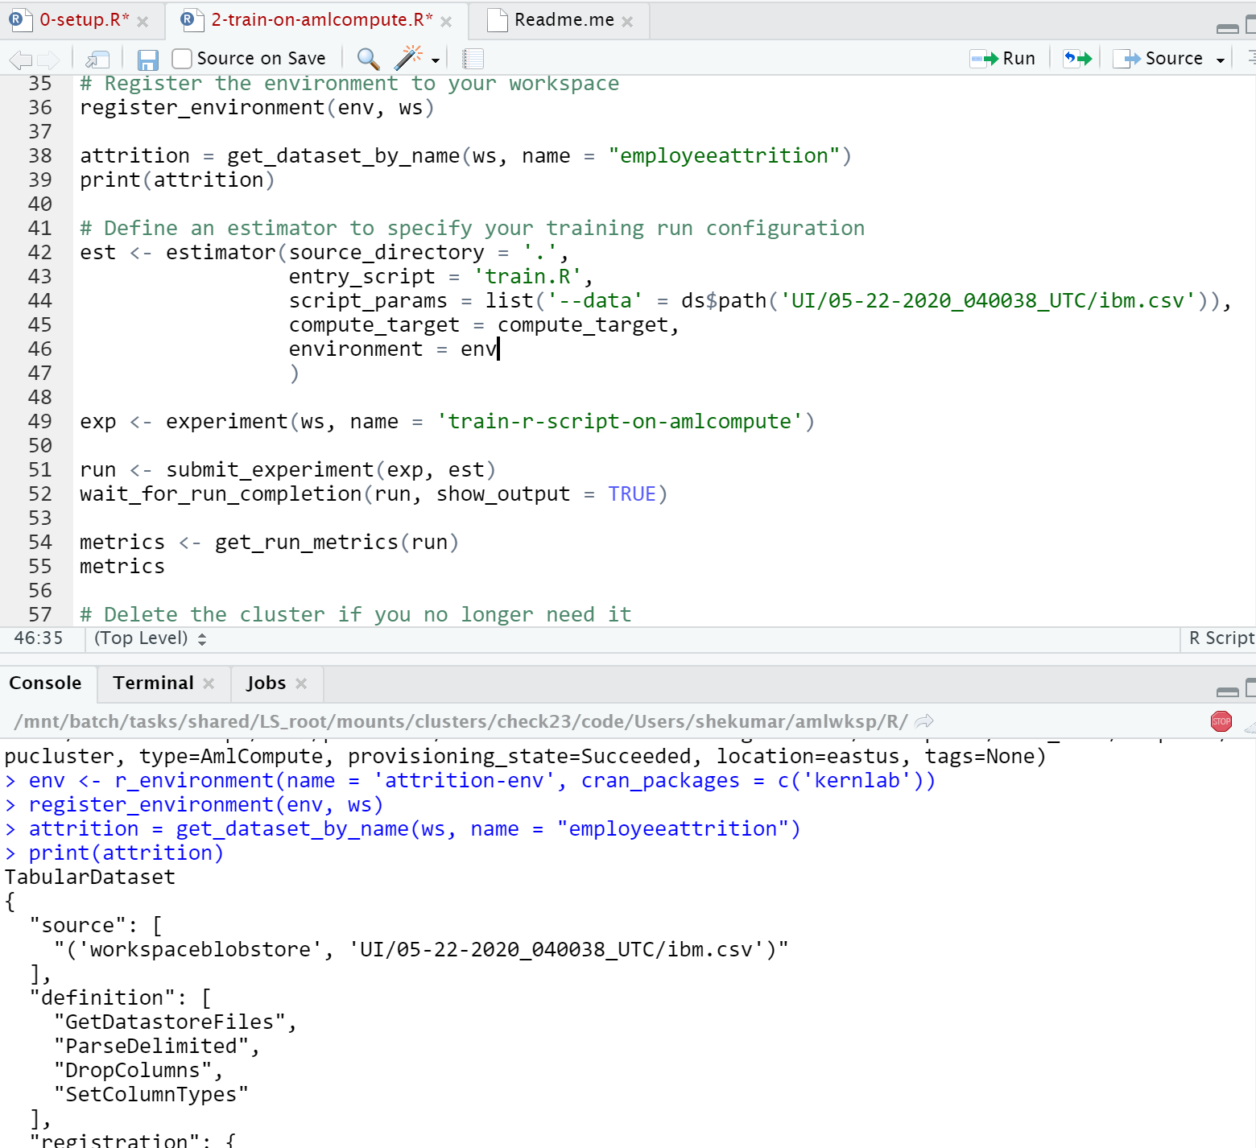

* If you navigate to your AML workspace you should be able to see the ongoing execution of the R script. When the script finishes you should be able to print the metrics from the completed run.

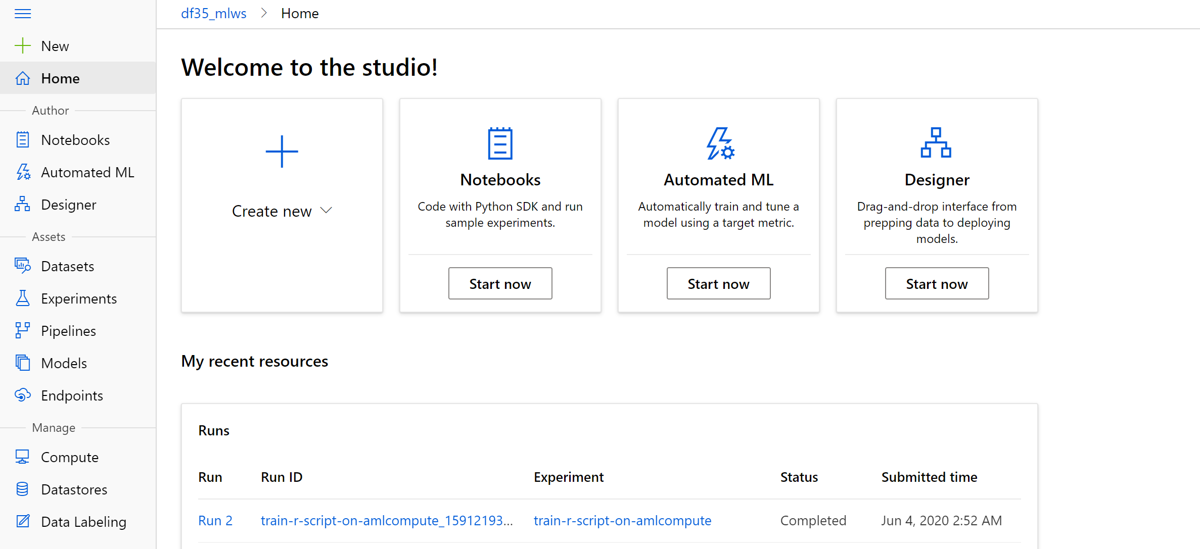

* After successfully training the model. Now we need to register the model in the AML workspace and deploy it as a container. Open 3-deploy-to-cloud.R and start executing the notebook. After the execution finishes. You would be able to see the model registered under “Models” in the AML workspace and also the REST endpoint available under “Endpoints”. The script also internal calls and tests sample data from this endpoint which should be visible in the script output

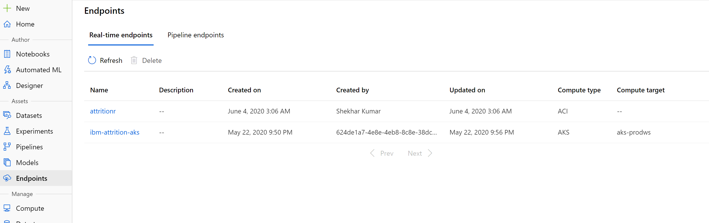

* With R you can also consume the model with a Shiny App. To use this model using shiny-app. Open the notebook 4-shiny-app.R. and click on “Run App”. Make sure to save all changed files before executing. The app should open in a new window and you should be able to see the input and output of the model.

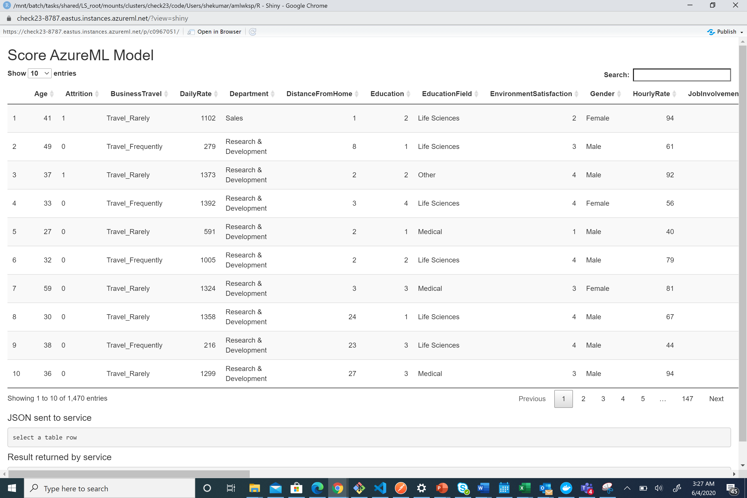

**Optional reading**

* <https://azure.github.io/azureml-sdk-for-r/index.html>
* <https://docs.microsoft.com/en-us/azure/machine-learning/tutorial-1st-r-experiment>

**8. MLOps**

Machine Learning Operations (MLOps) is based on [DevOps](https://azure.microsoft.com/overview/what-is-devops/) principles and practices that increase the efficiency of workflows. For example, continuous integration, delivery, and deployment. MLOps applies these principles to the machine learning process, with the goal of:

* Faster experimentation and development of models
* Faster deployment of models into production
* Quality assurance

MLOps will help you to understand how to build a Continuous Integration and Continuous Delivery pipeline for an ML/AI project. We will be using the Azure DevOps Project for build and release/deployment pipelines along with Azure ML services for model retraining pipeline, model management and operationalization.

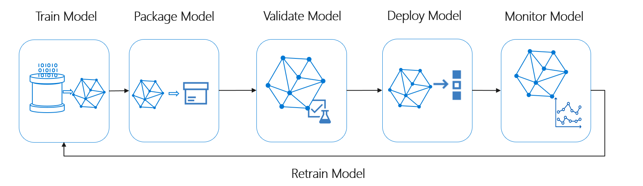

Azure Machine Learning provides the following MLOps capabilities:

* **Create reproducible ML pipelines**. Machine Learning pipelines allow you to define repeatable and reusable steps for your data preparation, training, and scoring processes.
* **Create reusable software environments** for training and deploying models.
* **Register, package, and deploy models from anywhere**. You can also track associated metadata required to use the model.
* **Capture the governance data for the end-to-end ML lifecycle**. The logged information can include who is publishing models, why changes were made, and when models were deployed or used in production.
* **Notify and alert on events in the ML lifecycle**. For example, experiment completion, model registration, model deployment, and data drift detection.
* **Monitor ML applications for operational and ML-related issues**. Compare model inputs between training and inference, explore model-specific metrics, and provide monitoring and alerts on your ML infrastructure.
* **Automate the end-to-end ML lifecycle with Azure Machine Learning and Azure Pipelines**. Using pipelines allows you to frequently update models, test new models, and continuously roll out new ML models alongside your other applications and services.

This is where the Azure Machine Learning shines the most. It presents the most complete and intuitive model lifecycle management experience alongside integrating with Azure DevOps and GitHub.

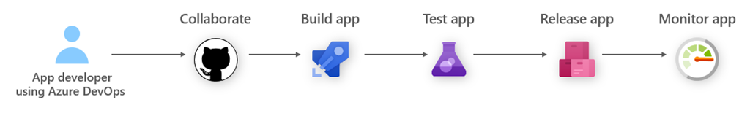

Following is the diagrammatic representation below for MLOps with Azure Machine Learning.

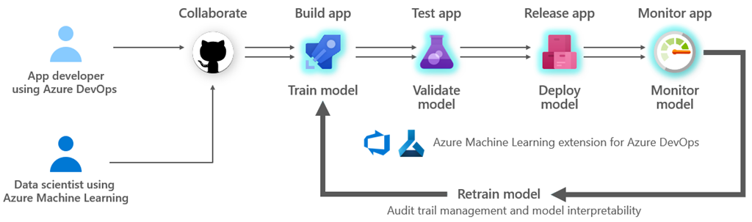

Additional information available at

* Model Management and Deployment - <https://docs.microsoft.com/en-us/azure/machine-learning/concept-model-management-and-deployment>
* Deployment Options - <https://docs.microsoft.com/en-us/azure/machine-learning/service/how-to-deploy-and-where>
* Event grid Integration - <https://docs.microsoft.com/en-us/azure/machine-learning/service/concept-event-grid-integration>

Following is the notebook that you can execute using SDK and research further:

* deploy-attrition-model.ipynb => Deploy the model to Azure Container Instance using Python SDK

**For rest of the workshop we will build the automated training and deployment using Azure DevOps.**

* Go to your Azure DevOps project and create a new project

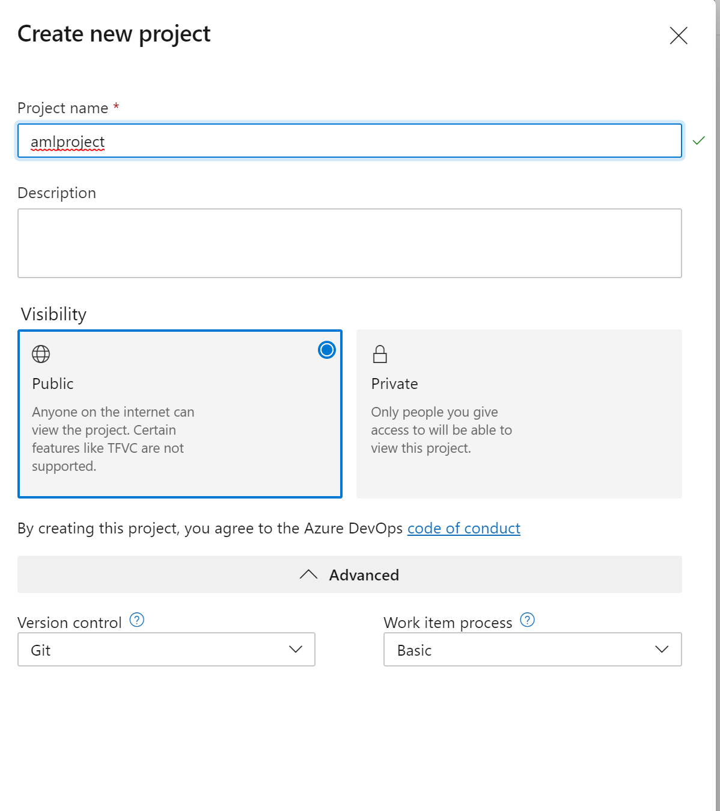

* Click Create
* Click the Repos area. Click on the Git repo dropdown at the top of the page and then on "Import Repository".

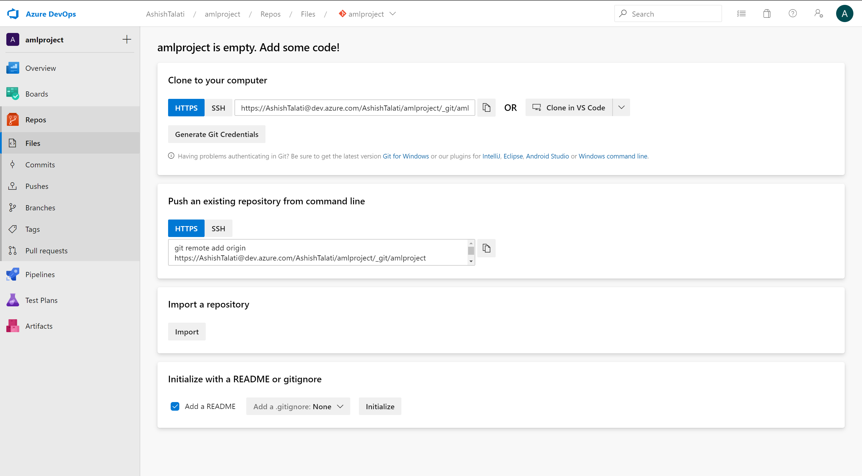

* Under clone URL, you can put <https://github.com/shkumar64/AzureMachineLearningWorkshop>
* Next, let's connect your ML workspace to Azure DevOps. (Note: This workshop leverages the **Azure Machine Learning** extension that should be installed in your organization from the [marketplace](https://marketplace.visualstudio.com/items?itemName=ms-air-aiagility.vss-services-azureml).)
* In order to set up automated training and deployment, you need to create a service connection to your ML workspace. To get there, go to your Azure DevOps project settings page (by clicking on the gear wheel to the bottom left of the screen), and then click on **Service connections** under the **Pipelines** section. The Azure ML extension uses an **Azure Resource Manager** service connection.

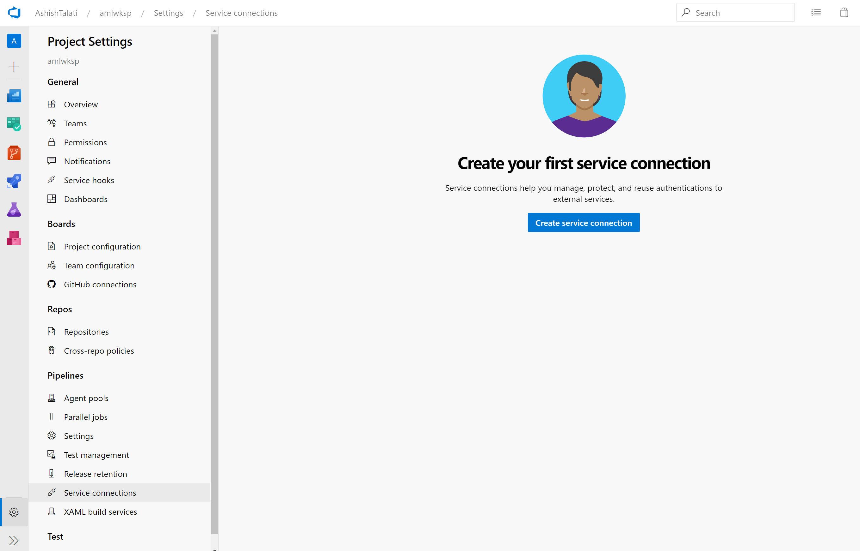

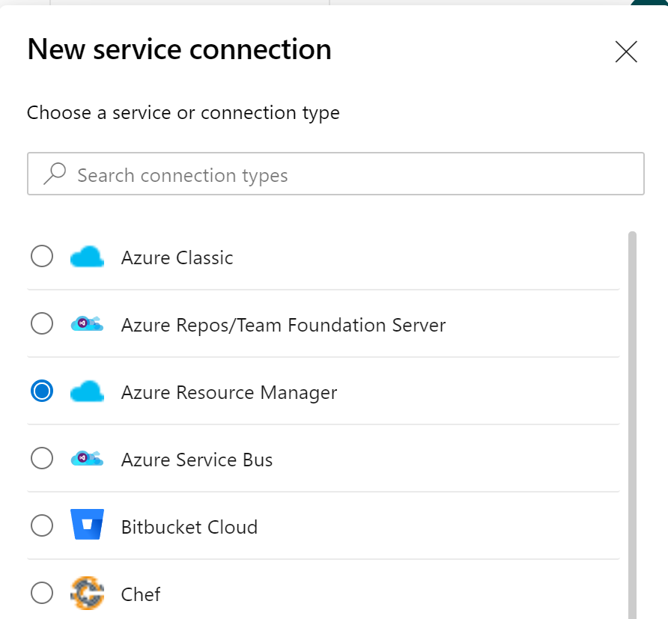

* Select Service principal (automatic)

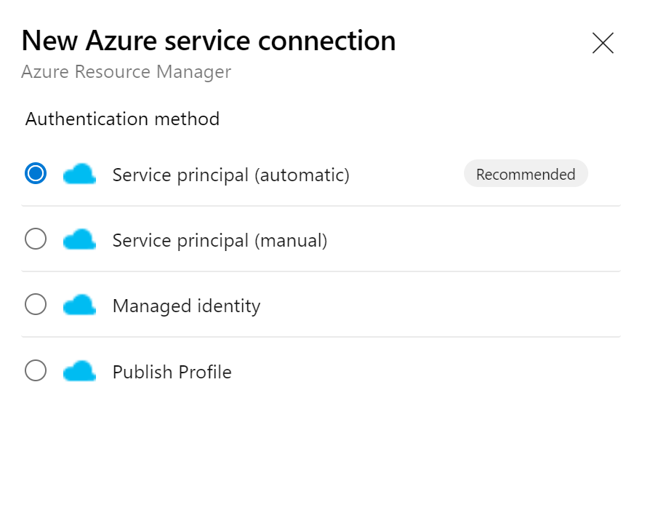

* **Important:** Make sure you point it to workshop workspace and be sure to name the Service connection
* **Note:** Creating service connection using Azure Machine Learning extension requires 'Owner' or 'User Access Administrator' permissions on the Workspace.

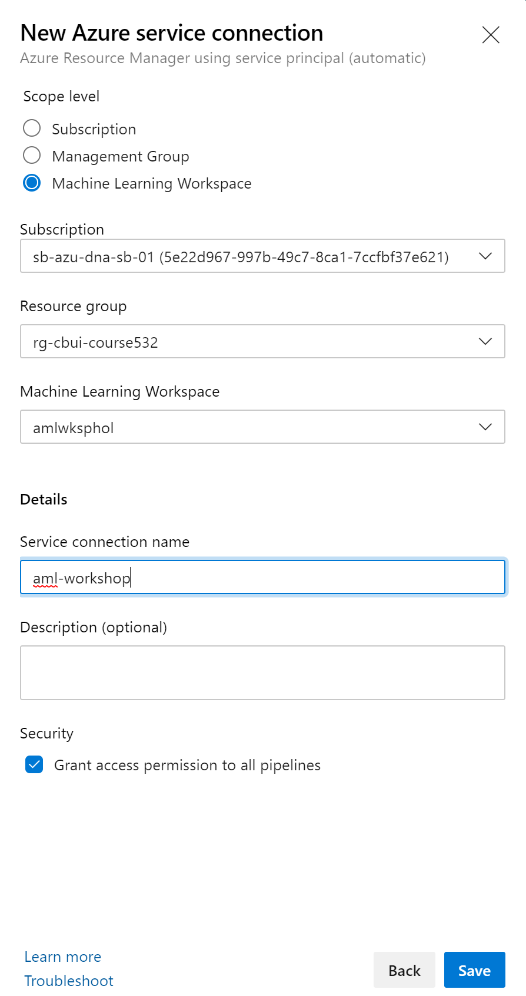

The first phase of bringing your ML workflow to production is being able to reproduce and automate the model training process.

In this repo, you will find four pipelines:

* pipelines/deploy-infrastructure.yml - Provisions a compute cluster for performing model training, as well as the AKS cluster for model deployment
* pipelines/train-and-register-model.yml - Trains the model on the compute cluster and registers it
* pipelines/deploy-model.yml - Deploys the model to the AKS cluster
* pipelines/delete-infrastructure.yml - Deletes the AKS cluster and also the compute cluster (just used here for testing here, so that you can delete your AKS cluster quickly)

The pipelines derive their configuration variables from:

* pipelines/config.yml - Contains all names and configuration paramters for the pipelines

Goto Pipelines (Rocket symbol), select Create Pipeline and pick Azure Repos Git:

* 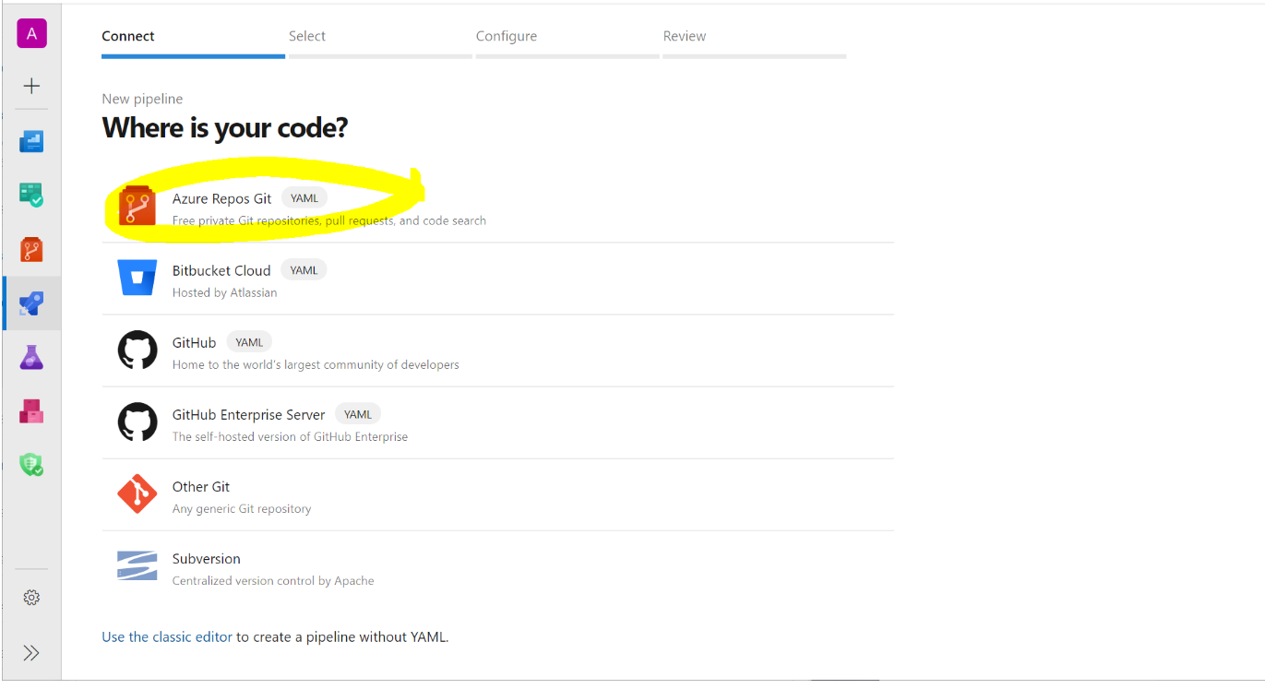

Select your repo:

* 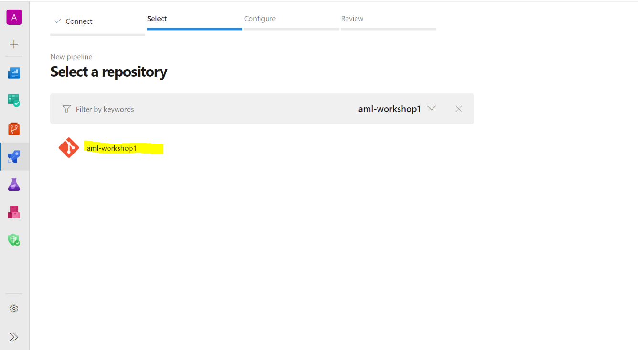

Select Existing Azure Pipelines YAML file:

* 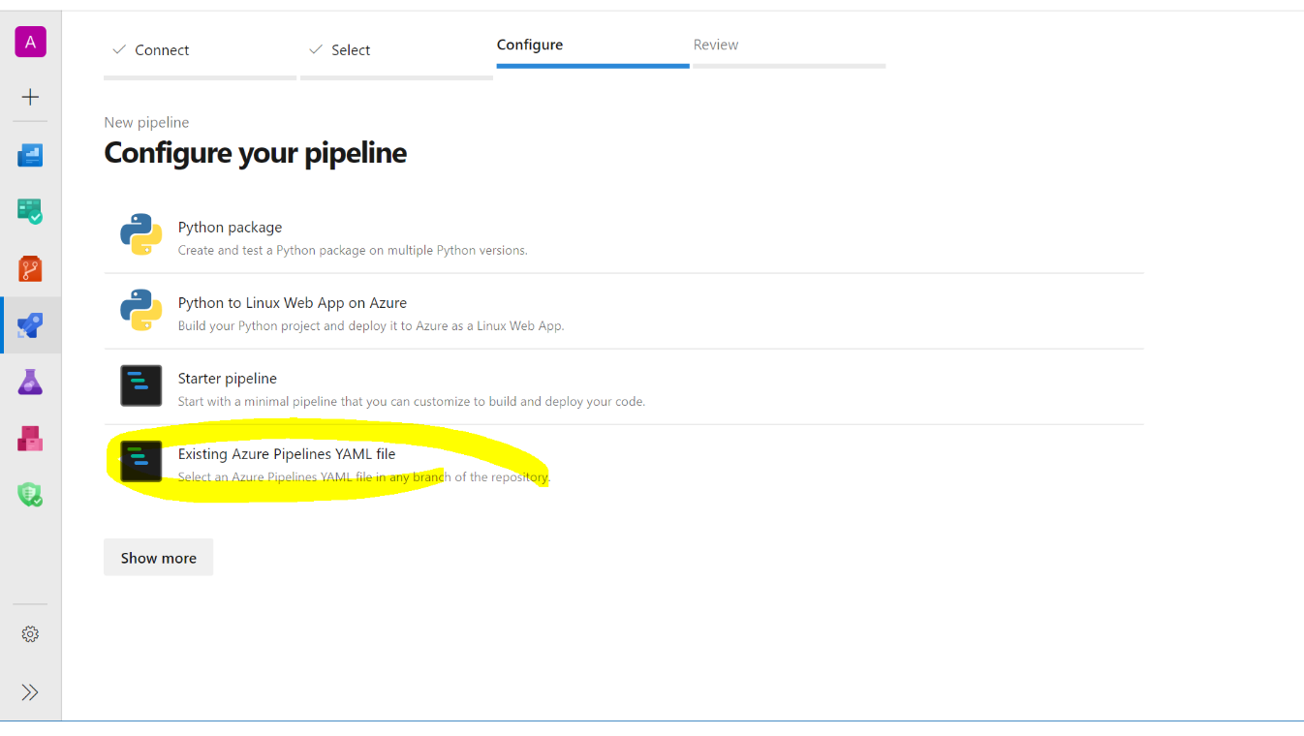

Select the pipeline /pipelines/deploy-infrastructure.yml from the list. Instead of hitting Run, hit the down arrow and select Save:

* 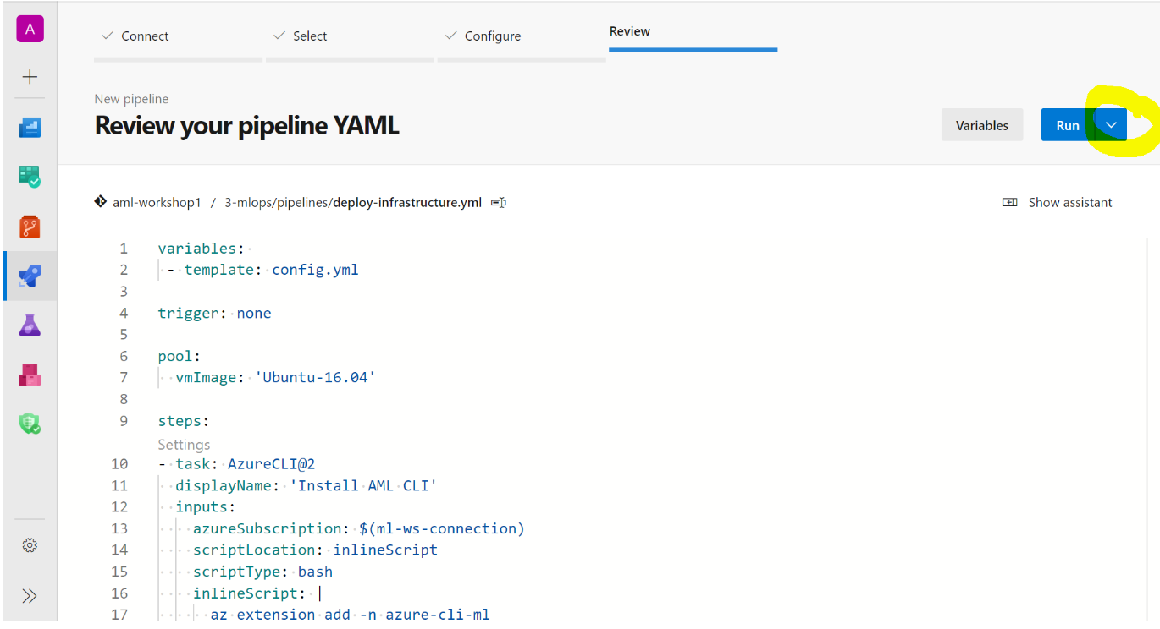

Then select the three dots and select Rename:

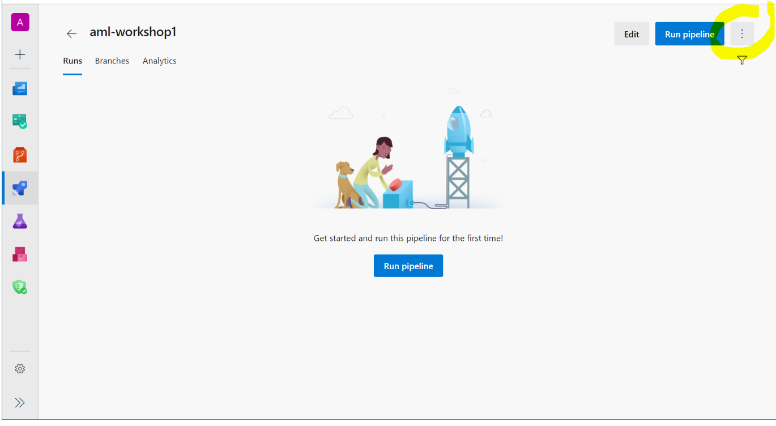

* Rename the pipeline to deploy-infrastructure and hit Save:
* 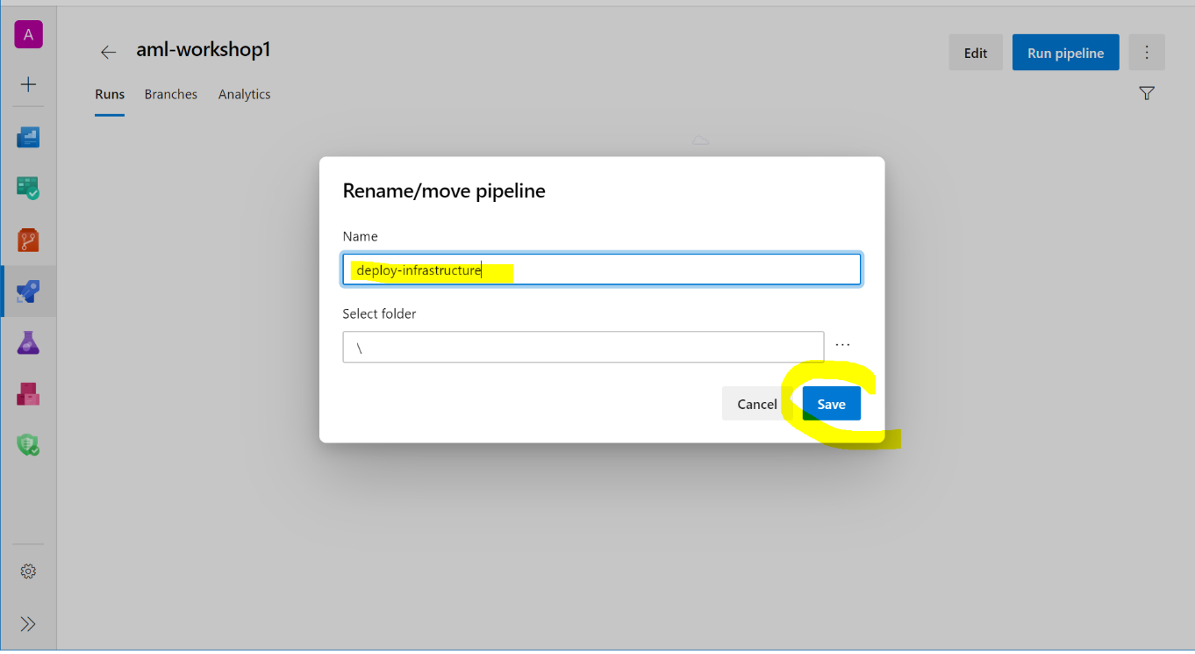

Repeat the steps above three times and import the following pipelines:

* /pipelines/train-and-register-model.yml and rename to train-and-register-model
* /pipelines/deploy-model.yml and rename to deploy-model
* /pipelines/delete-infrastructure.yml and rename to delete-infrastructure

Once done, your pipelines should look like this (select All tab):

* 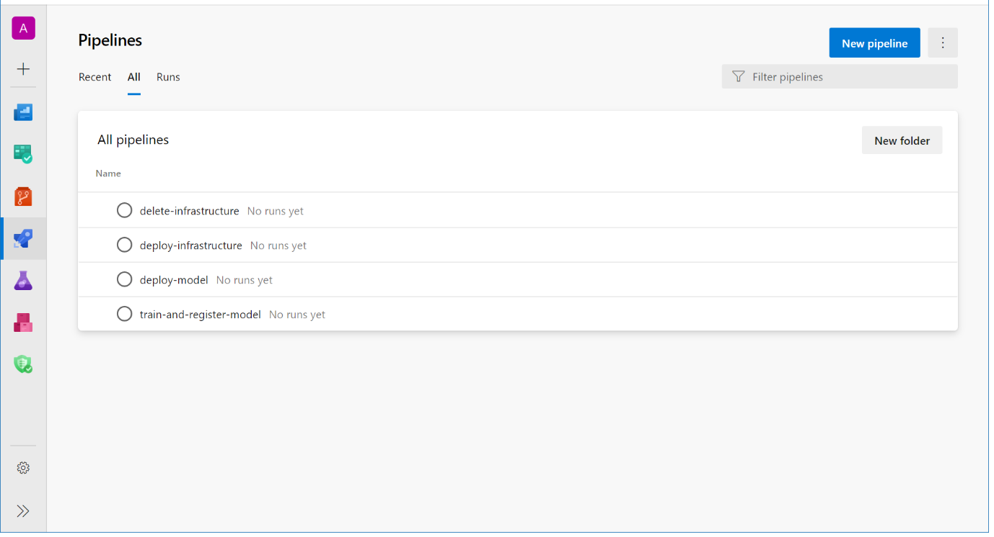

For sake of this workshop, we have disabled automatic triggering of the pipelines. Hence, we can now manually run three out of the four pipelines manually:

* + deploy-infrastructure
  + train-and-register-model
  + deploy-model

The last pipeline delete-infrastructure can be used to get rid of the AKS cluster (for saving cost).

* 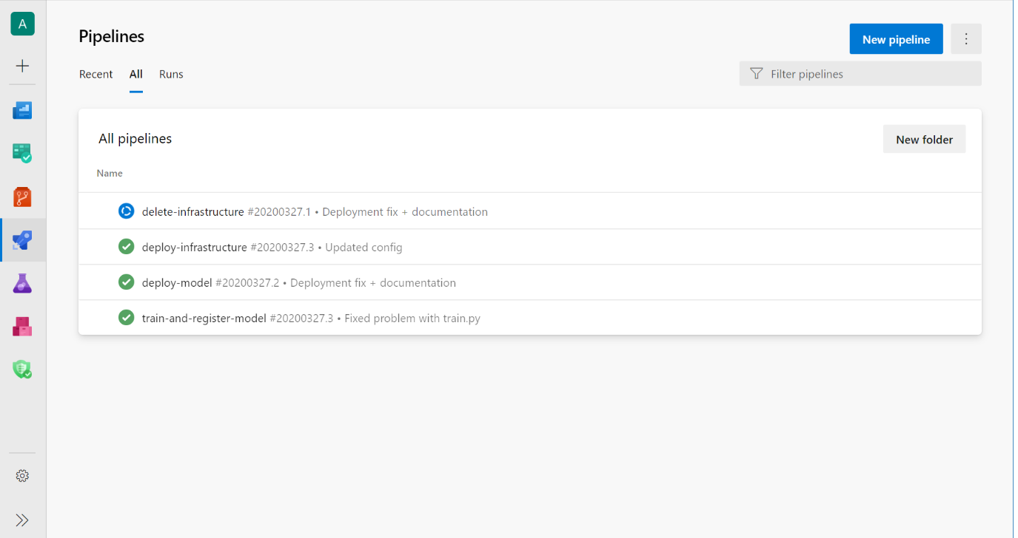

Once all three pipelines ran, we should be able to see in the AzureML studio:

* New experiment run should have been created
* Model should have been registered
* A new endpoint should have been registered

We can now try out the model by using the Consume tab under the AKS endpoint:

POST http://<your endpoint address>:80/api/v1/service/ibm-attrition-aks/score HTTP/1.1

Authorization: Bearer <your key>

Content-Type: application/json

{

"data": [{

"Age": 41,

"BusinessTravel": "Travel_Rarely",

"DailyRate": 1102,

"Department": "Sales",

"DistanceFromHome": 1,

"Education": 2,

"EducationField": "Life Sciences",

"EnvironmentSatisfaction": 2,

"Gender": "Female",

"HourlyRate": 94,

"JobInvolvement": 3,

"JobLevel": 2,

"JobRole": "Sales Executive",

"JobSatisfaction": 4,

"MaritalStatus": "Single",

"MonthlyIncome": 5993,

"MonthlyRate": 19479,

"NumCompaniesWorked": 8,

"OverTime": "No",

"PercentSalaryHike": 11,

"PerformanceRating": 3,

"RelationshipSatisfaction": 1,

"StockOptionLevel": 0,

"TotalWorkingYears": 8,

"TrainingTimesLastYear": 0,

"WorkLifeBalance": 1,

"YearsAtCompany": 6,

"YearsInCurrentRole": 4,

"YearsSinceLastPromotion": 0,

"YearsWithCurrManager": 5

}]

}

Response:

{"result": [0]}